Python

**JSON**

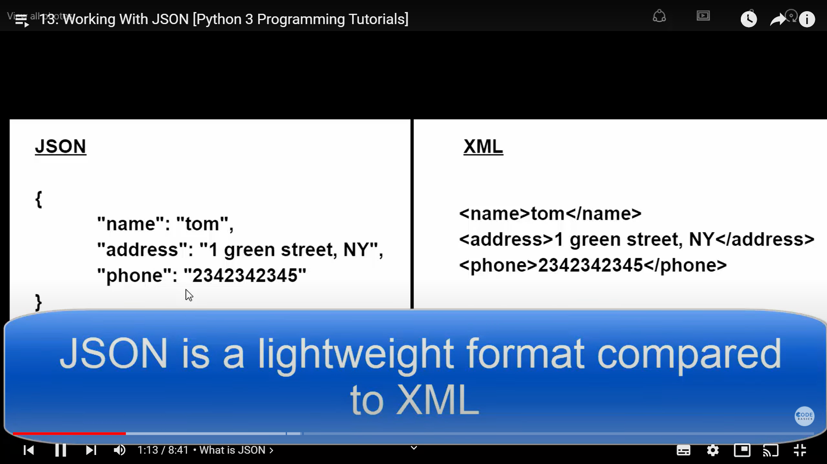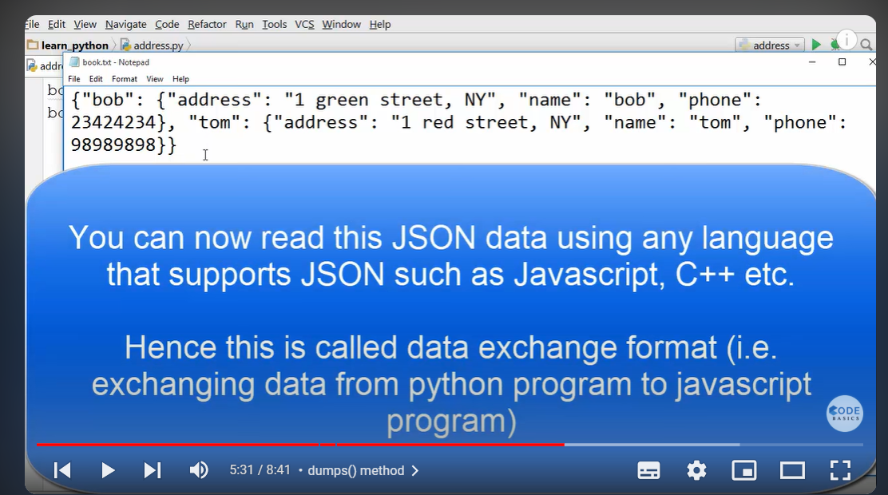

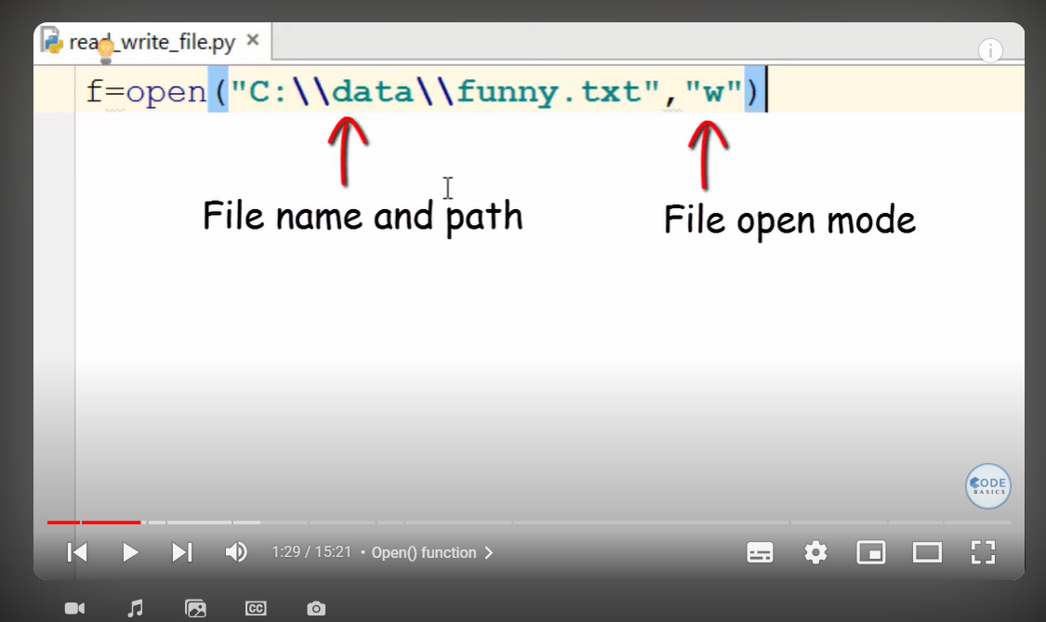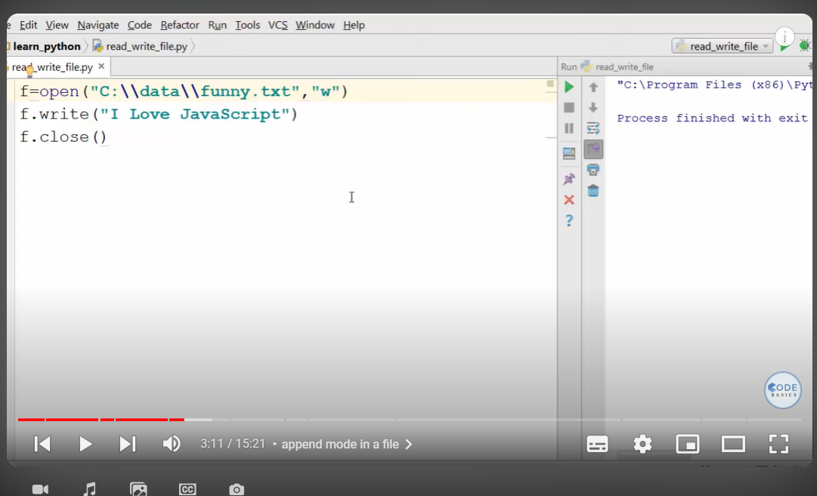

‘w’ overide the files while ‘a’ means append

Now ‘r’ read file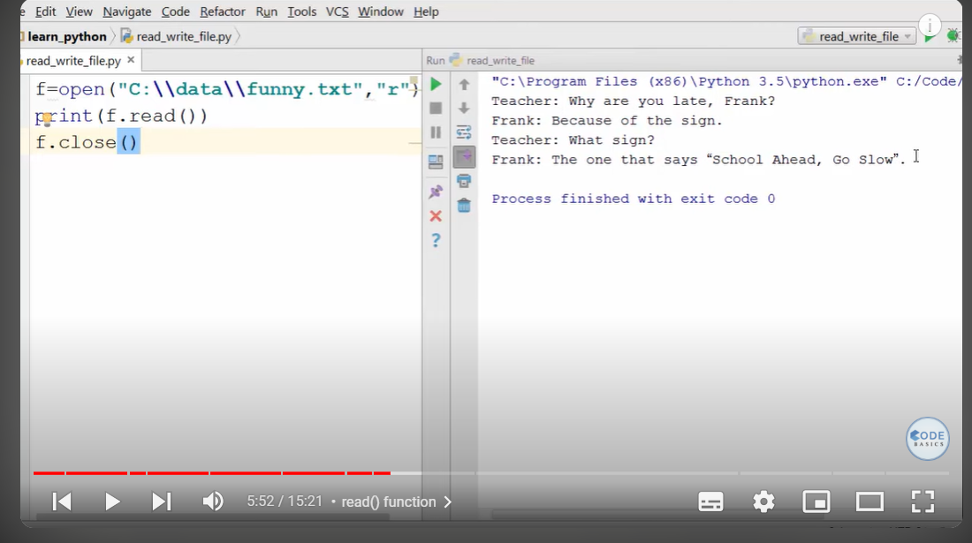

**Class and Objects**

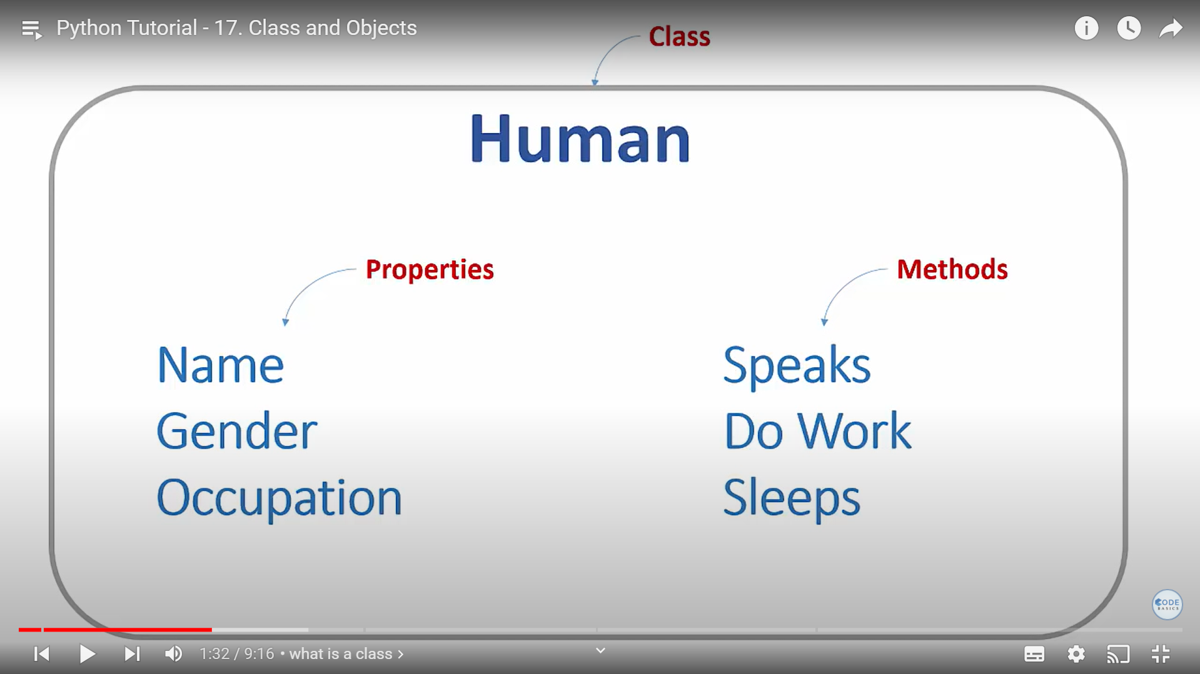

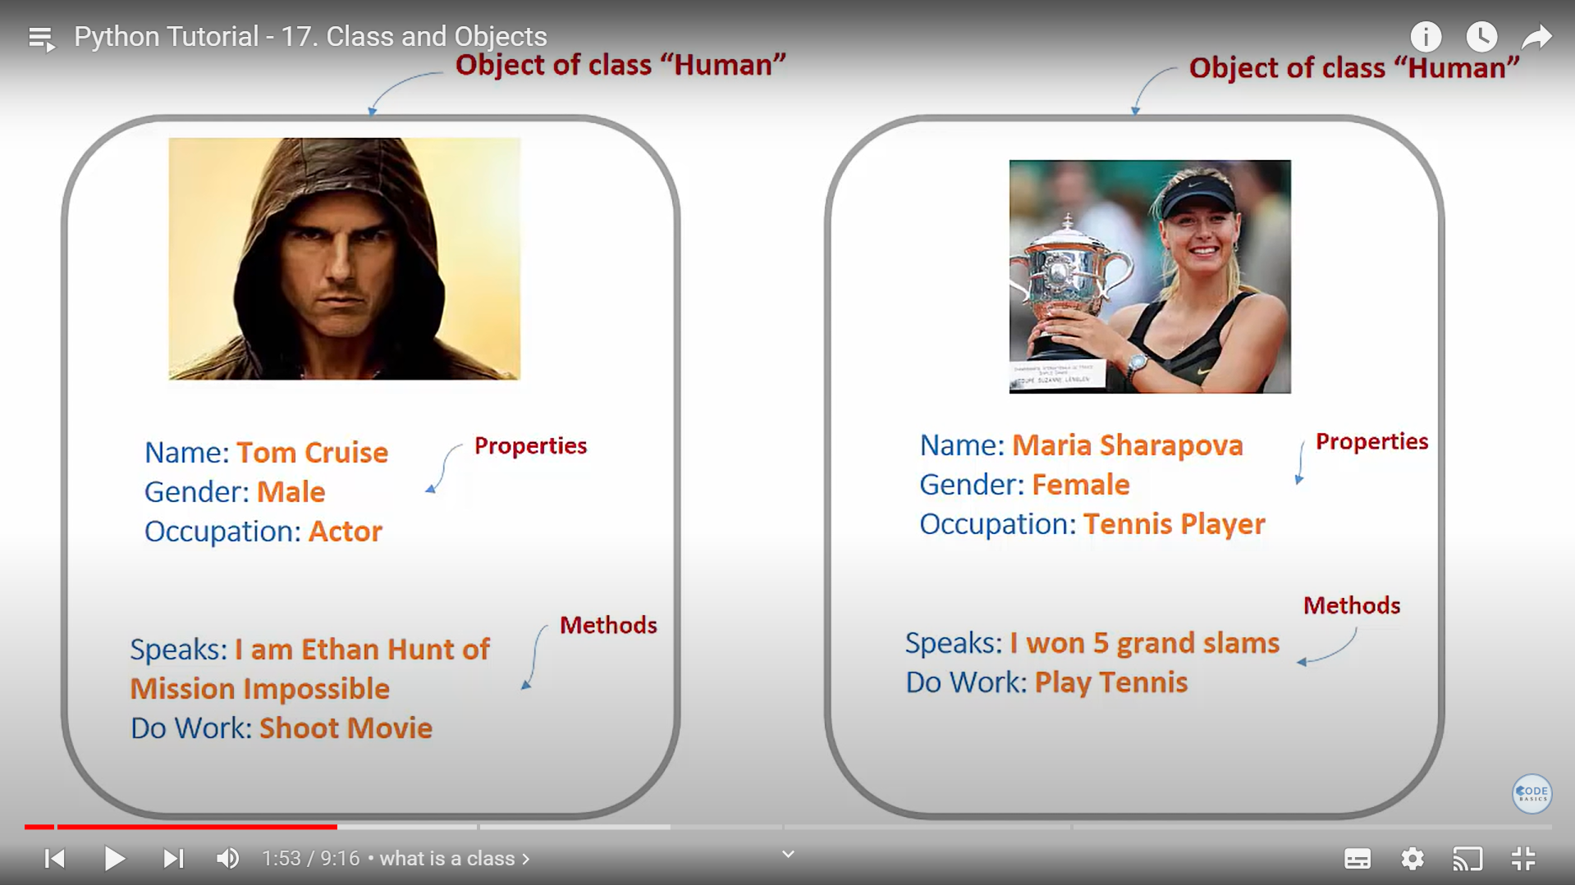

In class the argument which is pass from is called instance

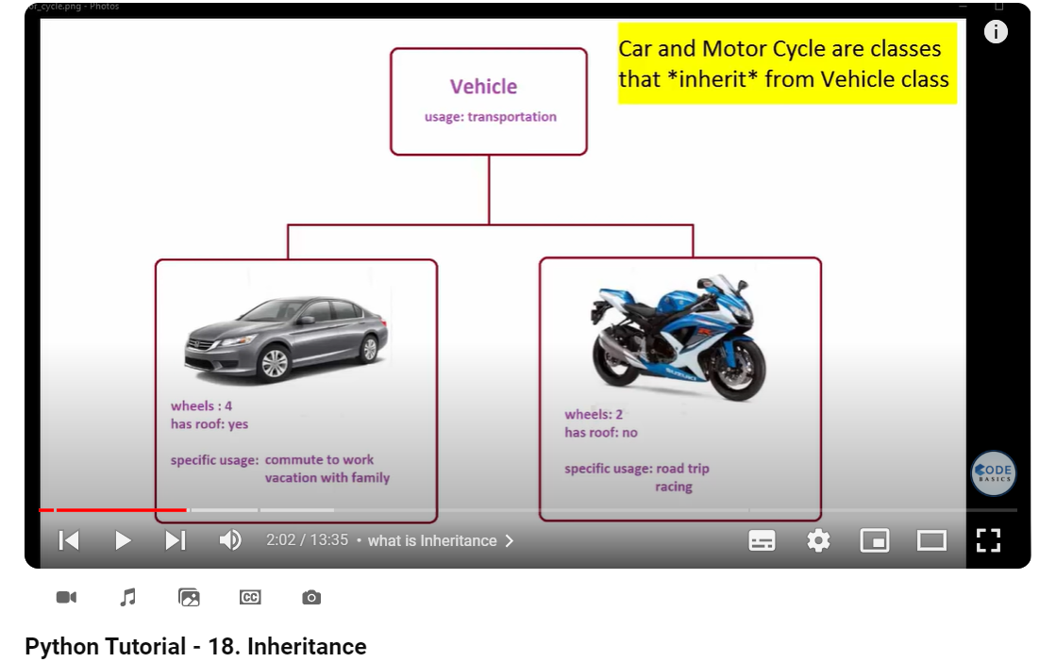 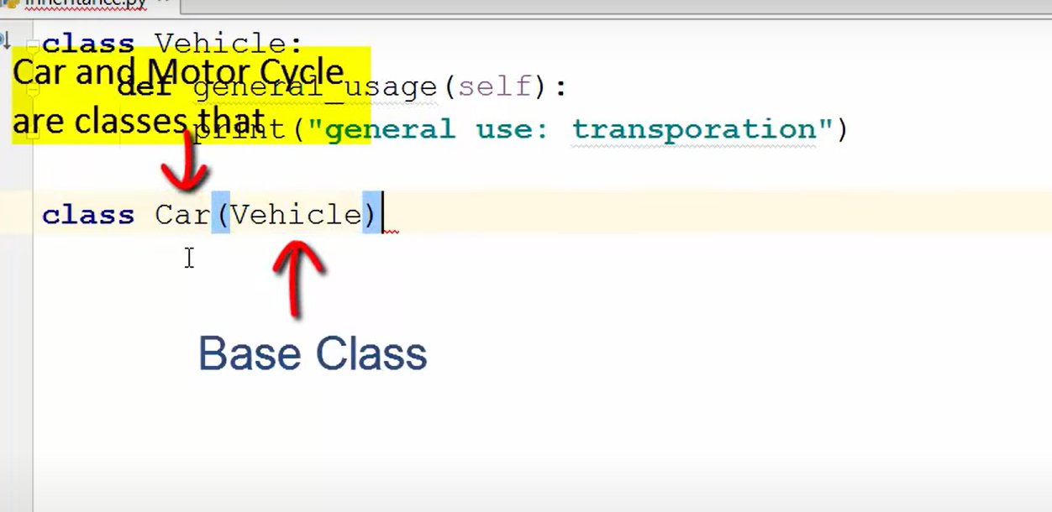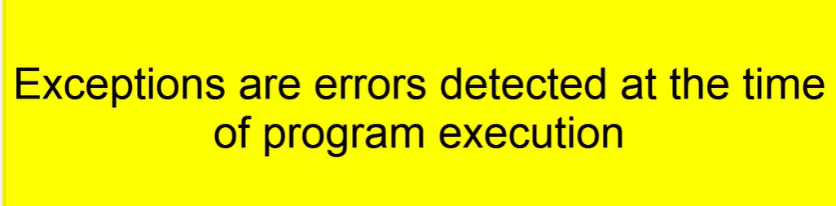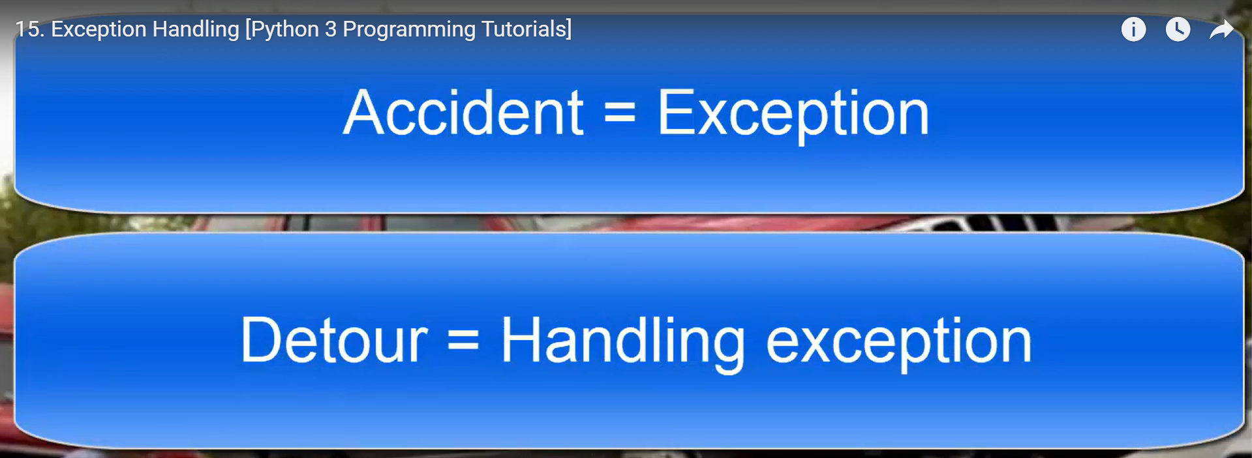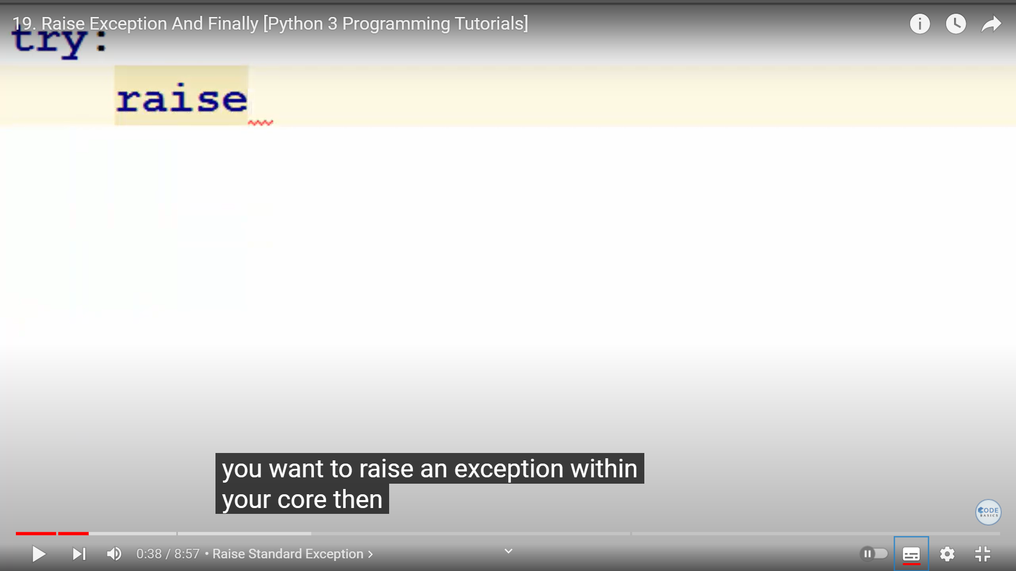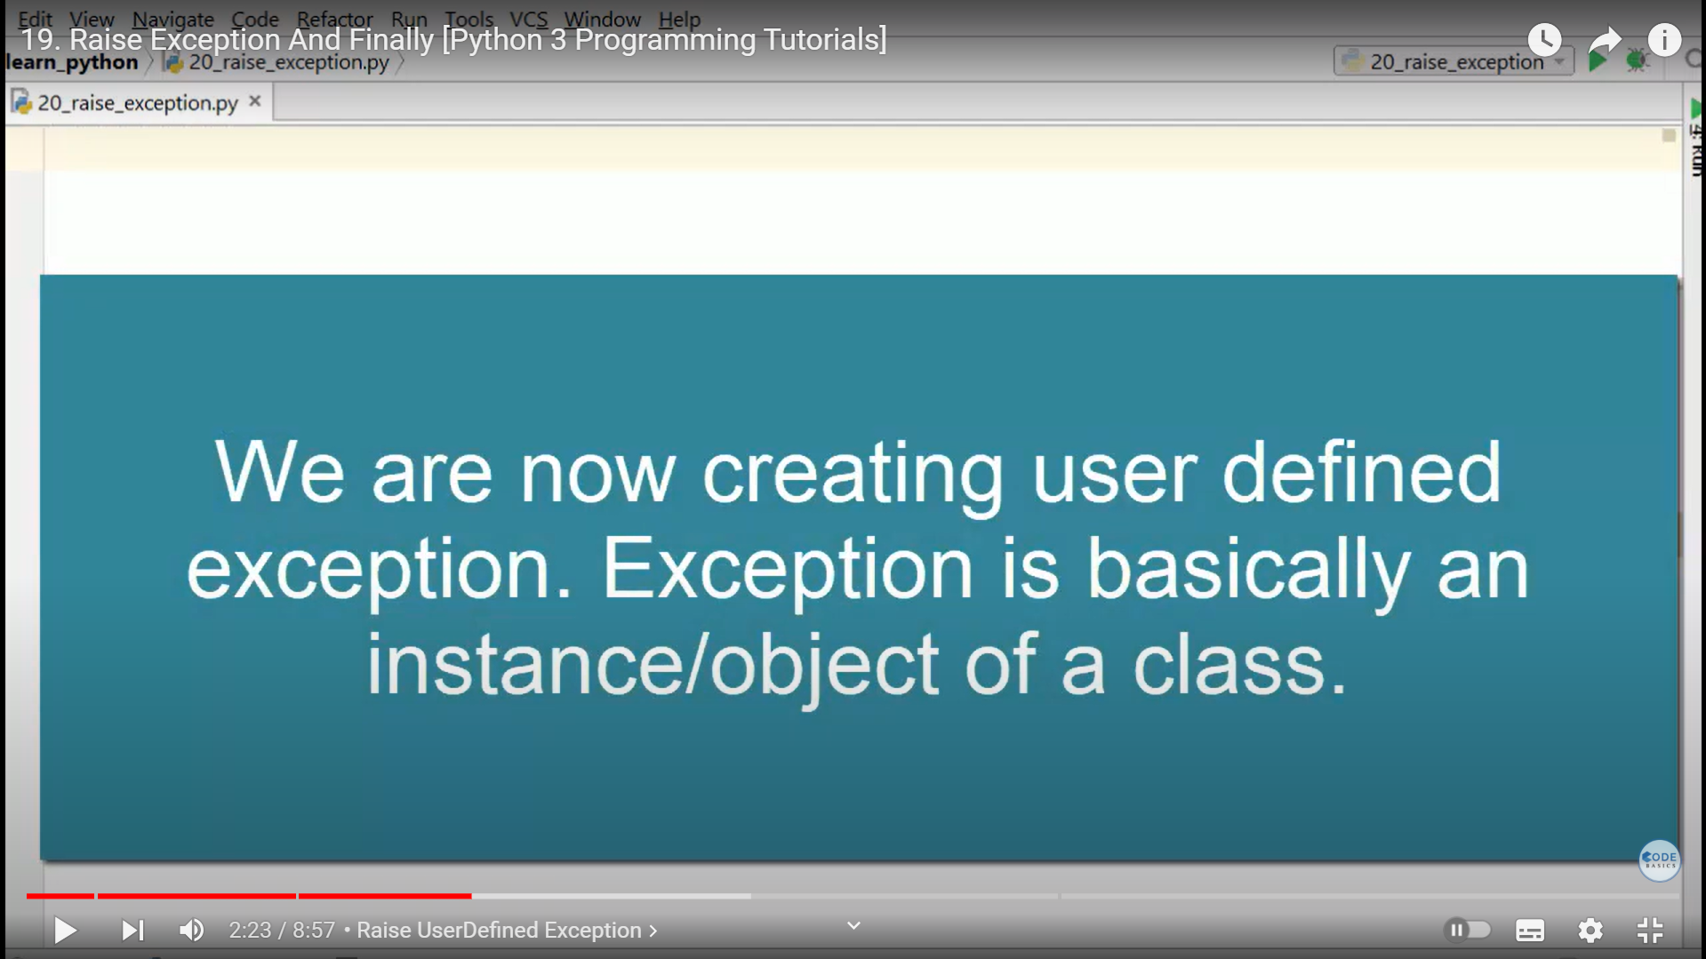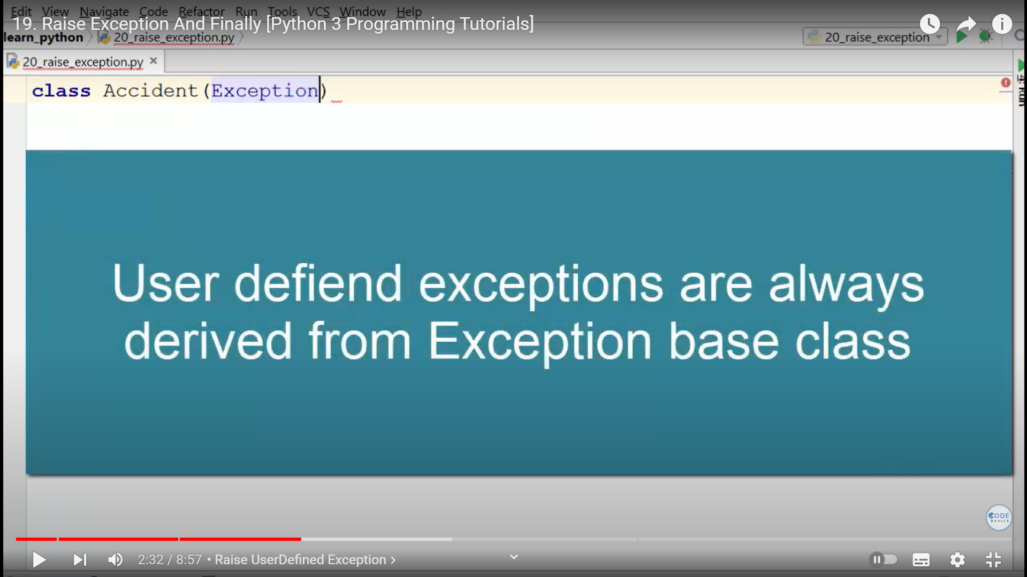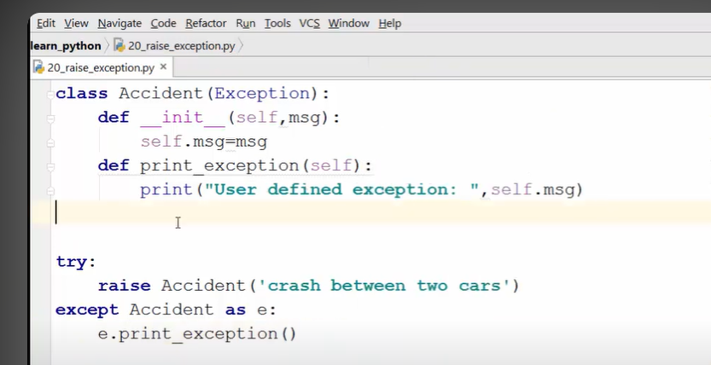

Handling exception is called **Detour**

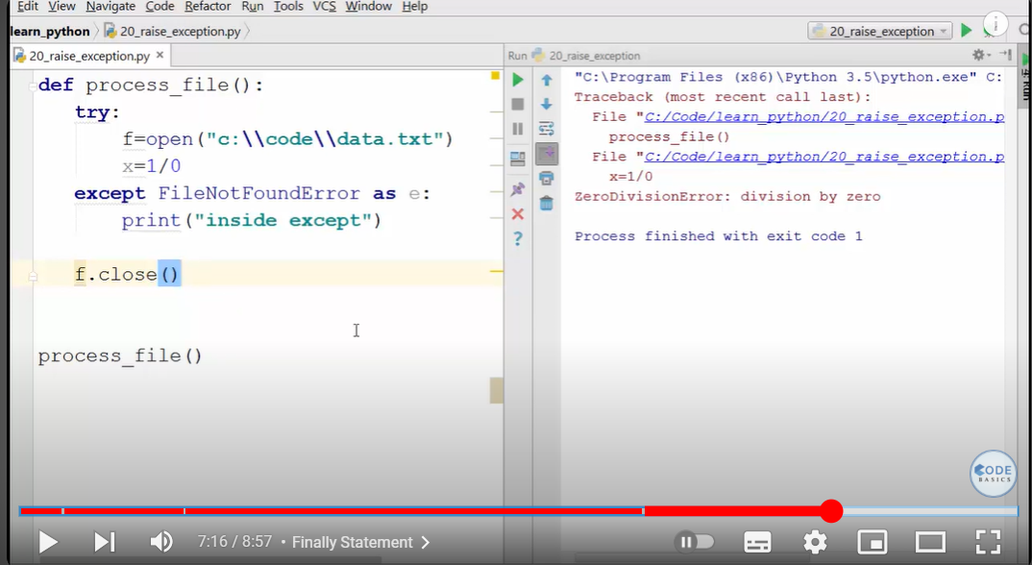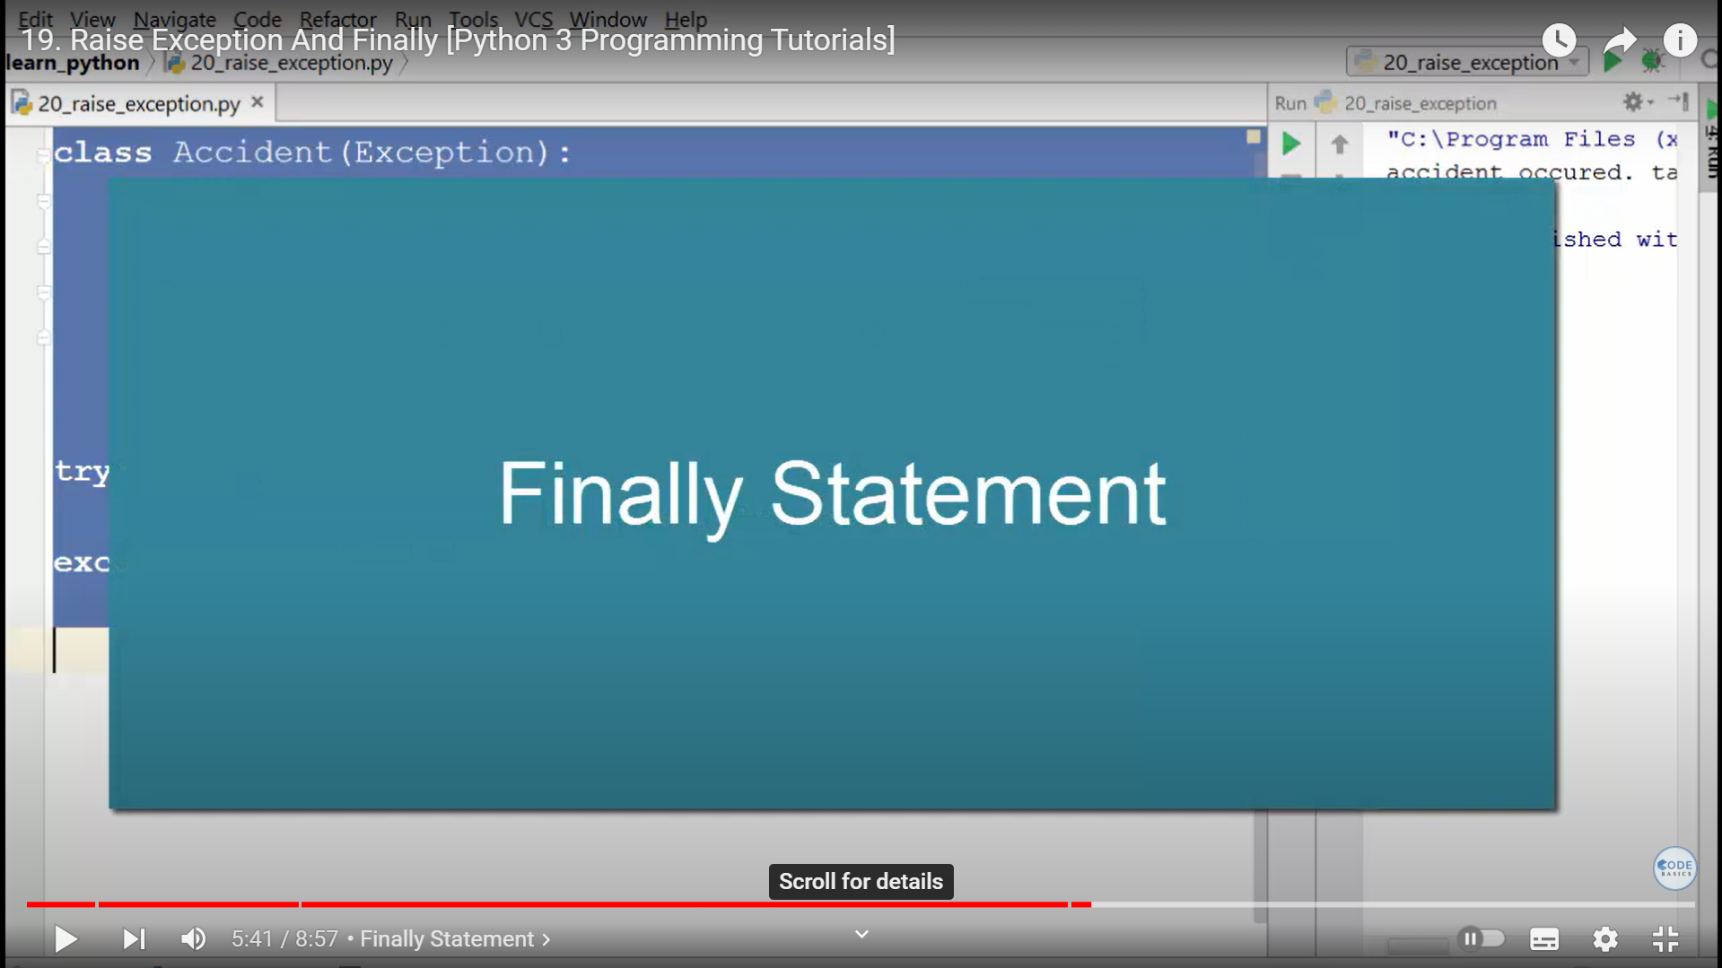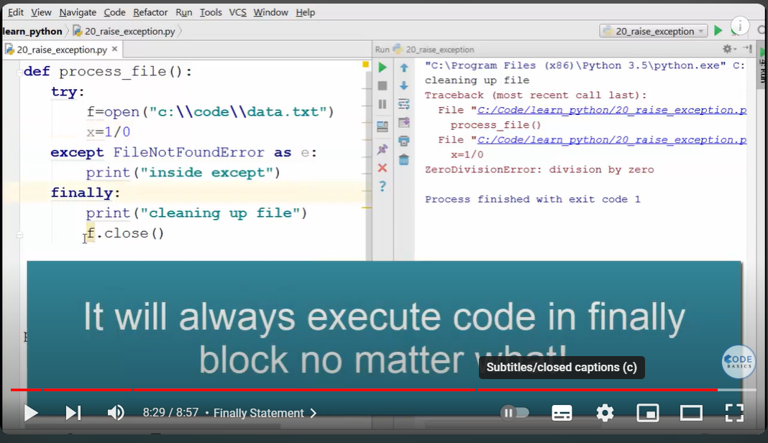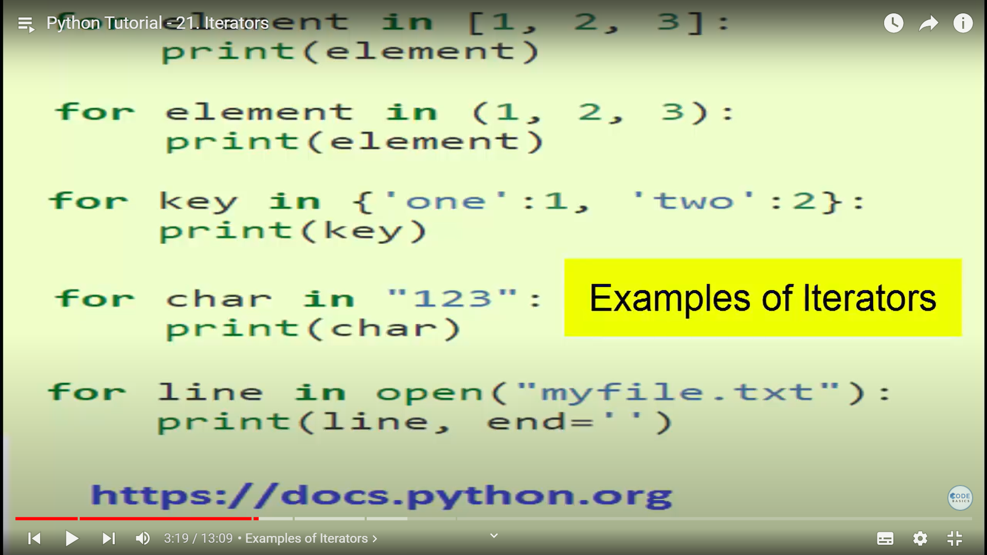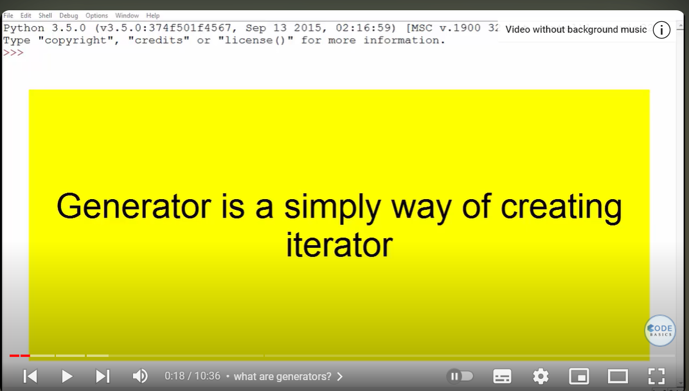

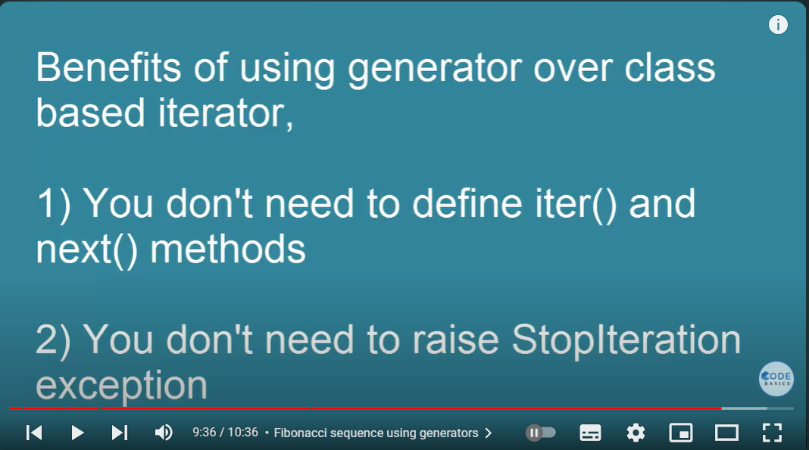

Numpy

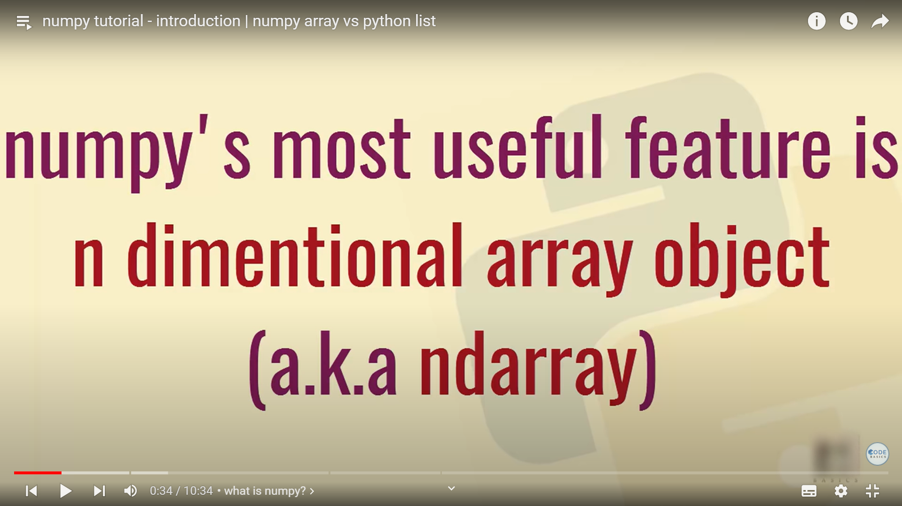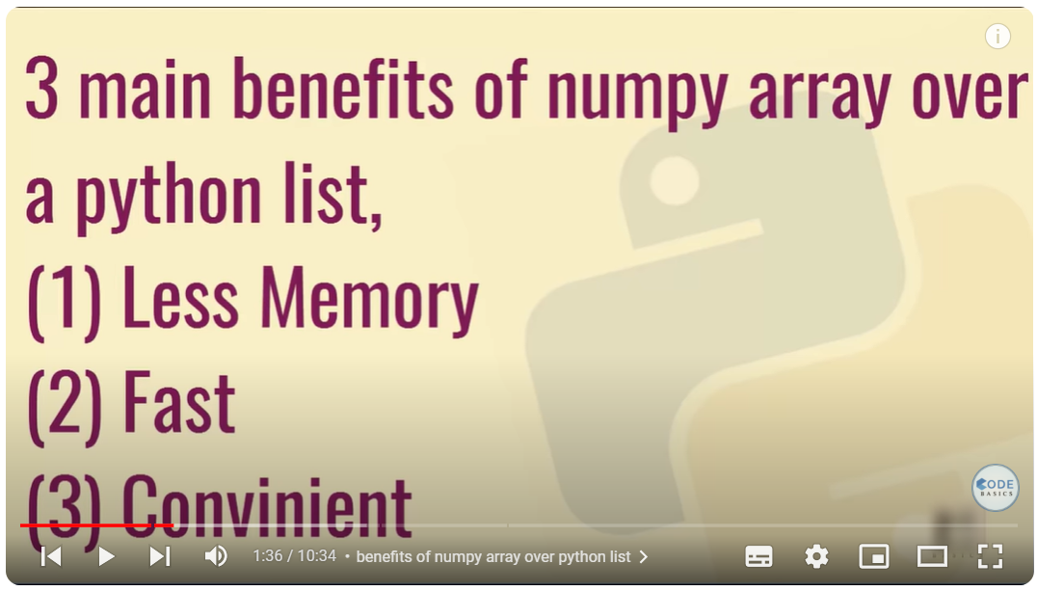

In python what is the difference bwtween: x=np.array([1,4,7]) and x=np.array([[1,4,7]])?

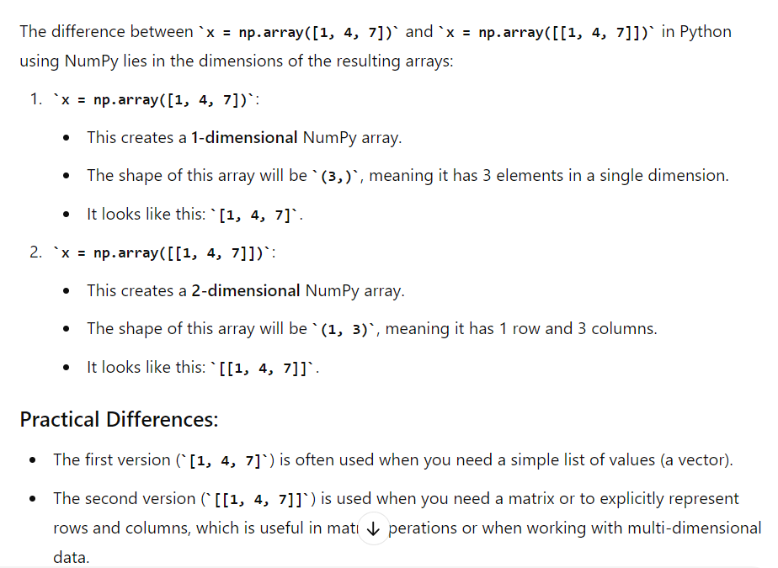

tell the difference between num_iters = 101 math.ceil(num_iters/10) and num_iters = 101 math.floor(num_iters/10)?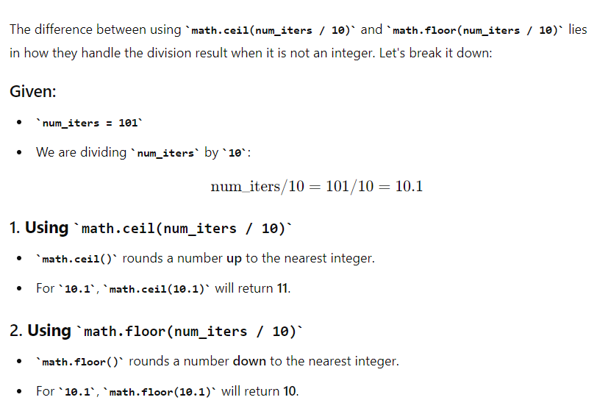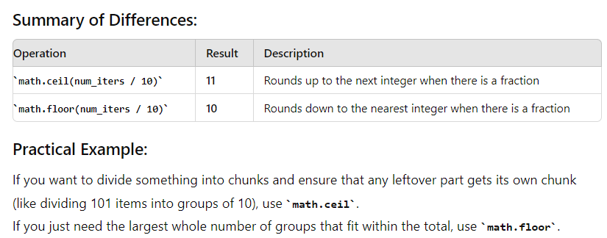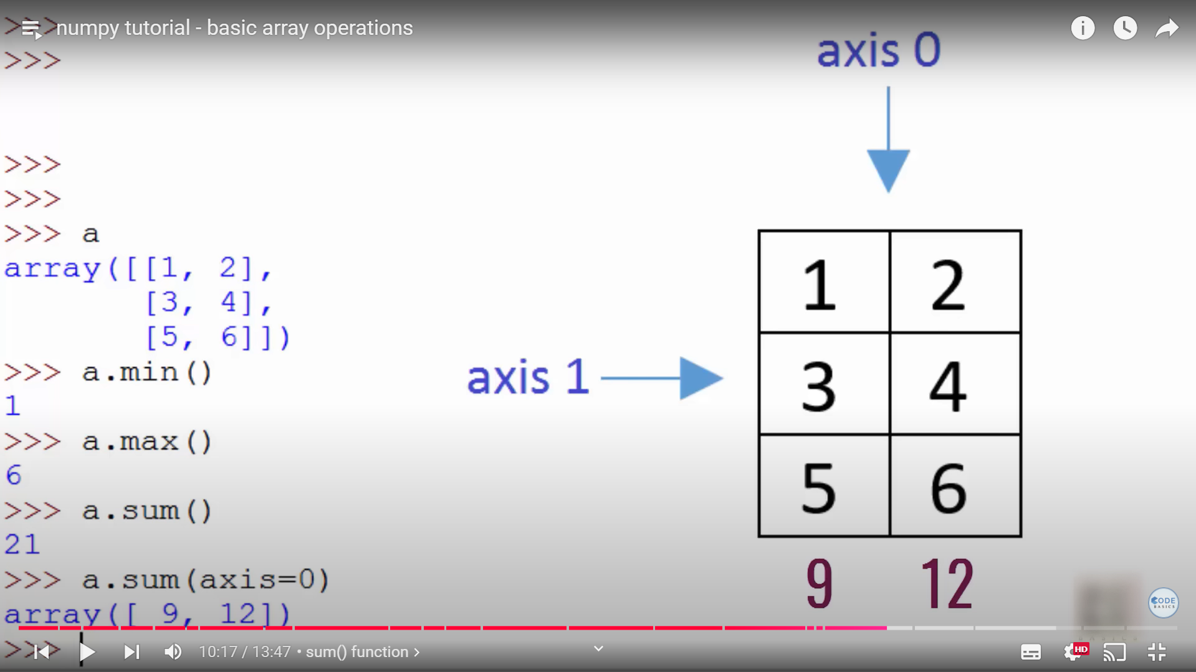

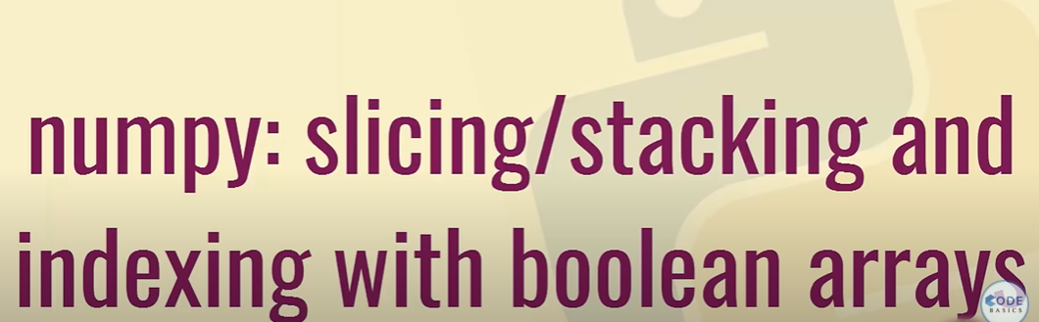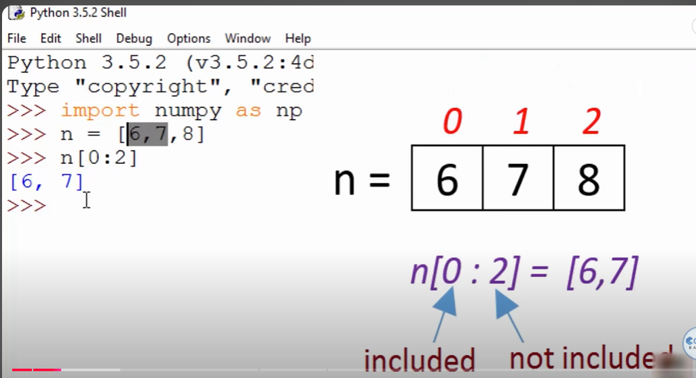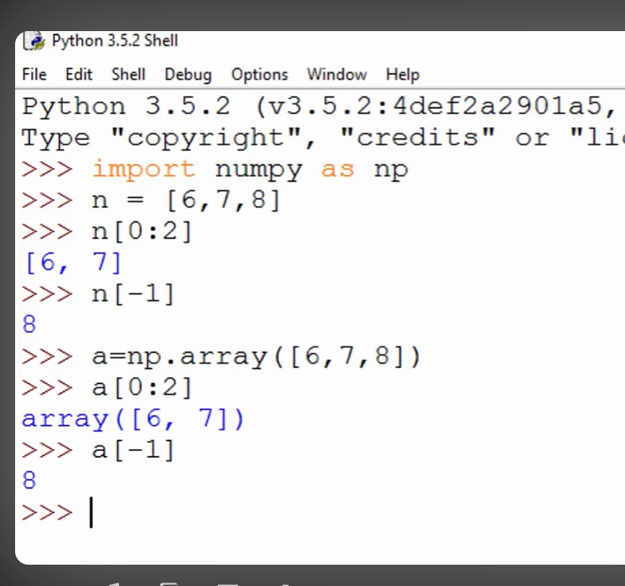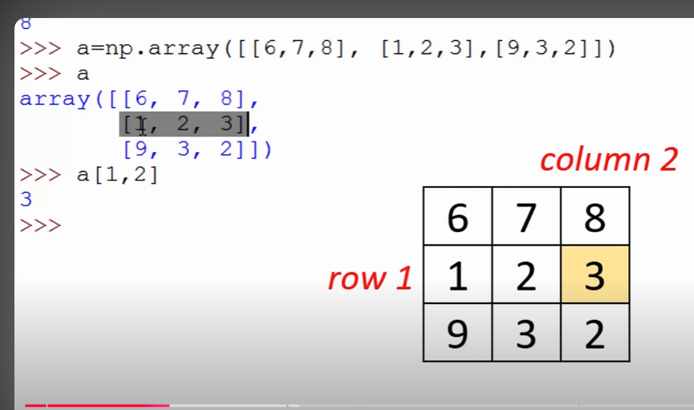

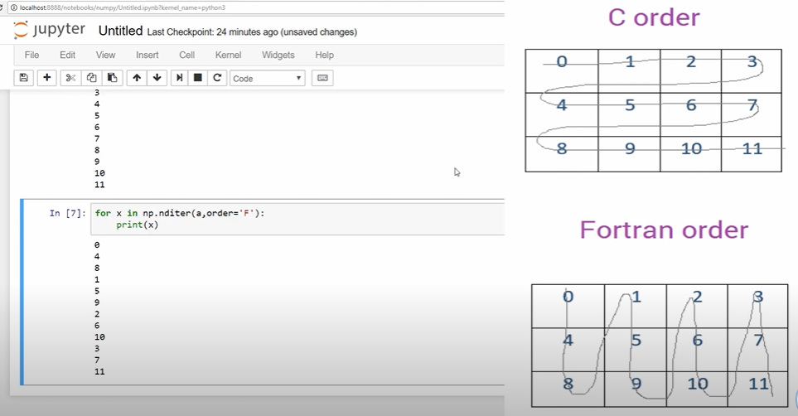

U-NET

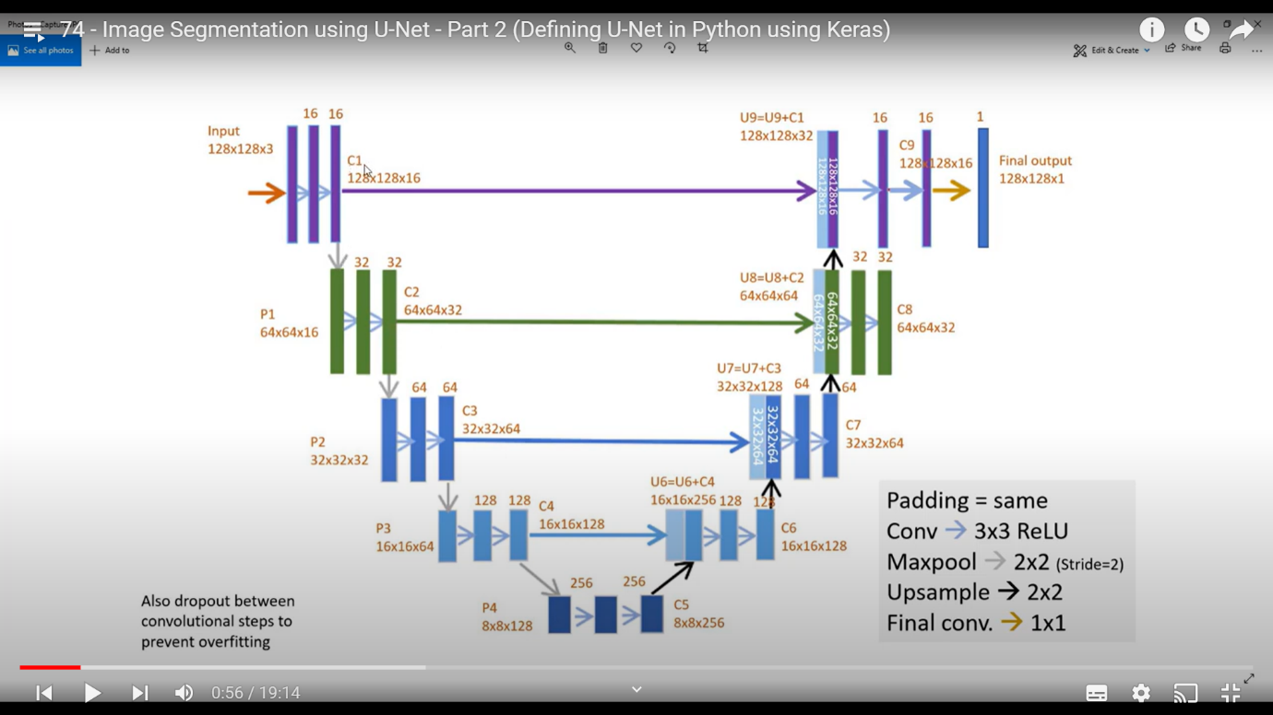

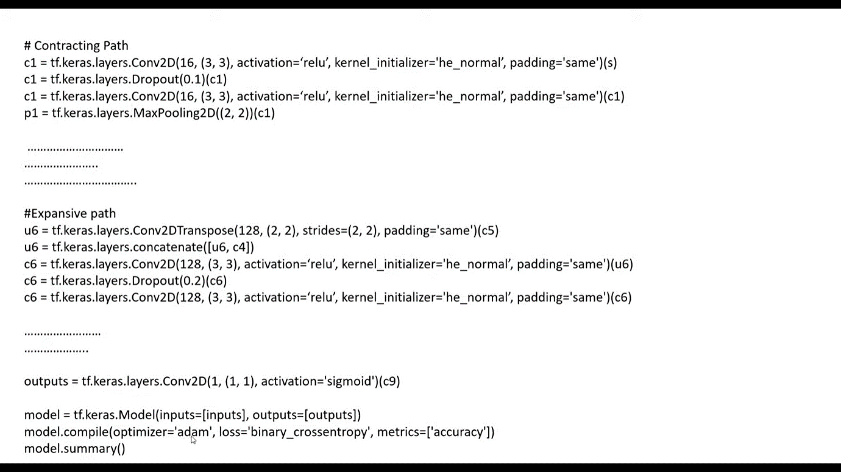

Parameter calculations:

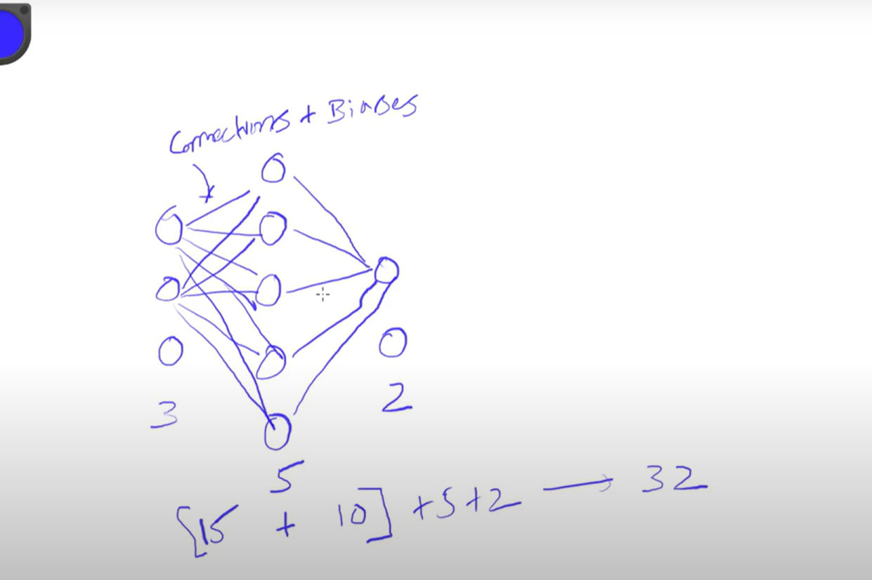

For u-net total parameter is(for grey scale tale 1):

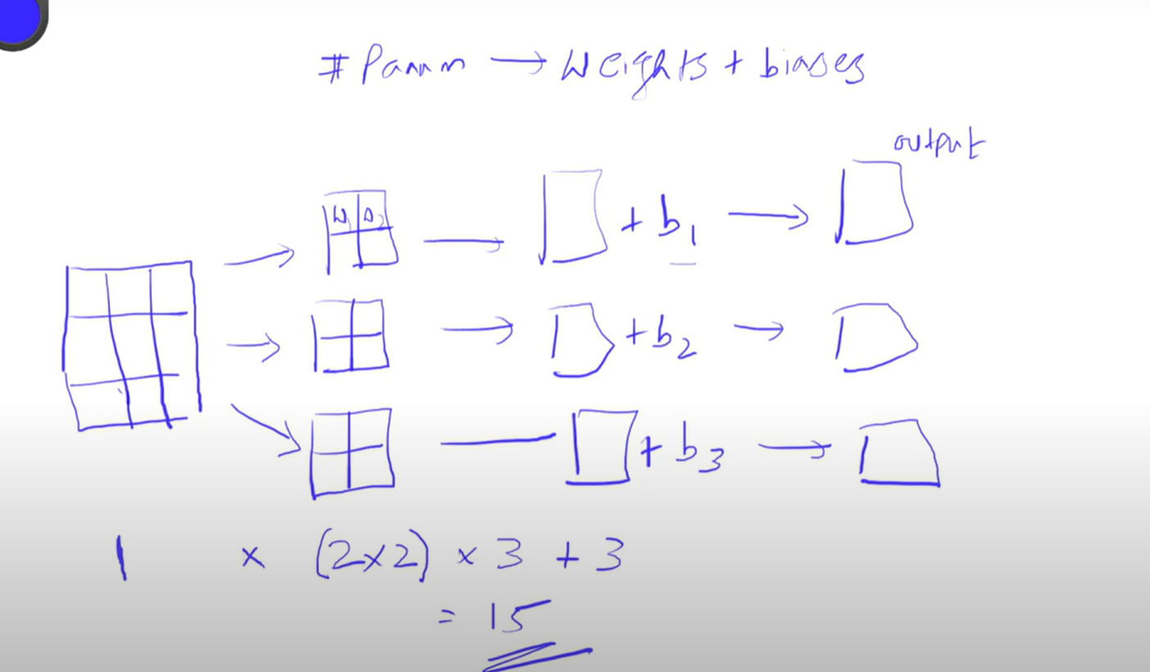

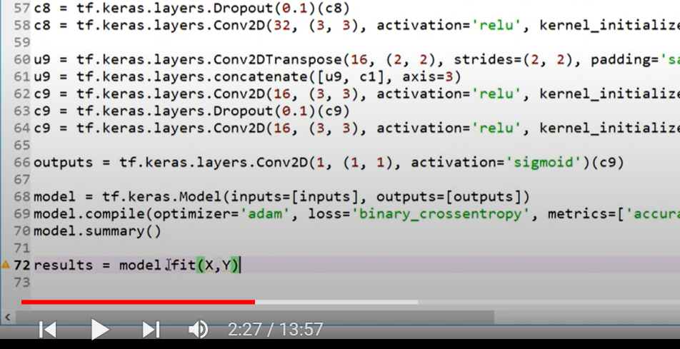

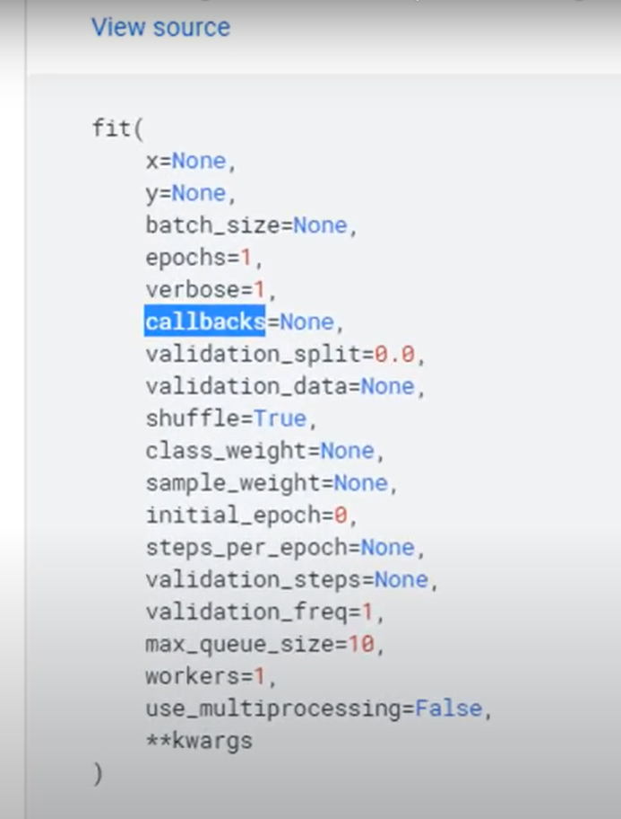

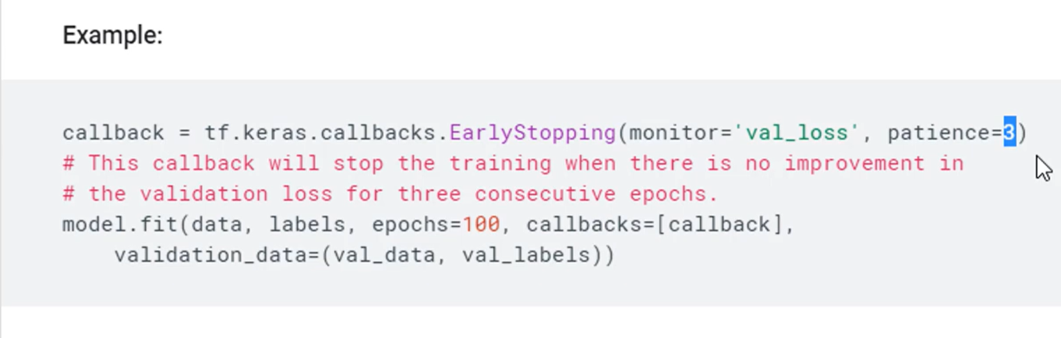

**what are the supervised algorithm and unsupervised algorithm in machine learning**

In machine learning, algorithms are broadly categorized into **supervised** and **unsupervised** learning, based on how they learn from data. Here’s a detailed explanation of each:

### **Supervised Learning**

Supervised learning algorithms are trained on labeled data. Each training example is paired with an output label, and the algorithm learns to predict the label based on the input features. The goal is to make accurate predictions or classifications on new, unseen data based on the patterns learned from the training data.

#### **Types of Supervised Learning Algorithms:**

1. **Classification:**

- **Objective:** Predict categorical labels.

- **Examples:**

- **Logistic Regression:** Predicts probabilities for binary outcomes.

- **Decision Trees:** Tree-like model of decisions for classification.

- **Random Forest:** Ensemble of decision trees to improve accuracy.

- **Support Vector Machines (SVM):** Finds the hyperplane that best separates classes.

- **k-Nearest Neighbors (KNN):** Classifies based on the majority class among nearest neighbors.

- **Naive Bayes:** Based on Bayes’ theorem with strong independence assumptions.

- **Neural Networks:** Complex models with layers of interconnected nodes.

2. **Regression:**

- **Objective:** Predict continuous values.

- **Examples:**

- **Linear Regression:** Models the relationship between dependent and independent variables with a linear equation.

- **Ridge Regression:** Linear regression with L2 regularization to prevent overfitting.

- **Lasso Regression:** Linear regression with L1 regularization to perform feature selection.

- **Polynomial Regression:** Models the relationship as a polynomial function.

- **Support Vector Regression (SVR):** Uses SVM principles for regression tasks.

- **Neural Networks:** Used for complex regression problems.

### **Unsupervised Learning**

Unsupervised learning algorithms are trained on unlabeled data. The algorithm tries to identify patterns, structures, or relationships within the data without predefined labels. The goal is to discover hidden patterns or groupings in the data.

#### **Types of Unsupervised Learning Algorithms:**

1. **Clustering:**

- **Objective:** Group similar data points together.

- **Examples:**

- **K-Means Clustering:** Partitions data into `K` clusters based on similarity.

- **Hierarchical Clustering:** Builds a hierarchy of clusters using methods like agglomerative or divisive clustering.

- **DBSCAN (Density-Based Spatial Clustering of Applications with Noise):** Identifies clusters based on density and can find arbitrarily shaped clusters.

- **Mean Shift Clustering:** Shifts data points towards the mode of the distribution.

2. **Dimensionality Reduction:**

- **Objective:** Reduce the number of features while retaining as much information as possible.

- **Examples:**

- **Principal Component Analysis (PCA):** Transforms data into a lower-dimensional space while preserving variance.

- **t-Distributed Stochastic Neighbor Embedding (t-SNE):** Visualizes high-dimensional data by reducing dimensions and preserving local structure.

- **Linear Discriminant Analysis (LDA):** Projects data into a lower-dimensional space to maximize class separability (often used in a supervised context but can be applied unsupervised).

3. **Association Rule Learning:**

- **Objective:** Discover interesting relationships or associations between variables in large datasets.

- **Examples:**

- **Apriori Algorithm:** Finds frequent itemsets and generates association rules.

- **Eclat Algorithm:** Uses a depth-first search strategy to find frequent itemsets.

4. **Anomaly Detection:**

- **Objective:** Identify unusual data points that do not fit the general pattern.

- **Examples:**

- **Isolation Forest:** Detects anomalies by isolating observations.

- **One-Class SVM:** Identifies anomalies based on the distribution of normal data.

### **Summary**

- **Supervised Learning:**

- **Data:** Labeled data (input-output pairs).

- **Goal:** Predict labels or values for new data.

- **Examples:** Classification (e.g., logistic regression) and regression (e.g., linear regression).

- **Unsupervised Learning:**

- **Data:** Unlabeled data (only inputs).

- **Goal:** Find patterns, groupings, or structures.

- **Examples:** Clustering (e.g., K-means), dimensionality reduction (e.g., PCA), and association rule learning (e.g., Apriori).

**difference between classification and regression**

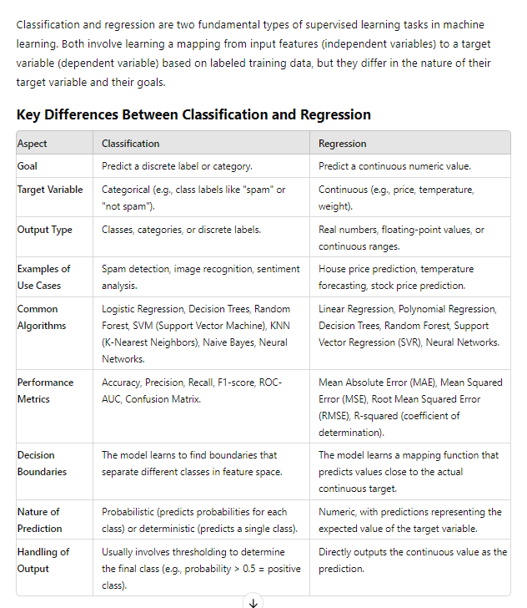

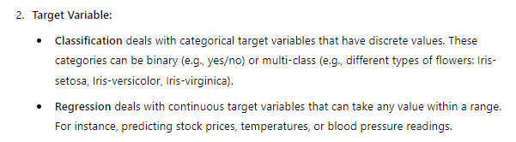

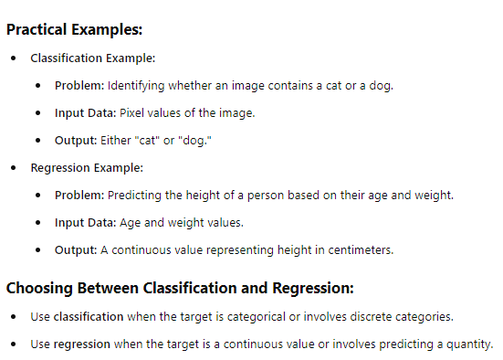

Linear regression(yes/no)

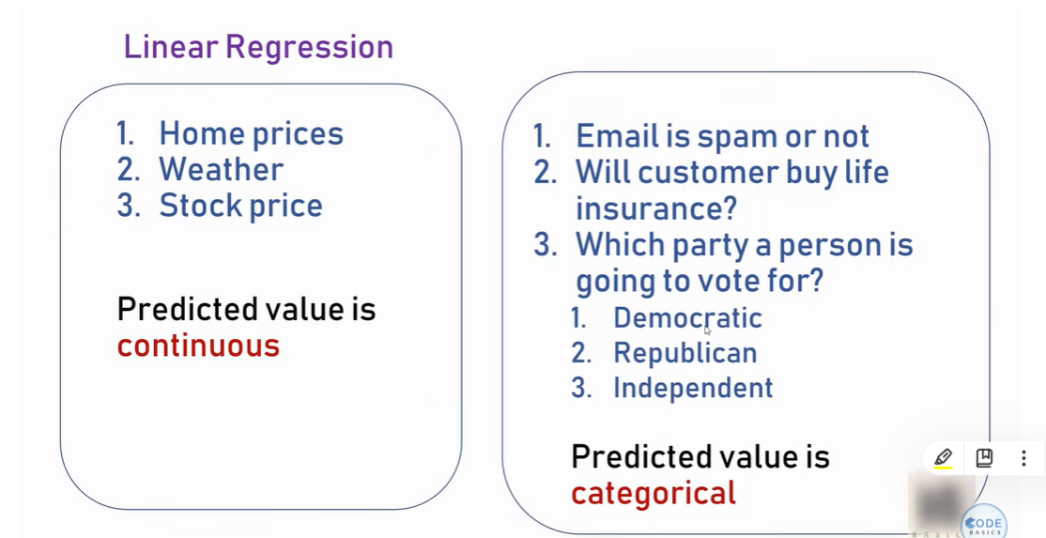

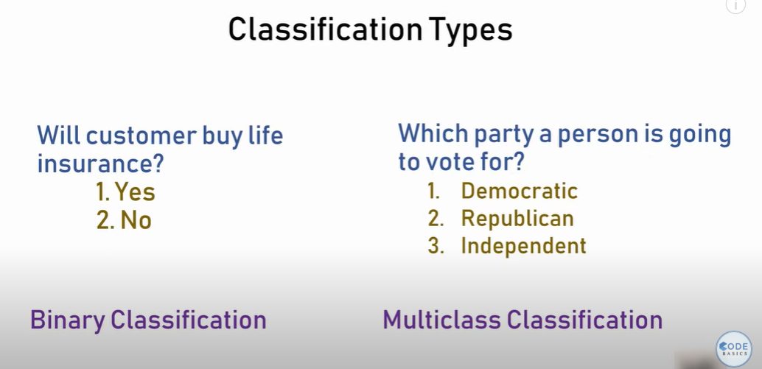

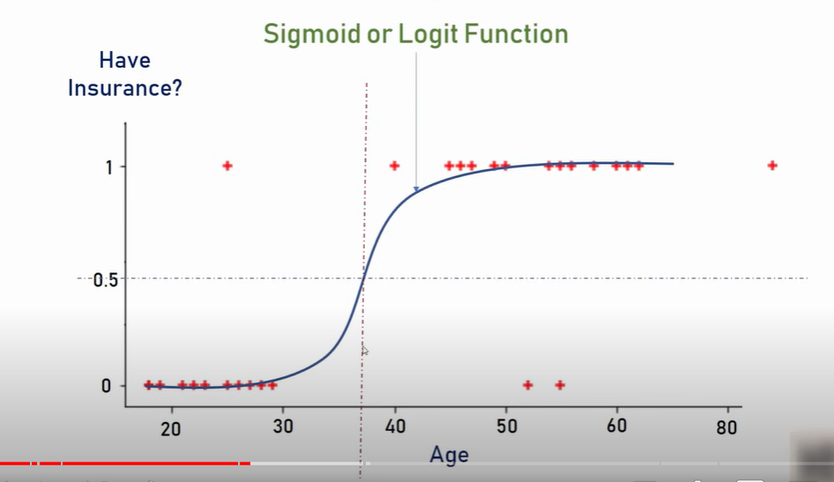

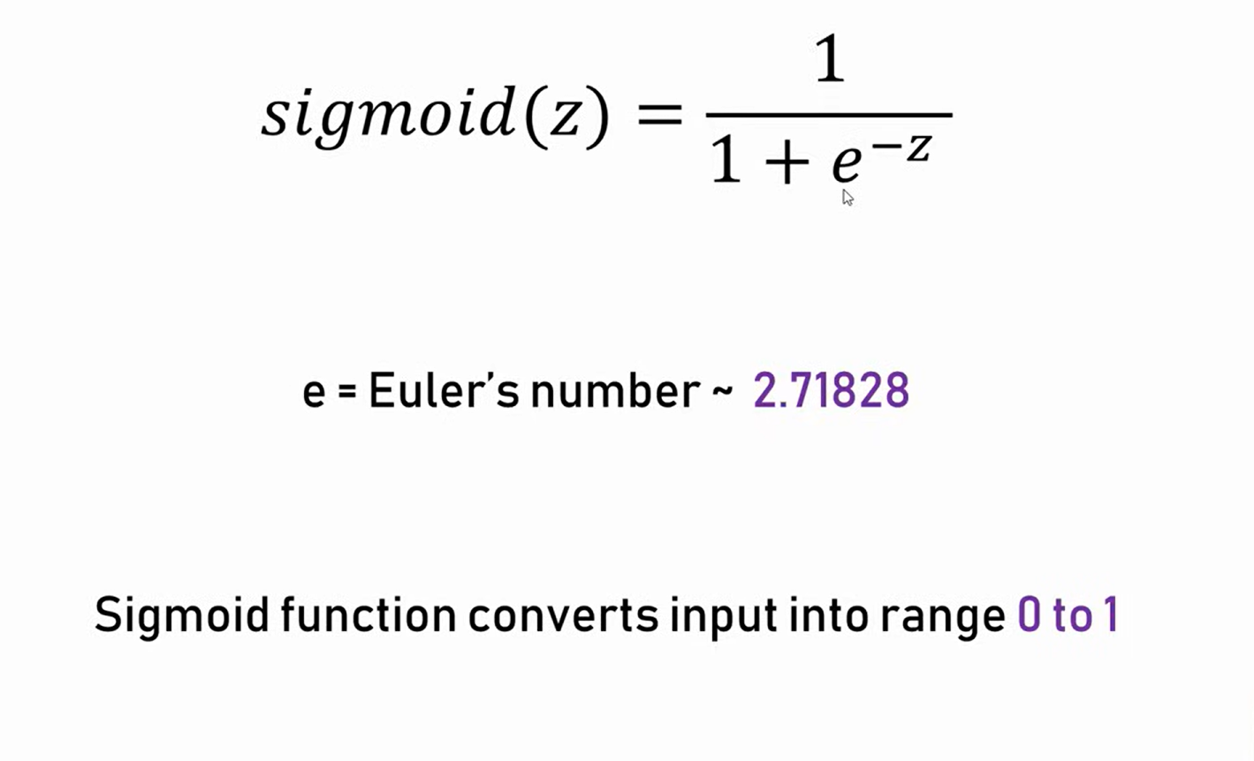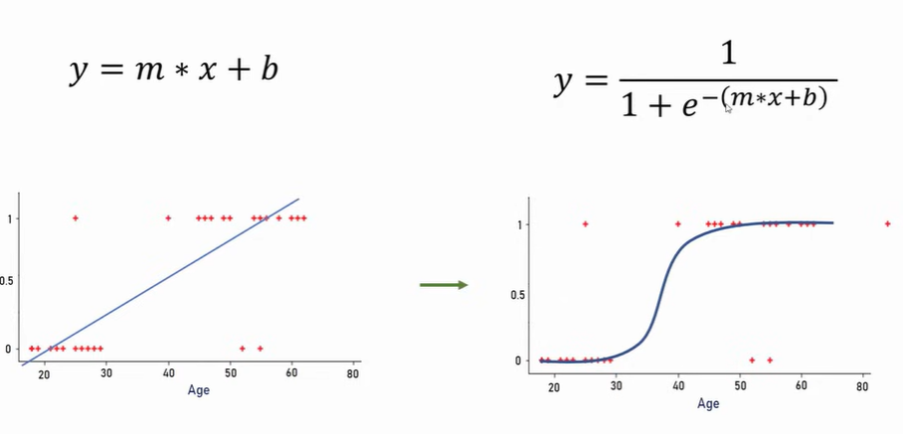

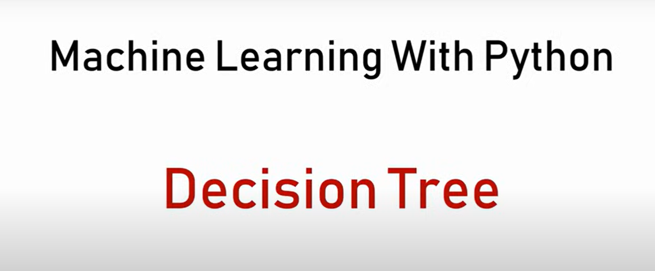

Using logistic regression

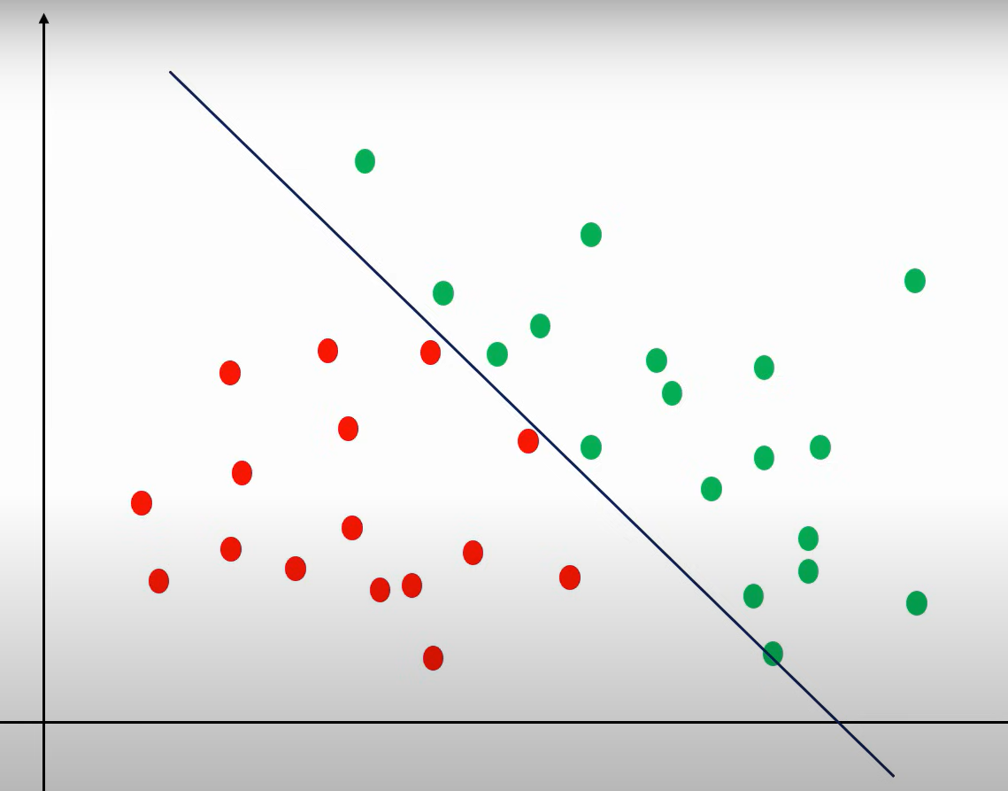

But decision tree in:  
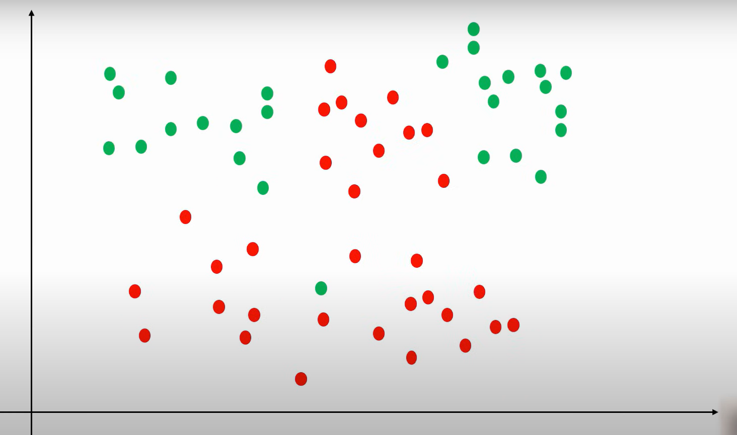

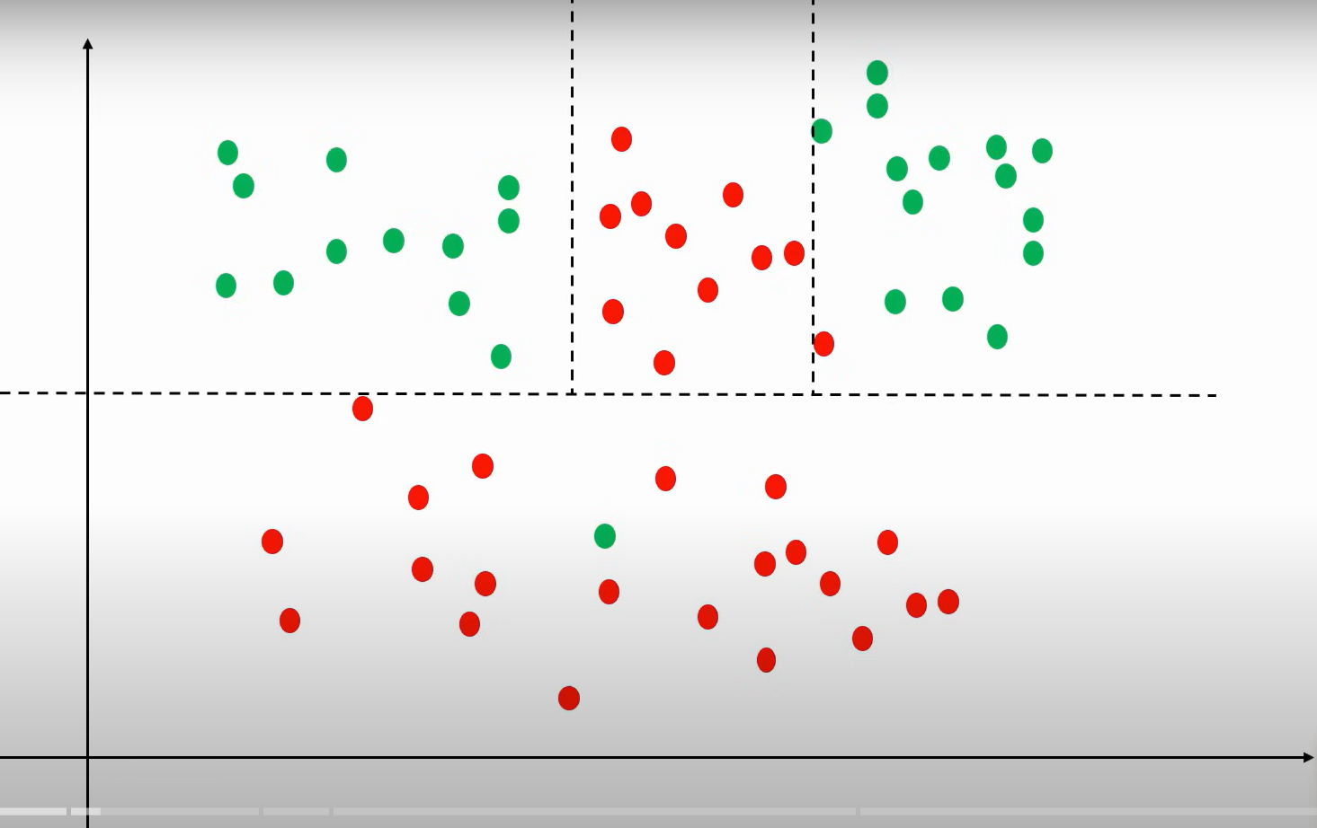

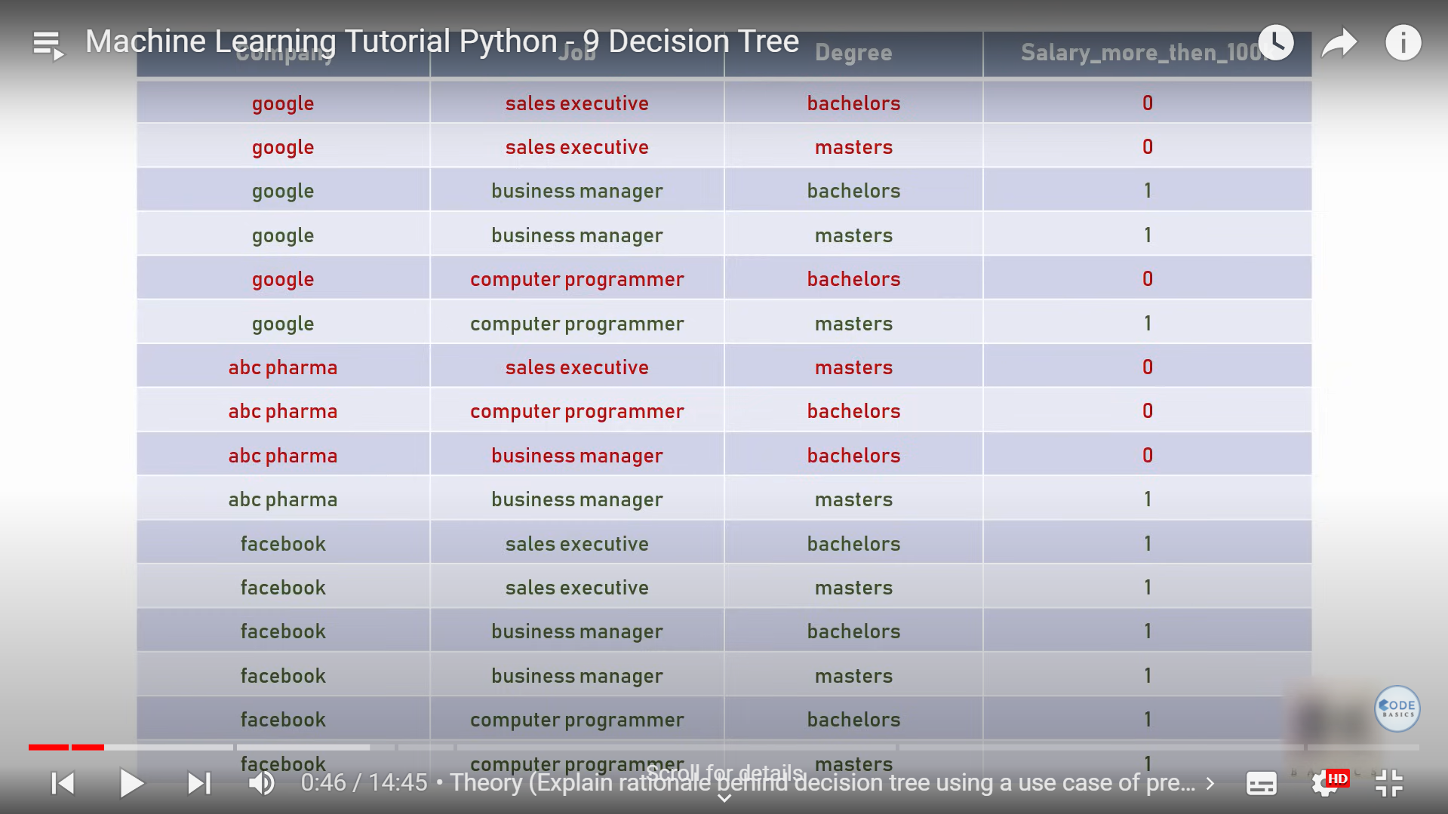

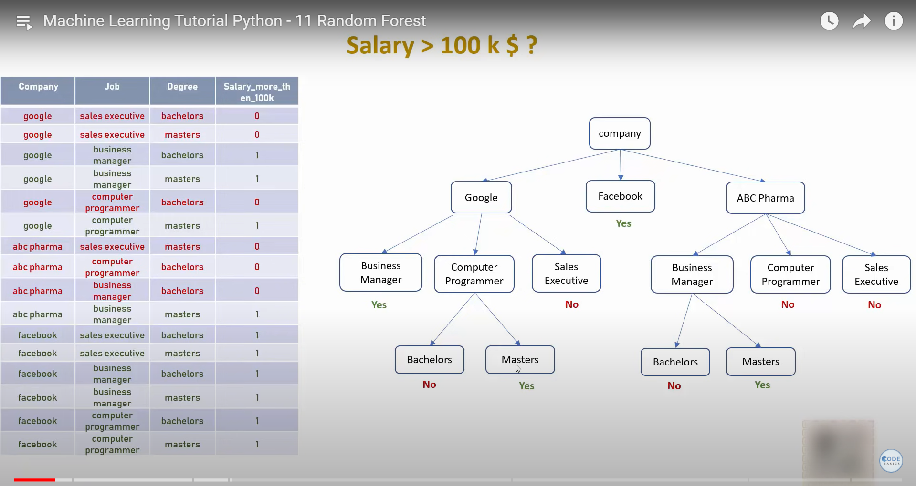

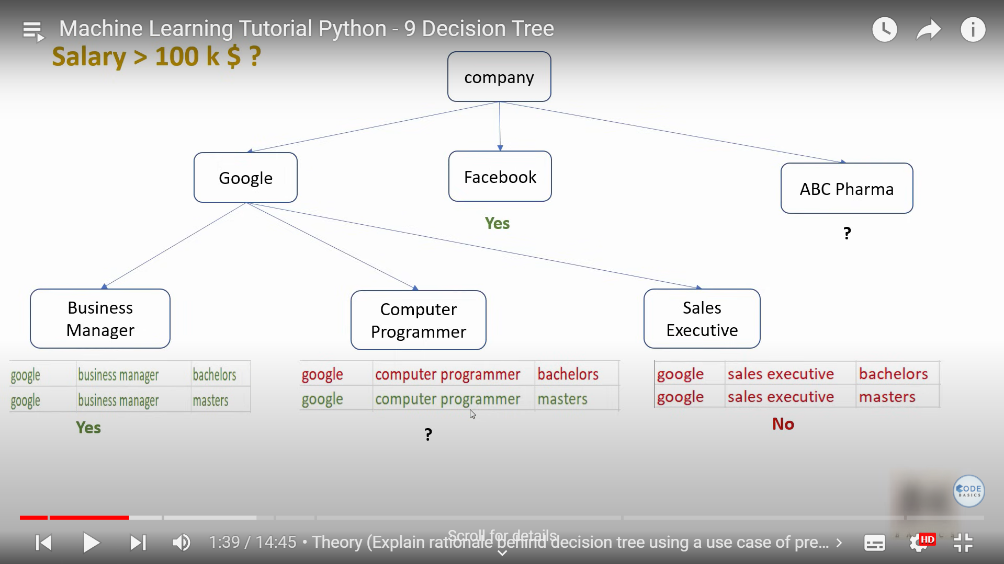

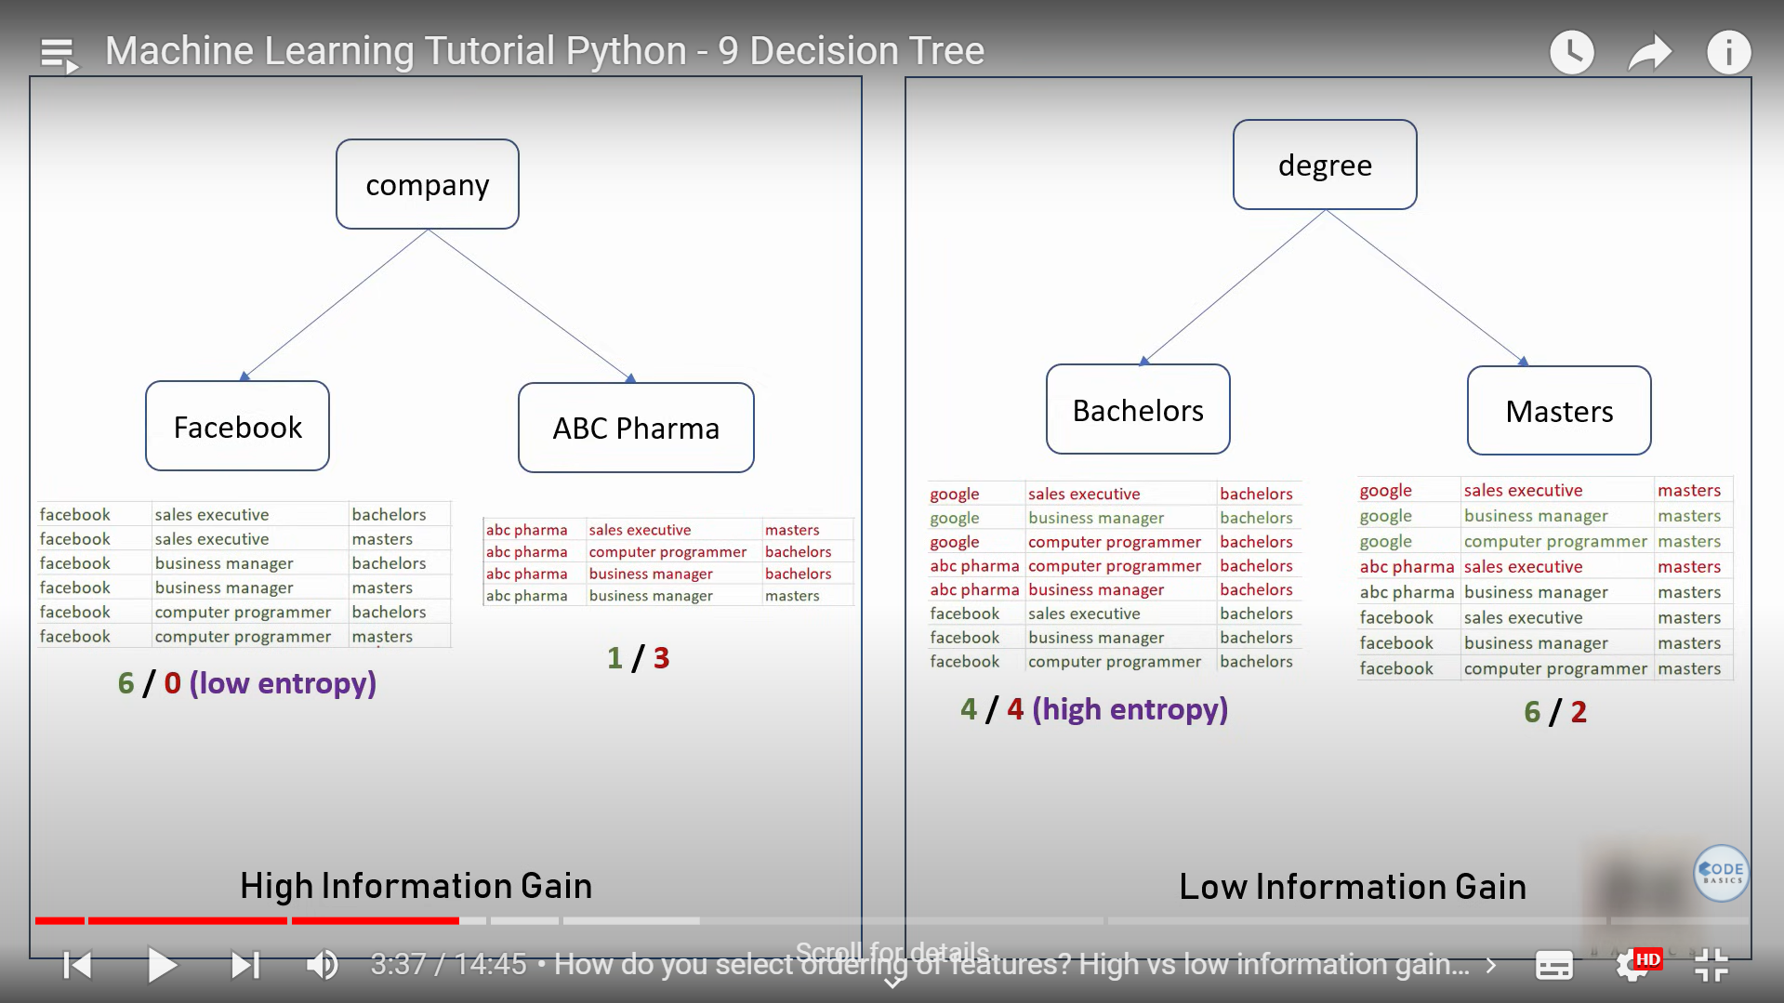

Random Forest

 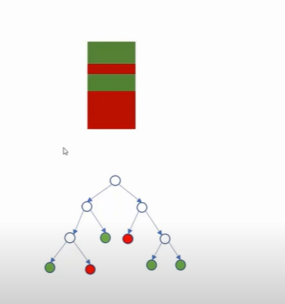

From single dataset creating multiple decision tree in random manner (using random sampling), then coming to an common decision is called random forest

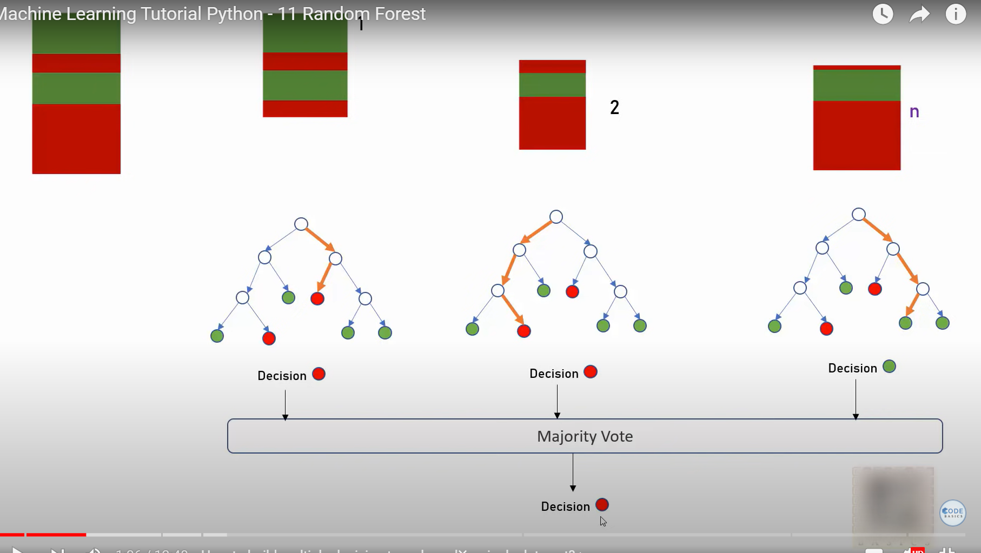

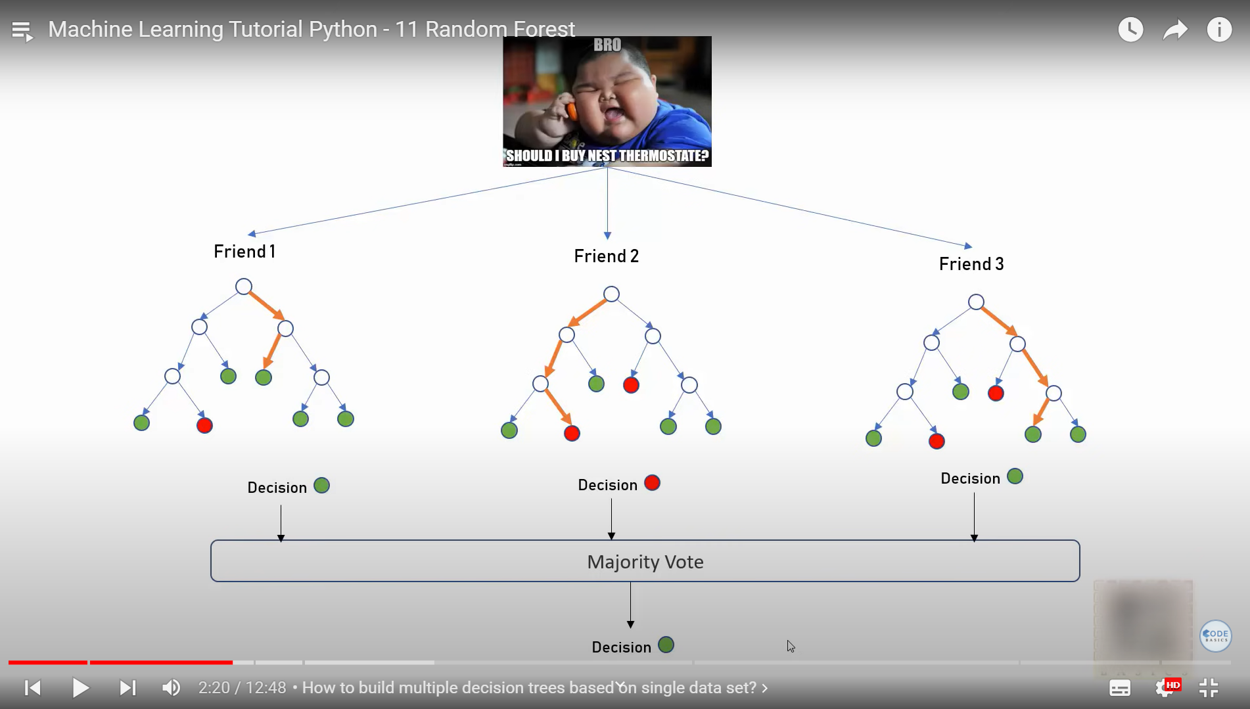

**Random Forest** is a versatile and powerful machine learning algorithm used for both classification and regression tasks. It belongs to the family of ensemble learning methods, which combine multiple models to improve overall performance. Here’s a detailed overview:

### **Overview of Random Forest**

1. **Ensemble Method:**

- Random Forest builds multiple decision trees during training and outputs the mode (classification) or mean (regression) of the predictions of the individual trees. This ensemble approach helps to reduce overfitting and improves the model's generalization.

2. **Key Features:**

- **Bootstrap Aggregating (Bagging):** Each decision tree in the forest is trained on a different bootstrap sample of the training data (a sample with replacement).

- **Feature Randomness:** At each split in a decision tree, only a random subset of features is considered, which helps in decorrelating the trees and improving robustness.

### **How Random Forest Works**

1. **Bootstrap Sampling:**

- Generate multiple bootstrap samples from the original dataset. Each bootstrap sample is a random sample of the dataset with replacement.

2. **Building Decision Trees:**

- For each bootstrap sample, a decision tree is trained. During training, only a random subset of features is considered at each split, which introduces diversity among the trees.

3. **Voting/Averaging:**

- **Classification:** Each tree votes for a class, and the class with the majority votes is chosen as the final prediction.

- **Regression:** The prediction is the average of the predictions from all the trees.

### **Key Parameters of Random Forest**

1. **`n_estimators`:**

- **Description:** Number of decision trees in the forest.

- **Effect:** More trees usually improve performance and stability but increase computational cost. Typical values range from 100 to 500.

2. **`max_features`:**

- **Description:** Number of features to consider when looking for the best split.

- **Options:**

- **`auto` or `sqrt`:** Use the square root of the total number of features (default for classification).

- **`log2`:** Use the base-2 logarithm of the total number of features.

- **Integer:** Specific number of features to consider.

- **Float:** Fraction of features.

- **Effect:** Controls the randomness in the tree construction. Reducing the number of features can help prevent overfitting but may also reduce accuracy.

3. **`max_depth`:**

- **Description:** Maximum depth of each decision tree.

- **Effect:** Limits how deep each tree can grow. Shallow trees may underfit, while deeper trees may overfit.

4. **`min_samples_split`:**

- **Description:** Minimum number of samples required to split an internal node.

- **Effect:** Controls the minimum size of a node before it can be split. Larger values prevent the model from creating very small branches, which helps to prevent overfitting.

5. **`min_samples_leaf`:**

- **Description:** Minimum number of samples required to be at a leaf node.

- **Effect:** Ensures that leaf nodes have a minimum number of samples, which can help smooth the model and prevent overfitting.

6. **`bootstrap`:**

- **Description:** Whether bootstrap samples are used when building trees.

- **Options:**

- **`True`:** Use bootstrap samples (default).

- **`False`:** Use the whole dataset to build each tree.

- **Effect:** Using bootstrap samples introduces variability among the trees, which improves generalization.

7. **`oob_score`:**

- **Description:** Whether to use out-of-bag samples to estimate the generalization accuracy.

- **Effect:** If `True`, the model uses out-of-bag samples (samples not used in the bootstrap sample) to provide an unbiased estimate of the model's performance.

8. **`random_state`:**

- **Description:** Seed for random number generator.

- **Effect:** Ensures reproducibility of results by controlling the randomness in the model.

9. **`n_jobs`:**

- **Description:** Number of parallel jobs to run for both `fit` and `predict`.

- **Effect:** Speeds up computation by using multiple processors. Set to `-1` to use all available processors.

### **Example Code**

Here’s a basic example of using Random Forest for classification with the Iris dataset:

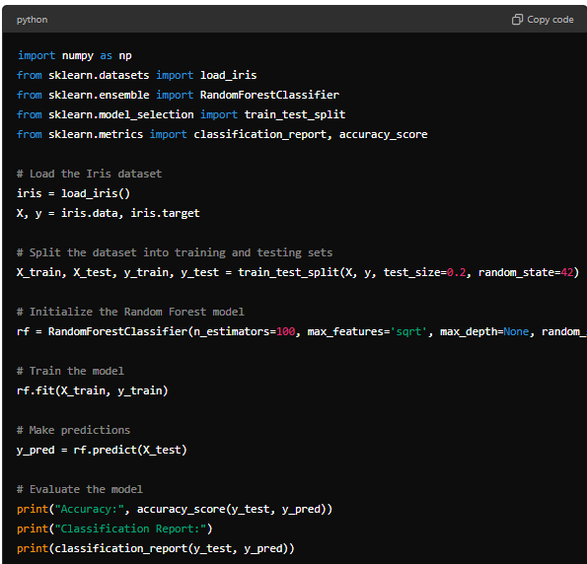

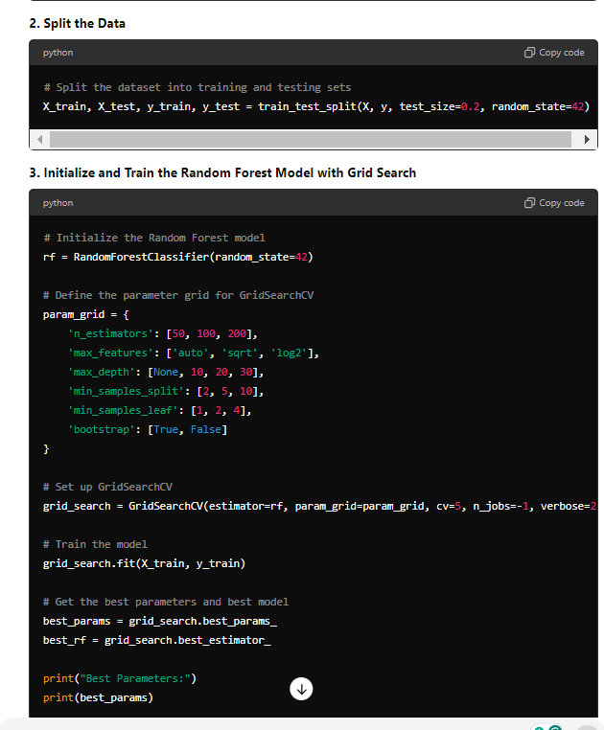 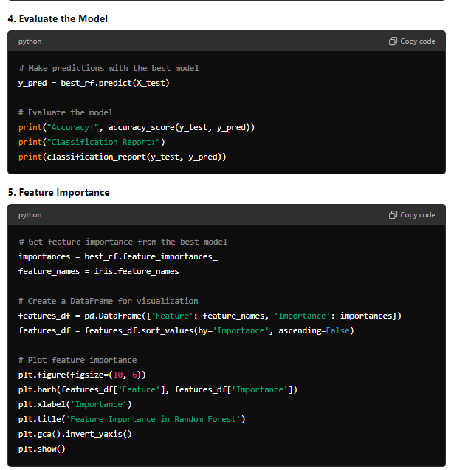 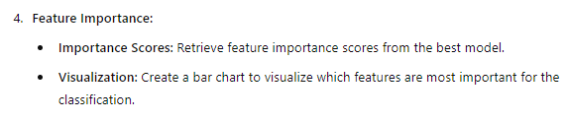 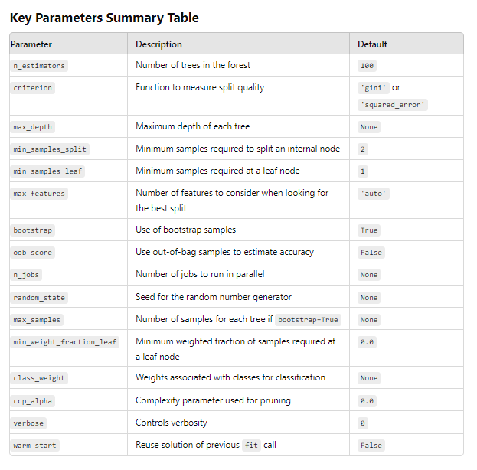

**Significant Parameters in Random Forest**

1. **n_estimators**:
   * **Description**: The number of decision trees in the forest.
   * **Type**: Integer.
   * **Default**: 100.
   * **Effect**: More trees generally improve performance and reduce overfitting, but increase training time and computational cost. A typical range is 100 to 500, but it can be increased for large datasets.
2. **criterion**:
   * **Description**: The function used to measure the quality of a split.
   * **Type**: String, 'gini' or 'entropy' for classification, and 'squared_error', 'absolute_error', 'poisson' for regression.
   * **Default**: 'gini' for classification, 'squared_error' for regression.
   * **Effect**: 'gini' and 'entropy' are used for classification; 'gini' is generally faster, while 'entropy' may provide slightly better accuracy by considering information gain. 'squared_error' is the default for regression, minimizing mean squared error.
3. **max_depth**:
   * **Description**: The maximum depth of each decision tree.
   * **Type**: Integer or None.
   * **Default**: None (nodes are expanded until all leaves are pure or contain fewer than min_samples_split samples).
   * **Effect**: Limits the depth of the trees. Shallower trees may underfit, while deeper trees may overfit. Setting max_depth helps control overfitting and reduces computation time.
4. **min_samples_split**:
   * **Description**: The minimum number of samples required to split an internal node.
   * **Type**: Integer or float.
   * **Default**: 2.
   * **Effect**: Controls when a node is split. Higher values prevent the model from creating very small branches, which can help reduce overfitting.
5. **min_samples_leaf**:
   * **Description**: The minimum number of samples required to be at a leaf node.
   * **Type**: Integer or float.
   * **Default**: 1.
   * **Effect**: Controls the minimum size of leaf nodes. Larger values smooth the model, which can prevent overfitting by not allowing very small splits.
6. **max_features**:
   * **Description**: The number of features to consider when looking for the best split.
   * **Type**: Integer, float, 'auto', 'sqrt', 'log2' or None.
   * **Default**: 'auto' (all features for regression, sqrt(n_features) for classification).
   * **Effect**: Controls the number of features to consider at each split:
     + **auto or sqrt**: Square root of the total number of features.
     + **log2**: Logarithm (base 2) of the total number of features.
     + **Integer**: Exact number of features.
     + **Float**: Percentage of features.
   * Lower values reduce overfitting but may decrease accuracy.
7. **bootstrap**:
   * **Description**: Whether bootstrap samples are used when building trees.
   * **Type**: Boolean (True or False).
   * **Default**: True.
   * **Effect**: If True, each tree is trained on a random subset (with replacement) of the data, adding variability and robustness to the model. If False, the entire dataset is used to train each tree.
8. **oob_score** (Out-of-Bag Score):
   * **Description**: Whether to use out-of-bag samples to estimate the generalization accuracy.
   * **Type**: Boolean (True or False).
   * **Default**: False.
   * **Effect**: If True, the model uses the samples not included in each bootstrap sample to validate and estimate its performance. This can provide an unbiased estimate of model accuracy without needing a separate validation set.
9. **n_jobs**:
   * **Description**: The number of jobs (threads) to run in parallel for fit and predict.
   * **Type**: Integer.
   * **Default**: None (uses 1 job).
   * **Effect**: Setting this to -1 uses all available processors, speeding up training and prediction, especially for large datasets.
10. **random_state**:
    * **Description**: Seed of the random number generator.
    * **Type**: Integer.
    * **Default**: None.
    * **Effect**: Ensures reproducibility by controlling randomness in the model. Different seeds will produce different results. Use a fixed seed to reproduce the same model results.
11. **max_samples**:
    * **Description**: If bootstrap=True, the number of samples to draw from X to train each base estimator.
    * **Type**: Integer or float.
    * **Default**: None (draws all samples).
    * **Effect**: Limits the number of samples per tree, which can reduce computation time or improve generalization for very large datasets.

SVM

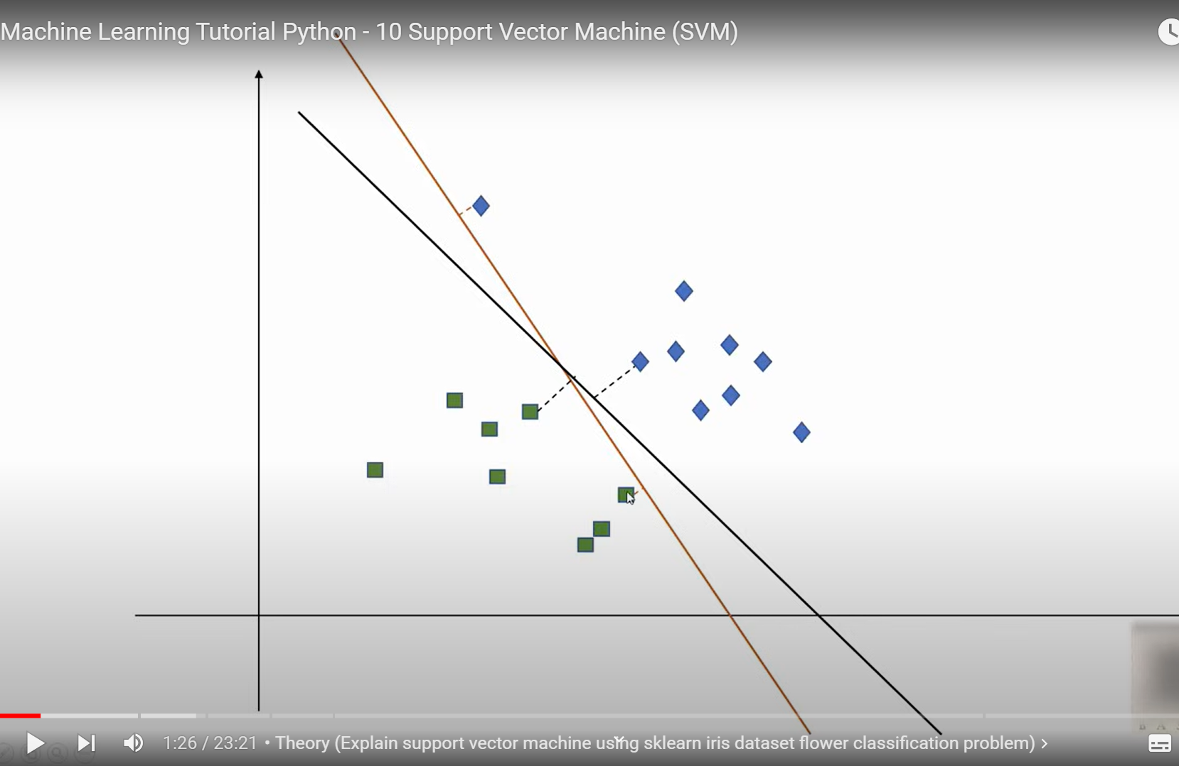

These line is better as classification mismatch is less with the nearby data-points are called support vectors:  
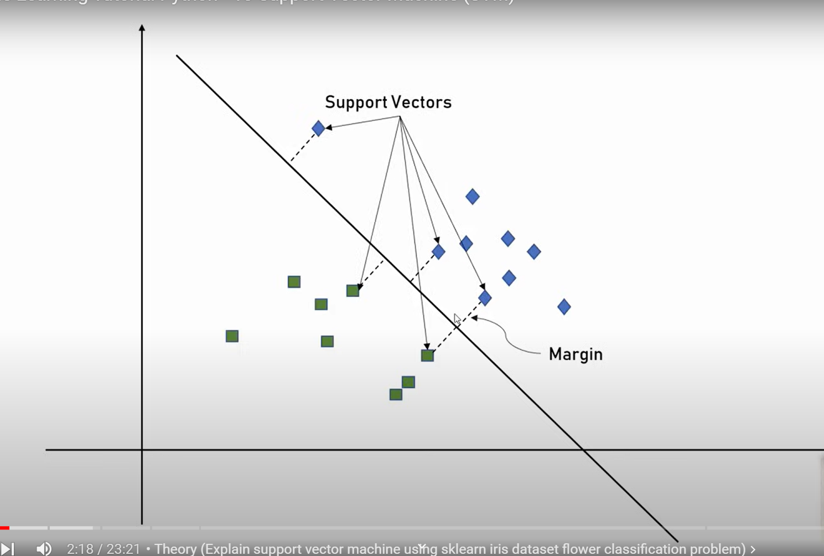

Like hyper-plane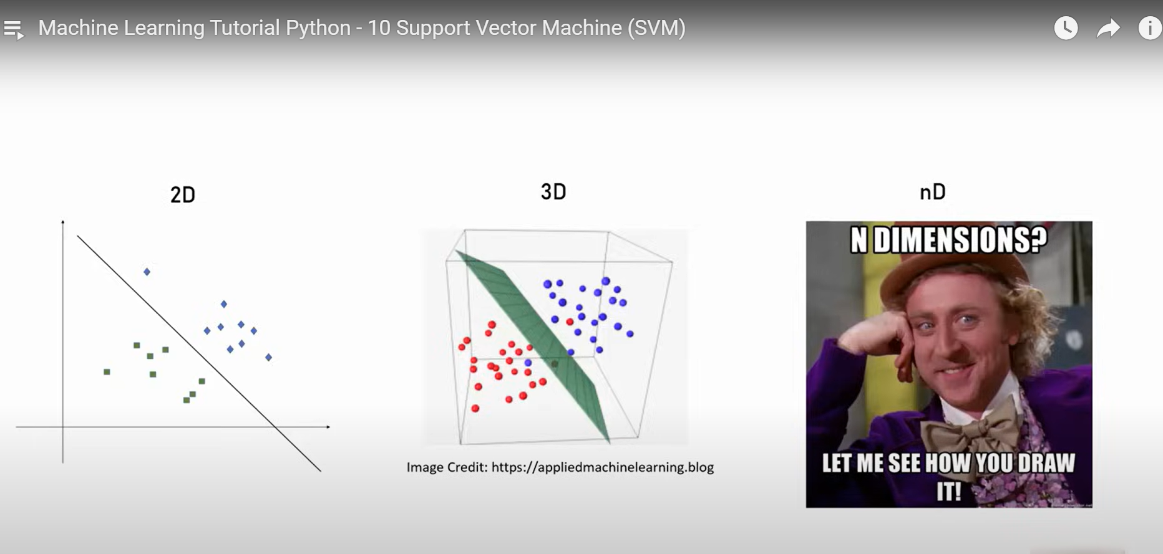

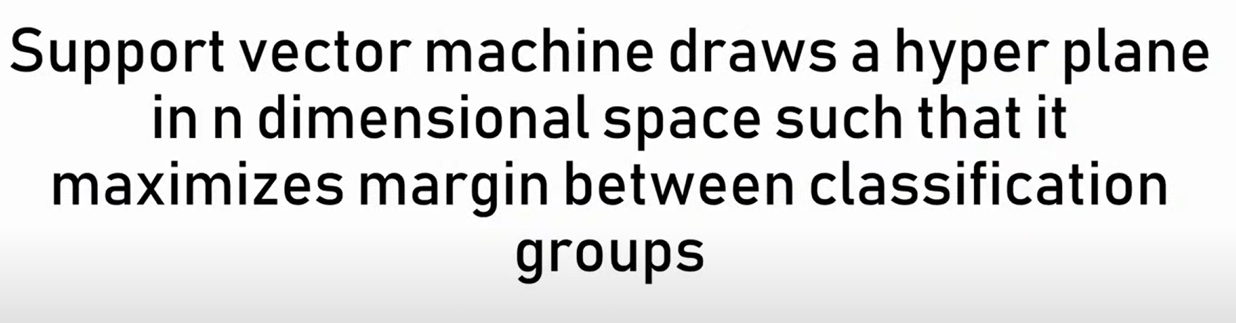

High gamma taking the lowest the nearest point and low ….fartest point consideration  
accuracy mostly high in low gamma

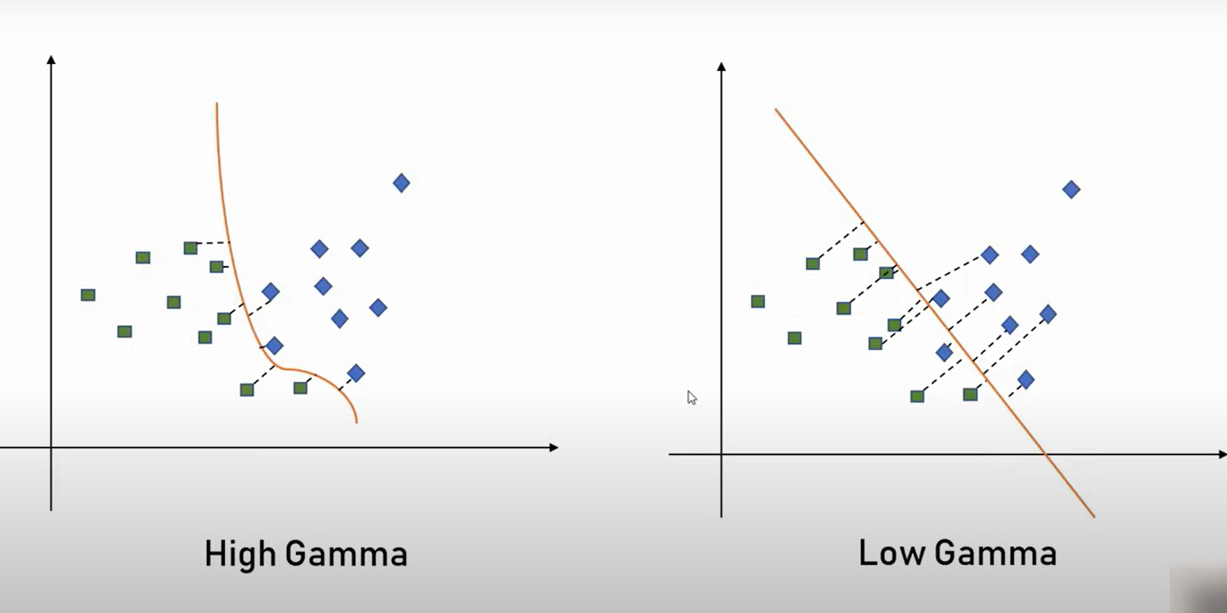

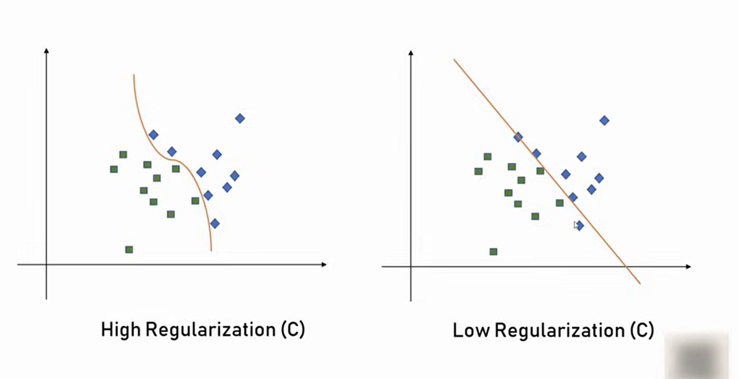

Therefore, in SVM (C) is a regularization parameter

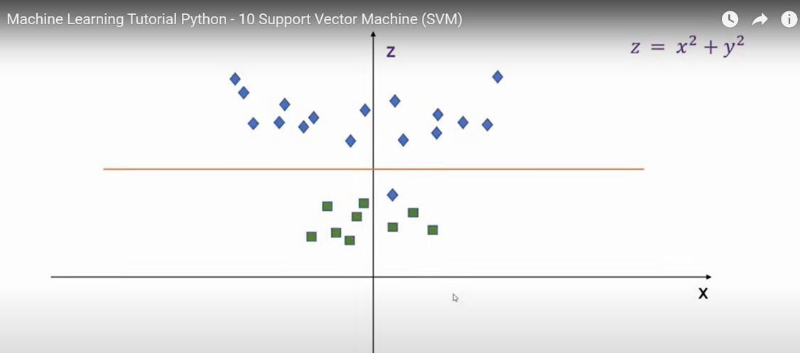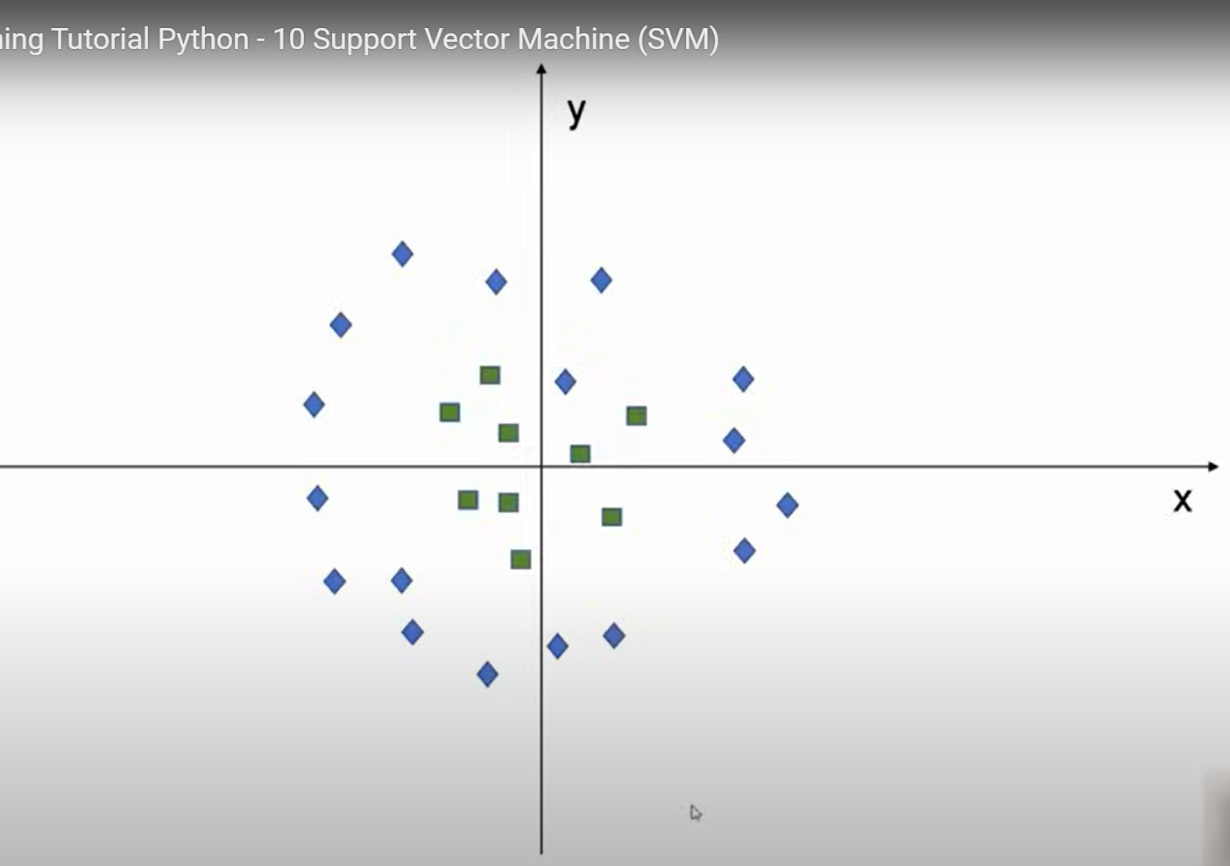

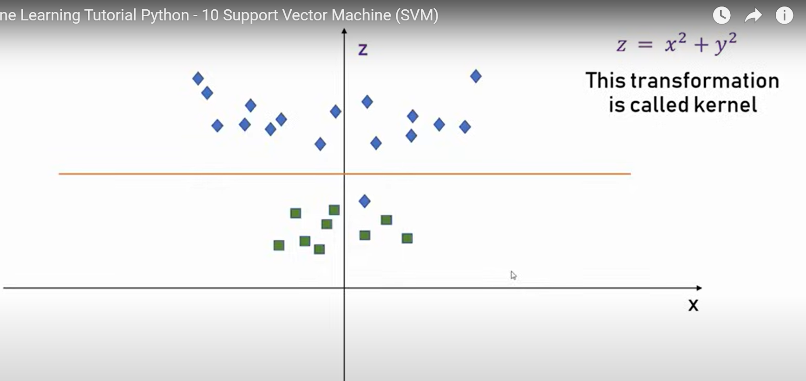

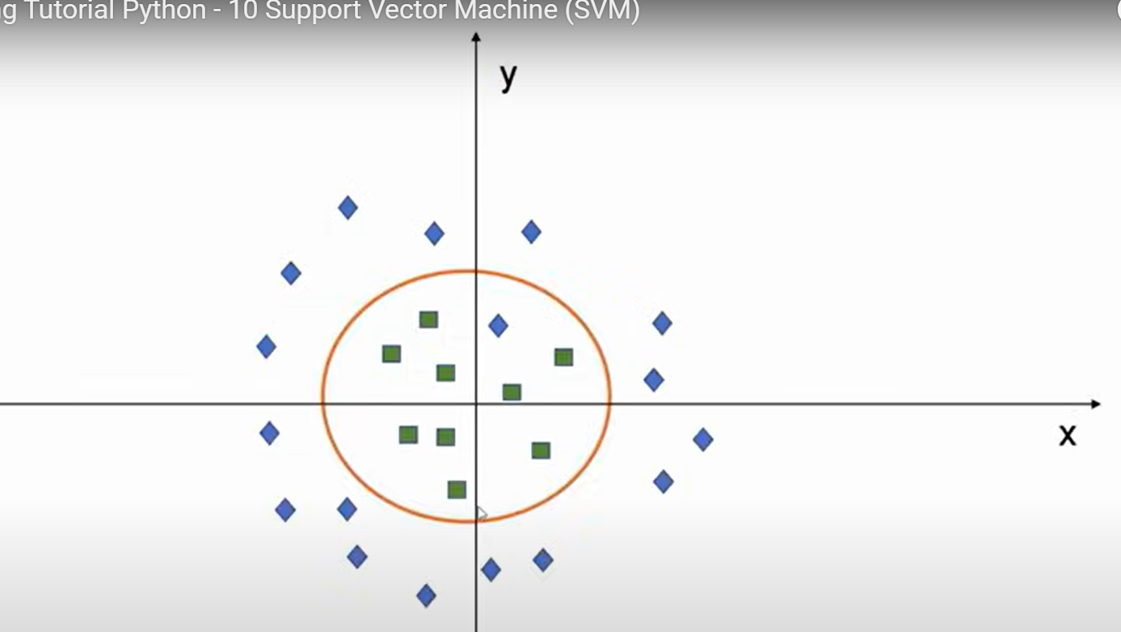

**Support Vector Machine (SVM)** is a powerful and versatile supervised machine learning algorithm used for both classification and regression tasks. SVMs are particularly well-known for their effectiveness in high-dimensional spaces and are widely used for binary classification problems.

### **1. Core Concept of SVM:**

The main idea behind SVM is to find the best boundary (or hyperplane) that separates the data points of different classes. It aims to maximize the margin, which is the distance between the hyperplane and the closest data points from each class. These closest data points are known as **support vectors**.

### **2. How SVM Works:**

- **Hyperplane:** In an SVM model, the hyperplane is a decision boundary that separates different classes. In a 2-dimensional space, the hyperplane is a line, while in higher dimensions, it becomes a plane or hyperplane.

- **Margin:** The margin is the distance between the hyperplane and the nearest data points from each class. SVM aims to maximize this margin to ensure that the model generalizes well to unseen data.

- **Support Vectors:** The data points that are closest to the hyperplane and influence its position are called support vectors. These points are crucial in determining the optimal hyperplane.

### **3. Types of SVM:**

- **Linear SVM:** Used when the data is linearly separable, meaning a straight line (or hyperplane) can perfectly separate the classes.

- **Non-Linear SVM:** Used when the data is not linearly separable. In this case, SVM uses a **kernel trick** to transform the original feature space into a higher-dimensional space where a linear hyperplane can separate the data.

### **4. Kernels in SVM:**

- **Linear Kernel:** Suitable for linearly separable data.

- **Polynomial Kernel:** Allows the hyperplane to be a polynomial function of the input features.

- **Radial Basis Function (RBF) Kernel:** Also known as the Gaussian kernel, it is widely used for non-linear data. It can map the data to an infinite-dimensional space.

- **Sigmoid Kernel:** Similar to a neural network's activation function, often used in specific cases.

### **5. Key Parameters of SVM:**

- **C (Regularization Parameter):** Controls the trade-off between maximizing the margin and minimizing classification error. A smaller `C` creates a wider margin but allows some misclassifications, while a larger `C` aims for a smaller margin with fewer misclassifications.

- **Kernel:** Determines the type of kernel function to use (linear, polynomial, RBF, etc.). The kernel defines how the input space is transformed into a higher-dimensional feature space.

- **Gamma:** Relevant for non-linear kernels like RBF and polynomial. It defines the influence of a single training example. A higher gamma means the model tries to fit the data more closely, while a lower gamma makes the model more generalized.

### **6. Advantages of SVM:**

- **Effective in High-Dimensional Spaces:** SVM is suitable for cases where the number of features is large compared to the number of samples.

- **Versatile with Different Kernels:** The ability to use different kernel functions makes SVM adaptable to various types of data.

- **Robust to Overfitting:** Especially in high-dimensional spaces, SVM tends to be less prone to overfitting if the appropriate kernel and parameters are chosen.

### **7. Disadvantages of SVM:**

- **Computationally Expensive:** Training time can be long for large datasets, especially with non-linear kernels.

- **Hard to Interpret:** The results of SVM can be difficult to interpret, especially with non-linear kernels and high-dimensional data.

- **Sensitive to Feature Scaling:** SVM relies on distances between data points, so it is crucial to scale or normalize features.

### **8. Use Cases of SVM:**

- **Classification Tasks:** SVM is widely used in text classification, image classification, and handwriting recognition.

- **Outlier Detection:** SVM can be adapted to detect anomalies and outliers in datasets.

- **Regression Tasks:** Though less common, SVM can also be used for regression (called Support Vector Regression or SVR).

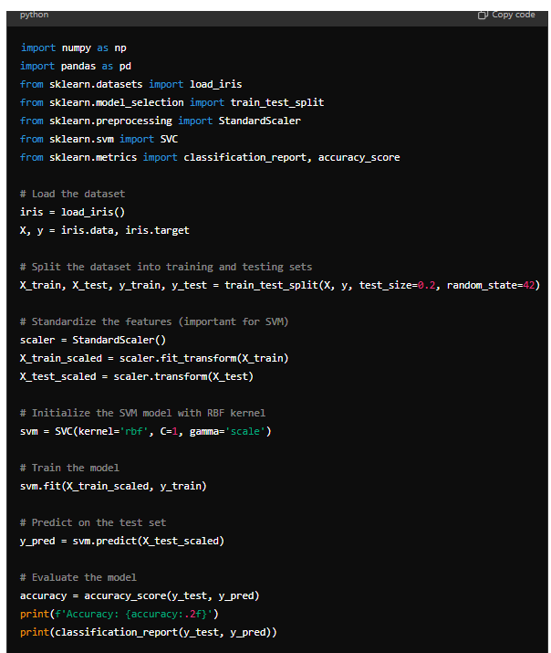 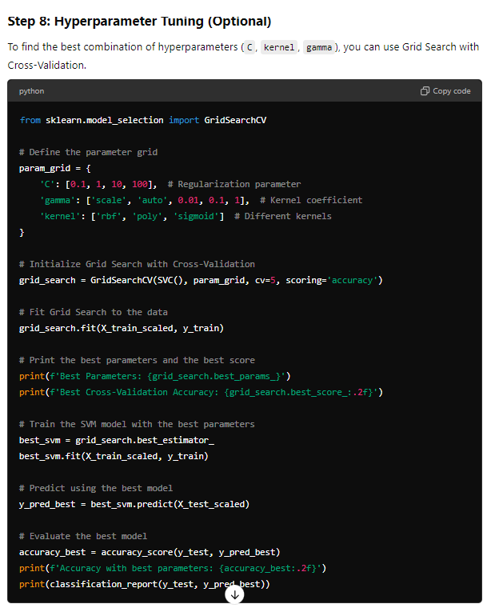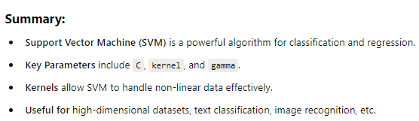

describe all the significant and useful parameters related to SVM

### **1. C (Regularization Parameter)**

- **Description:** Controls the trade-off between maximizing the margin and minimizing classification error. `C` determines how much you want to avoid misclassifying each training example.

- **Effect:**

- **Small `C` Value:** A small value of `C` makes the decision surface smoother, allowing some misclassifications. This leads to a wider margin and helps in creating a generalized model, but might underfit the data.

- **Large `C` Value:** A large `C` value aims for a smaller margin with fewer misclassifications, thus fitting the training data more tightly. This can improve training accuracy but may lead to overfitting.

- **Typical Usage:** Start with `C=1` (default) and adjust based on cross-validation results.

### **2. Kernel**

- **Description:** Defines the type of hyperplane used to separate the data. The kernel function determines how the input features are transformed into a higher-dimensional space.

- **Types:**

- **`linear`:** Suitable for linearly separable data. It uses a linear hyperplane to separate classes.

- **`poly`:** A polynomial kernel. Allows for more complex relationships between classes by using a polynomial function.

- **`rbf` (Radial Basis Function or Gaussian):** A popular kernel for non-linear data. It maps the input features to an infinite-dimensional space using a Gaussian function.

- **`sigmoid`:** Similar to the sigmoid function used in neural networks, useful in specific scenarios like two-class classification problems.

- **Effect:** Choosing the right kernel is critical:

- **Linear Kernel:** Faster, suitable for high-dimensional datasets or when the data is linearly separable.

- **RBF Kernel:** Handles non-linear data well; widely used.

- **Polynomial and Sigmoid Kernels:** Useful for specific data structures but may require more computational resources.

- **Typical Usage:** Use `rbf` as the default; try `linear` for very high-dimensional data or `poly` if you suspect polynomial relationships.

### **3. Gamma (Kernel Coefficient)**

- **Description:** Defines how far the influence of a single training example reaches, affecting the shape of the decision boundary. It's particularly relevant for non-linear kernels (`rbf`, `poly`, and `sigmoid`).

- **Effect:**

- **Small Gamma:** Creates a smoother decision boundary (influences a large area), making the model more generalized.

- **Large Gamma:** Creates a more complex decision boundary (influences a small area), allowing the model to fit closely to the training data, which may lead to overfitting.

- **Typical Usage:** `gamma='scale'` is the default and recommended starting point. Adjust based on the dataset’s complexity and performance results.

### **4. Degree**

- **Description:** Relevant only for the polynomial kernel (`poly`). It specifies the degree of the polynomial function.

- **Effect:**

- Higher degrees allow for more complex decision boundaries but can also lead to overfitting.

- Lower degrees might underfit if the data has complex relationships.

- **Typical Usage:** Start with `degree=3` (default) for `poly` kernels and adjust according to model performance.

### **5. Coef0**

- **Description:** Controls the influence of higher-order versus lower-order terms in the polynomial and sigmoid kernels.

- **Effect:**

- Used when you use `poly` or `sigmoid` kernels to adjust the balance between the linear and non-linear parts of the model.

- **Typical Usage:** Start with `coef0=0` (default) and adjust only if using `poly` or `sigmoid` kernels.

### **6. Shrinking**

- **Description:** A boolean parameter (`True` or `False`) that determines whether to use the shrinking heuristic, a method to speed up training by ignoring data points that are less likely to be support vectors.

- **Effect:**

- **True (Default):** Faster training, suitable for most cases.

- **False:** Might be useful for large datasets where the shrinking heuristic does not perform well.

- **Typical Usage:** Leave it as `True` unless experimenting with large datasets.

### **7. Probability**

- **Description:** A boolean parameter (`True` or `False`) that enables probability estimates for predictions. It uses cross-validation to calculate probabilities, which adds computation time.

- **Effect:**

- **True:** Provides probabilities for each class, useful for understanding confidence levels in predictions.

- **False (Default):** Faster predictions without probability estimates.

- **Typical Usage:** Set to `True` if you need probability estimates, otherwise keep it `False` for faster computations.

### **8. Class Weight**

- **Description:** Adjusts weights inversely proportional to class frequencies to handle imbalanced datasets.

- **Effect:**

- **`balanced`:** Automatically adjusts weights based on class frequencies in the data. Useful when classes are highly imbalanced.

- **Custom weights:** Manually specify weights for each class.

- **Typical Usage:** Use `class_weight='balanced'` for imbalanced datasets.

### **9. Decision Function Shape**

- **Description:** Determines the shape of the decision function. For multiclass problems, this parameter decides whether to use a one-vs-one (`ovo`) or one-vs-rest (`ovr`) strategy.

- **Options:**

- **`ovr` (One-vs-Rest):** Default, suitable for most cases.

- **`ovo` (One-vs-One):** Useful for datasets with many classes.

- **Typical Usage:** Leave as `ovr` unless you have specific reasons to use `ovo`.

### **10. Max Iterations**

- **Description:** Sets the maximum number of iterations to run for the optimization. A negative value means no limit.

- **Effect:**

- Helps control the computational cost of model training.

- **Typical Usage:** Keep as `-1` (no limit) for most cases, unless you have specific runtime constraints.

### **11. Verbose**

- **Description:** Controls the verbosity of output during training. Useful for debugging or understanding model behavior.

- **Effect:**

- Higher values provide more detailed output.

- **Typical Usage:** Generally set to `False` (default) for normal training. Set to `True` if you need detailed information for debugging.

### **Summary of Key Parameters:**

- **`C`:** Controls the trade-off between margin width and classification error.

- **`kernel`:** Determines the type of hyperplane (linear, polynomial, RBF, sigmoid).

- **`gamma`:** Defines the influence of each training example in non-linear kernels.

- **`degree`:** Relevant for polynomial kernels; controls the complexity.

- **`class_weight`:** Handles class imbalance.

- **`probability`:** Enables or disables probability estimates for predictions.

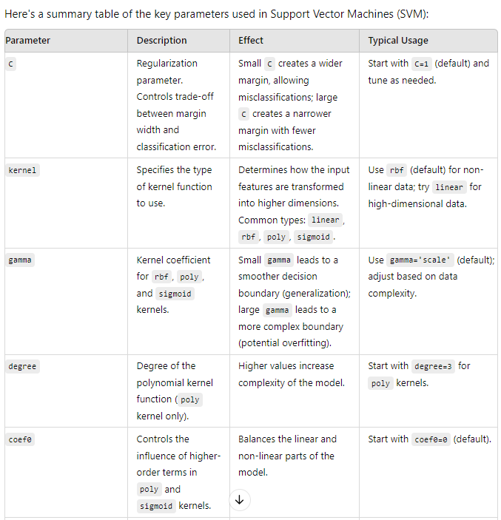 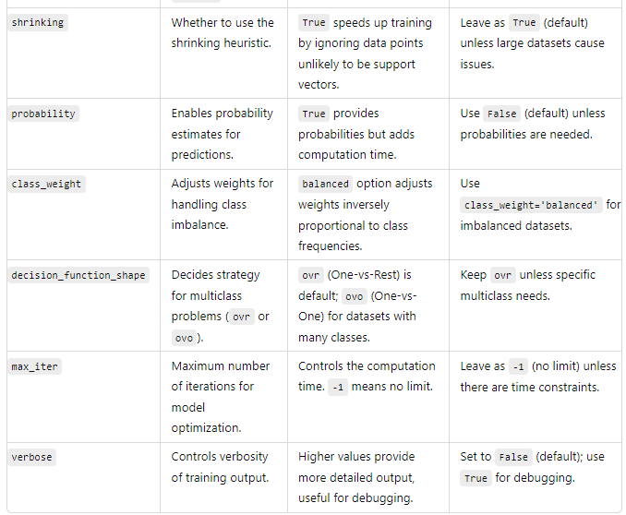 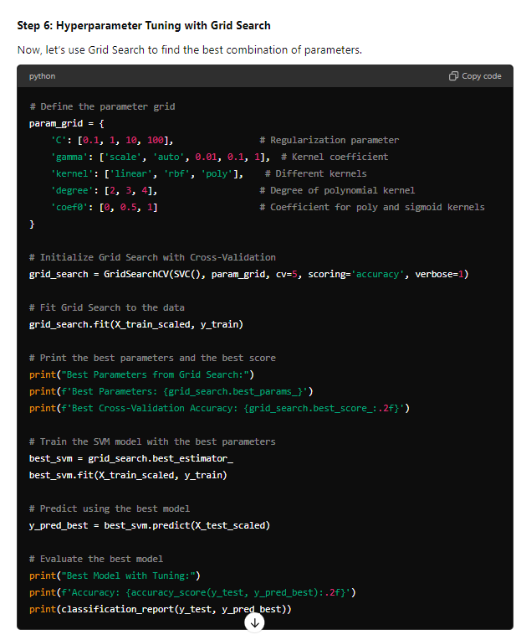

Cross Validation

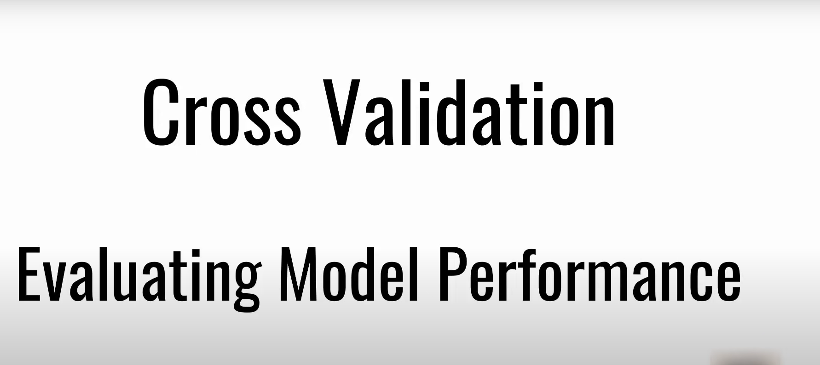

Making the sample fold(here each fold hold 20 sample)dividing into train and split,doing iterations till last fold and then taking average:

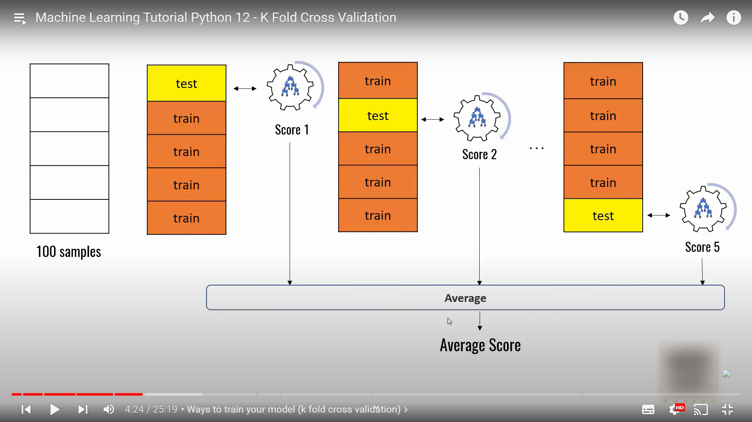

**K Means Clustering Algorithm**

For unsupervised/untargeted data ,we make clusters/features

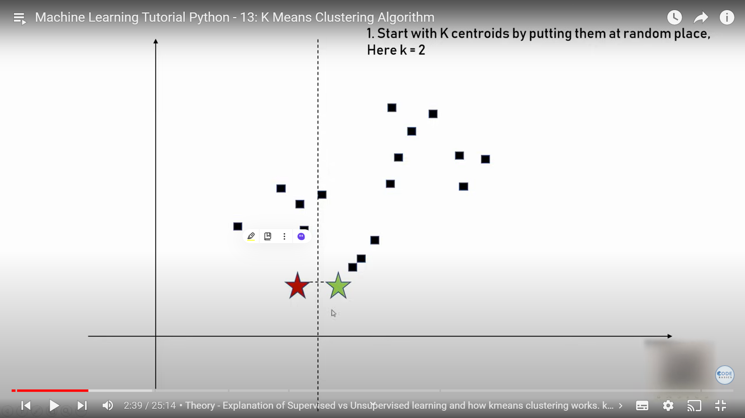

So two points

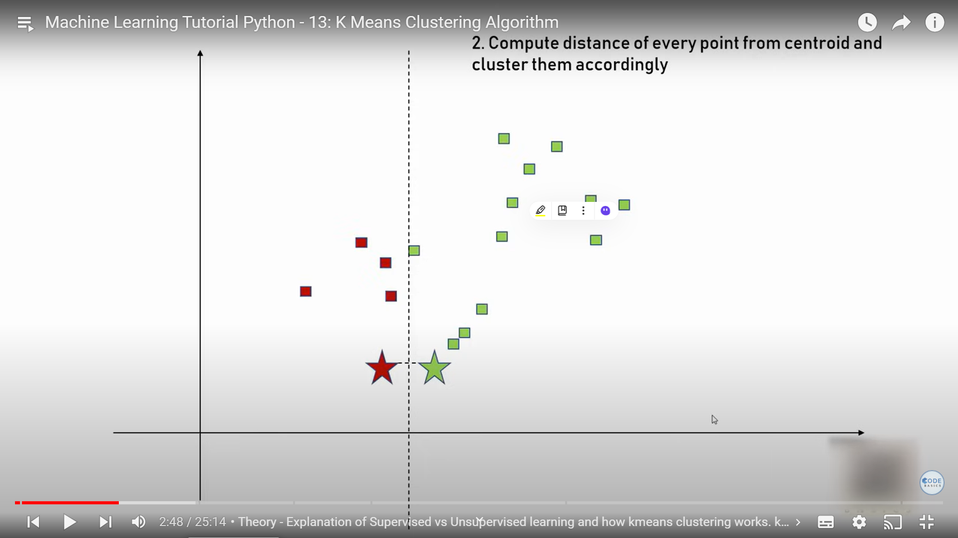

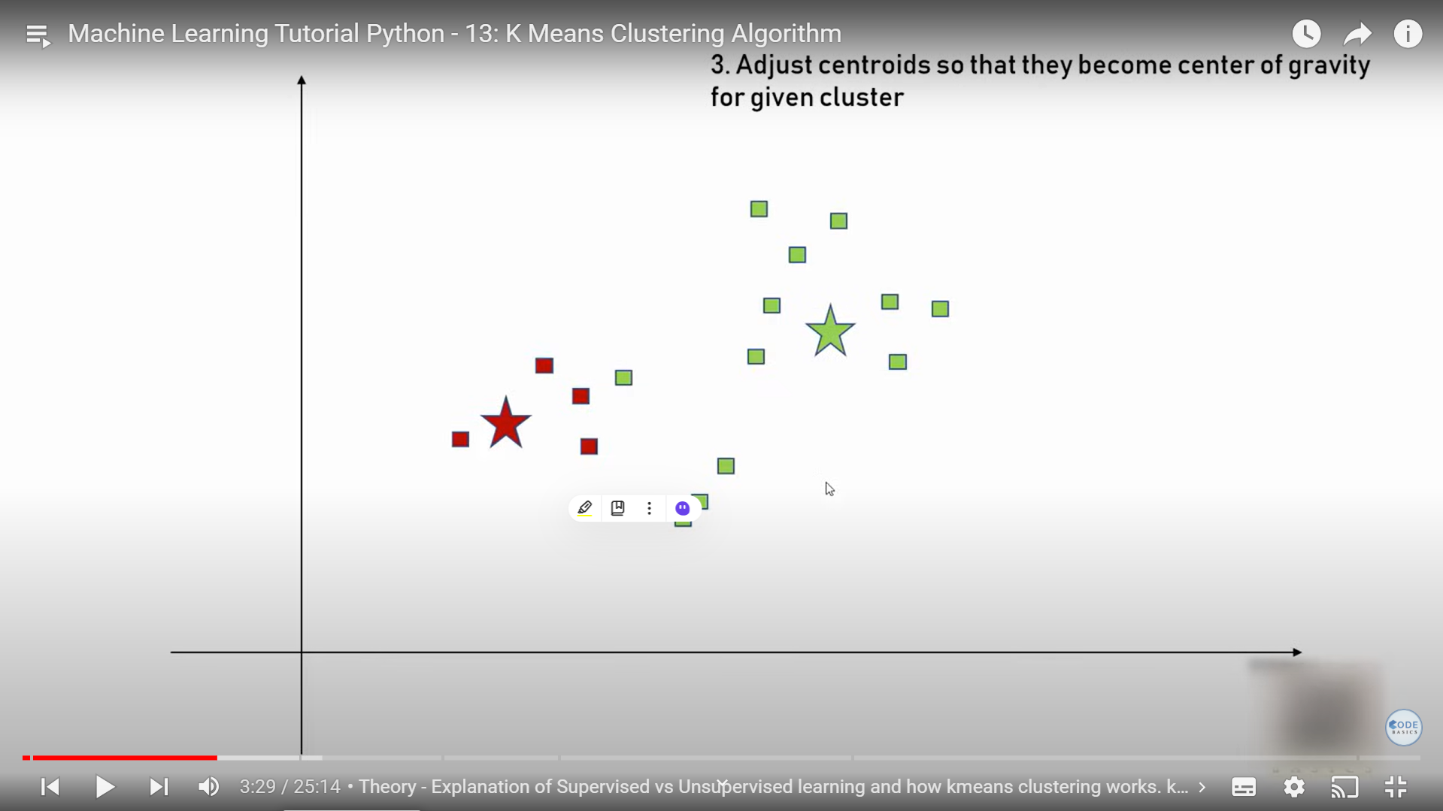

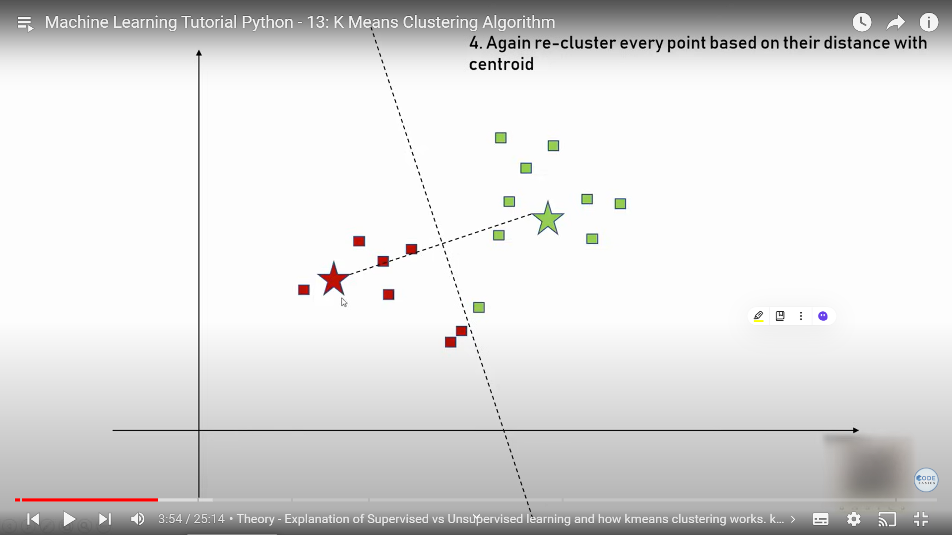

Keep on repeating until the clusters cannot be changed further:  
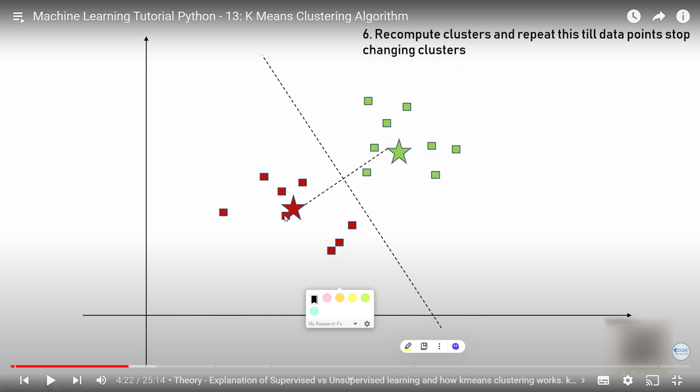

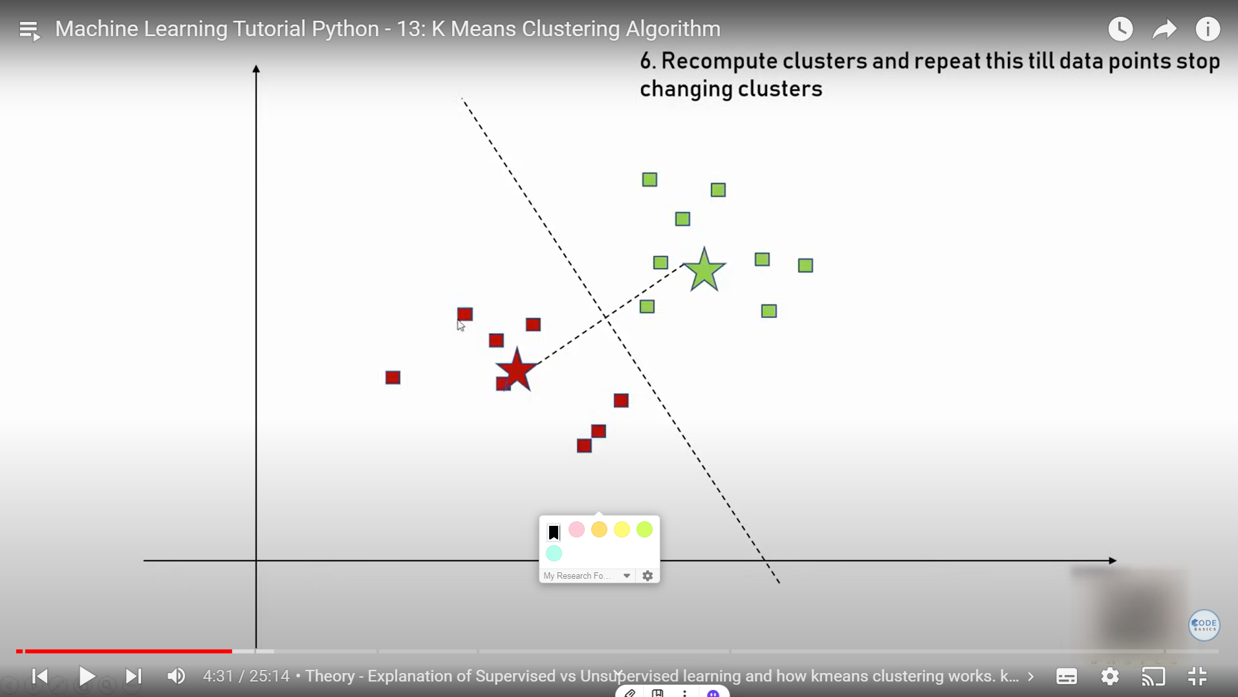

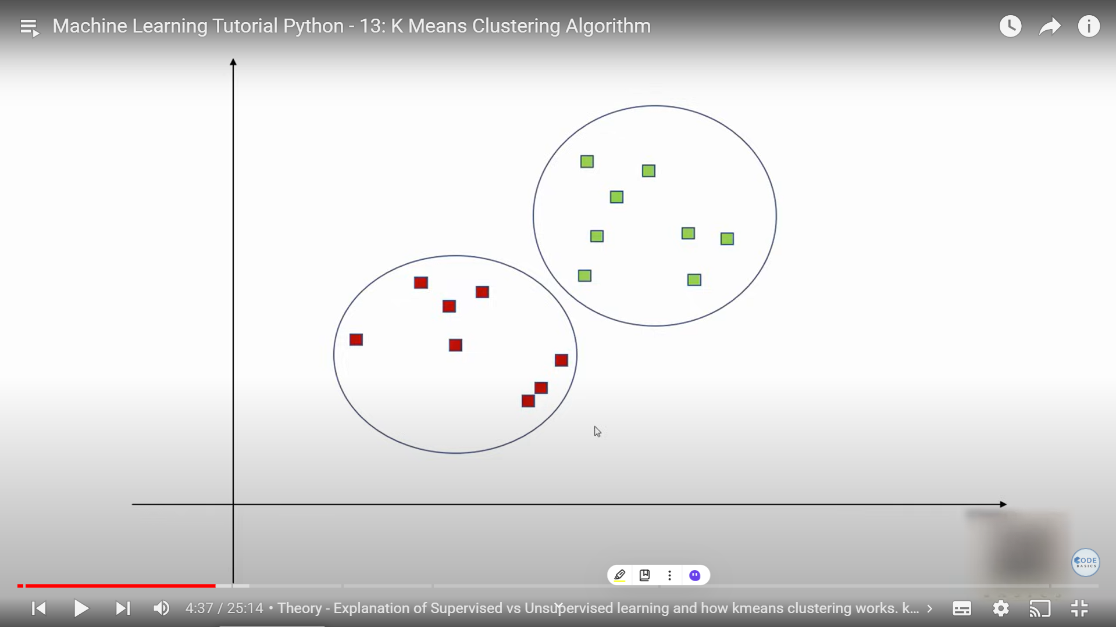

To find the right number of clusters:

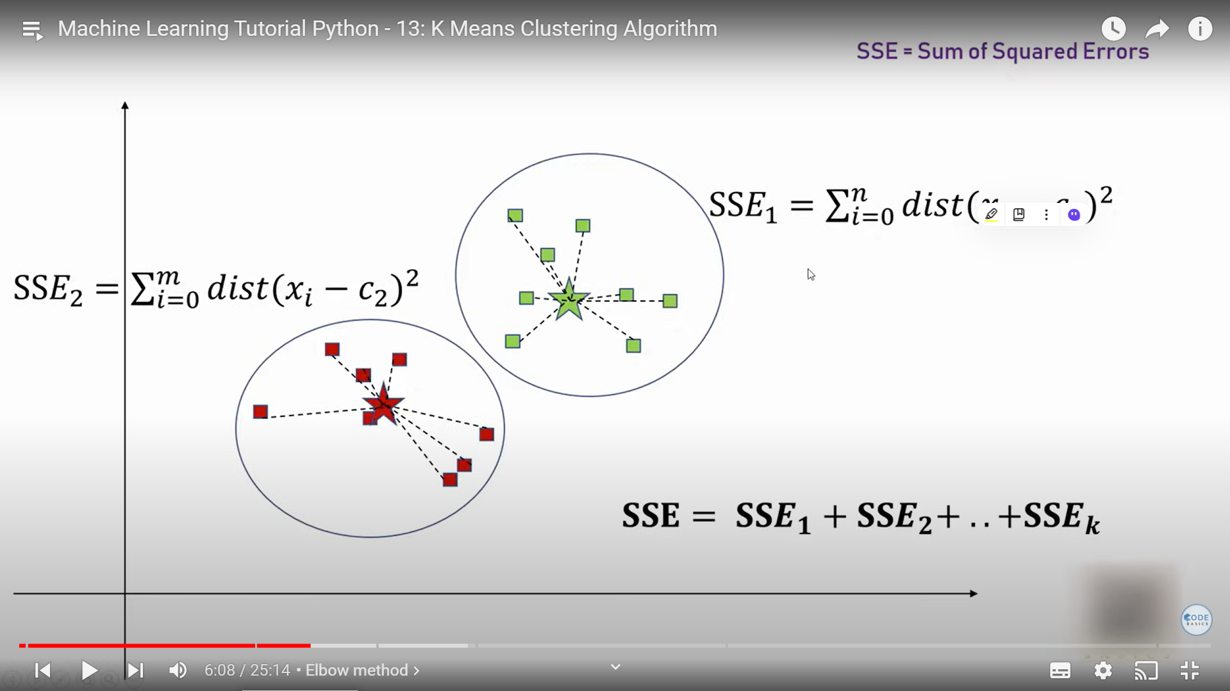

Make square error of individual dis from clusters and add them

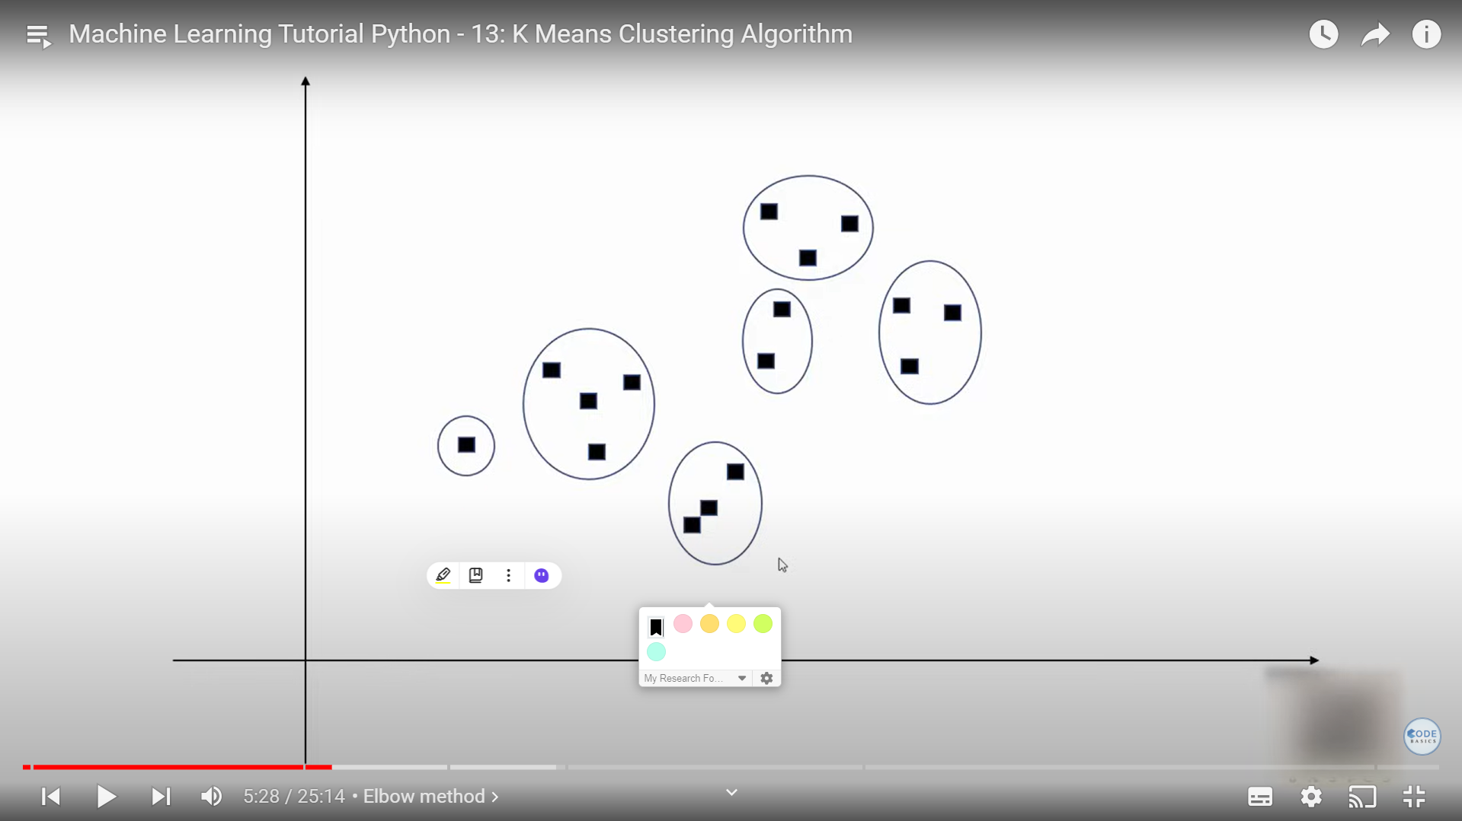

Error less when cluster number more with   
no of points== no of cluster means zero error

But we find the elbow for less cluster number and optimal minimum error  
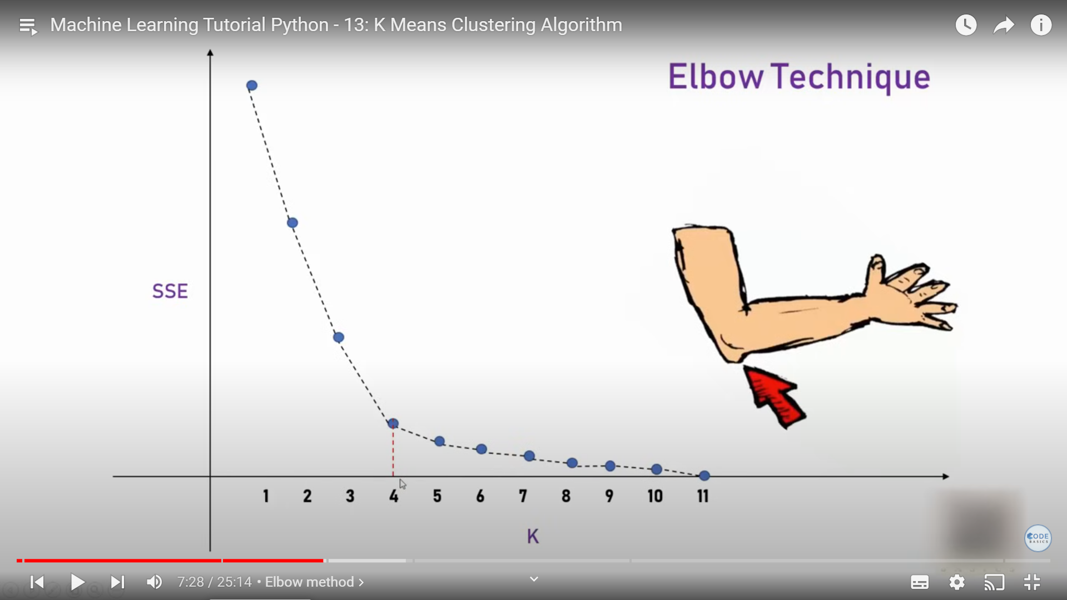

**K-means clustering** is a popular unsupervised machine learning algorithm used for partitioning a dataset into distinct clusters or groups. It aims to partition the data into `K` clusters in which each data point belongs to the cluster with the nearest mean. The goal is to minimize the variance within each cluster and maximize the variance between clusters.

### **Core Concepts of K-means Clustering**

1. **Cluster Centroids:**

- The centroid of a cluster is the mean of all the data points belonging to that cluster. It is the central point of the cluster.

2. **Objective Function:**

- The objective of K-means is to minimize the sum of squared distances between each data point and the centroid of its assigned cluster. This is known as the **within-cluster sum of squares (WCSS)** or **inertia**.

3. **Algorithm Steps:**

- **Step 1: Initialization**: Choose `K` initial centroids randomly (or use methods like K-means++ for better initialization).

- **Step 2: Assignment**: Assign each data point to the nearest centroid, forming `K` clusters.

- **Step 3: Update**: Recalculate the centroids of the clusters based on the current assignments.

- **Step 4: Repeat**: Repeat steps 2 and 3 until the centroids no longer change significantly or a specified number of iterations is reached.

4. **Convergence:**

- The algorithm converges when the centroids stabilize (i.e., their positions do not change) or after a predefined number of iterations. The algorithm may also converge when the cluster assignments no longer change.

### **Key Parameters of K-means Clustering**

1. **`K` (Number of Clusters):**

- **Description:** Specifies the number of clusters to form.

- **Effect:** The choice of `K` affects the clustering outcome. Selecting an inappropriate `K` can lead to poor clustering results. Methods like the **Elbow Method** or **Silhouette Score** can help determine an optimal `K`.

2. **`Max_iter`:**

- **Description:** The maximum number of iterations for the algorithm to run.

- **Effect:** Limits the number of iterations to prevent the algorithm from running indefinitely. The default is typically 300.

3. **`Init`:**

- **Description:** Method for initializing the centroids.

- **Options:**

- **`'k-means++'`**: A smarter initialization method that helps to speed up convergence.

- **`'random'`**: Randomly chooses initial centroids.

- **Effect:** Initialization affects convergence speed and clustering quality. `k-means++` is often preferred for better results.

4. **`N_init`:**

- **Description:** Number of times the algorithm is run with different centroid seeds.

- **Effect:** Running the algorithm multiple times with different initializations can help find a better clustering result. The best result is chosen based on the lowest inertia.

5. **`Algorithm`:**

- **Description:** Algorithm to use for the K-means clustering.

- **Options:**

- **`'auto'`**: Automatically chooses the best algorithm based on the input data.

- **`'full'`**: Standard K-means algorithm.

- **`'elkan'`**: An optimized version of K-means that can be faster with certain types of data.

- **Effect:** Different algorithms can affect the performance and speed of clustering.

### **Advantages of K-means Clustering**

- **Simplicity:** Easy to understand and implement.

- **Efficiency:** Works well with large datasets and is computationally efficient.

- **Scalability:** Can handle large datasets with a relatively low time complexity.

### **Disadvantages of K-means Clustering**

- **Choice of `K`:** Requires the number of clusters `K` to be specified in advance, which may not be known.

- **Sensitivity to Initialization:** Results can vary based on the initial centroid positions.

- **Assumption of Spherical Clusters:** Assumes clusters are spherical and equally sized, which may not be true for all datasets.

- **Sensitive to Outliers:** Outliers can significantly affect the centroid locations and clustering results.

### **Applications of K-means Clustering**

- **Market Segmentation:** Grouping customers based on purchasing behavior.

- **Image Compression:** Reducing the number of colors in an image by clustering pixel colors.

- **Anomaly Detection:** Identifying unusual data points by seeing if they fit well into any cluster.

- **Document Clustering:** Grouping similar documents based on content.

```

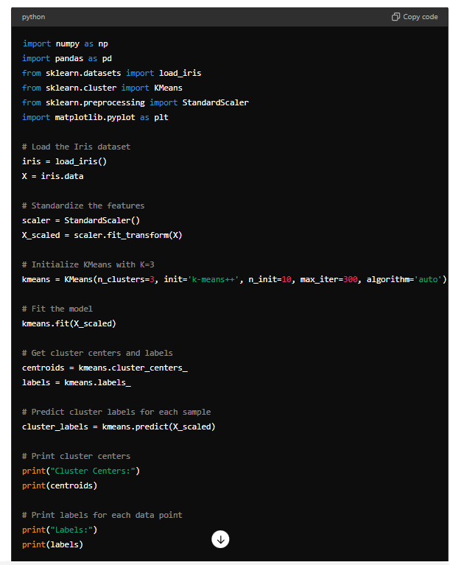 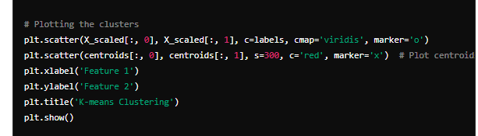 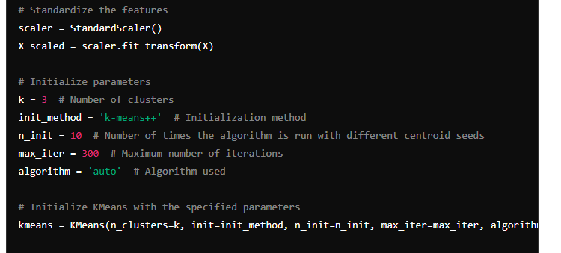



### **Explanation:**

1. **Data Preparation:** Load the Iris dataset and scale the features.

2. **K-means Initialization:** Set `K=3` (as we know the dataset has 3 classes) and initialize K-means with parameters.

3. **Model Fitting:** Fit the K-means model on the scaled data.

4. **Results:** Print cluster centers and labels assigned to each data point.

5. **Visualization:** Plot the clusters and centroids.

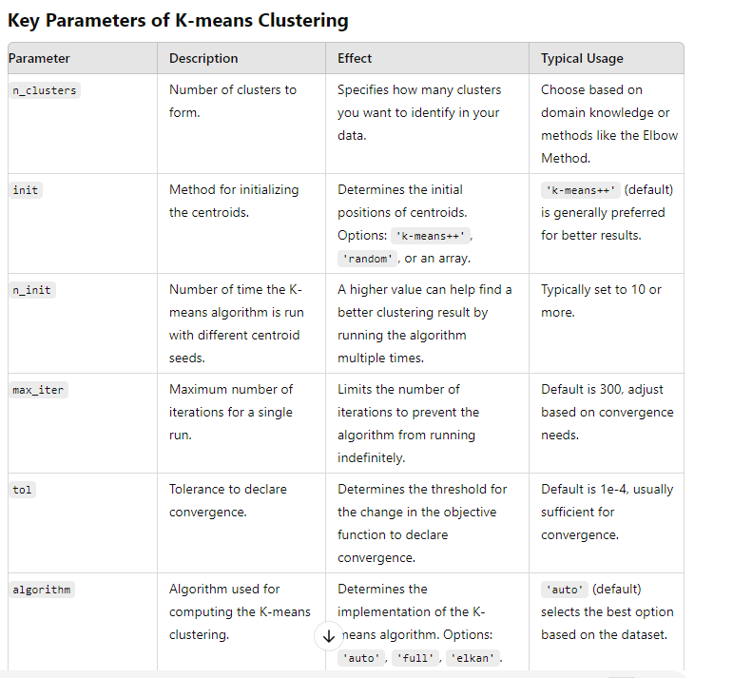 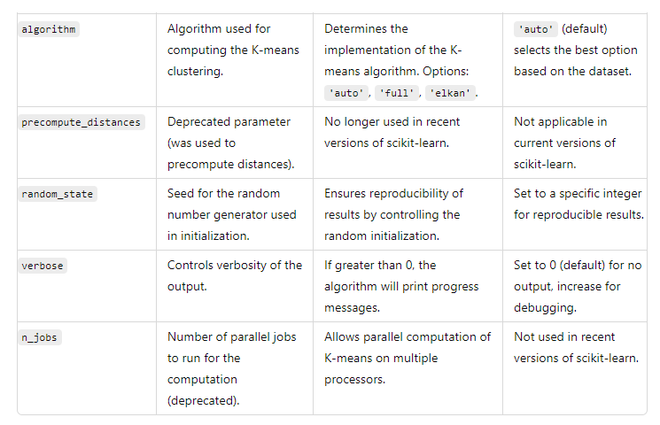

***Over-fitting issue can be addressed by many methods, among them L1nad L2 regularization are notable***

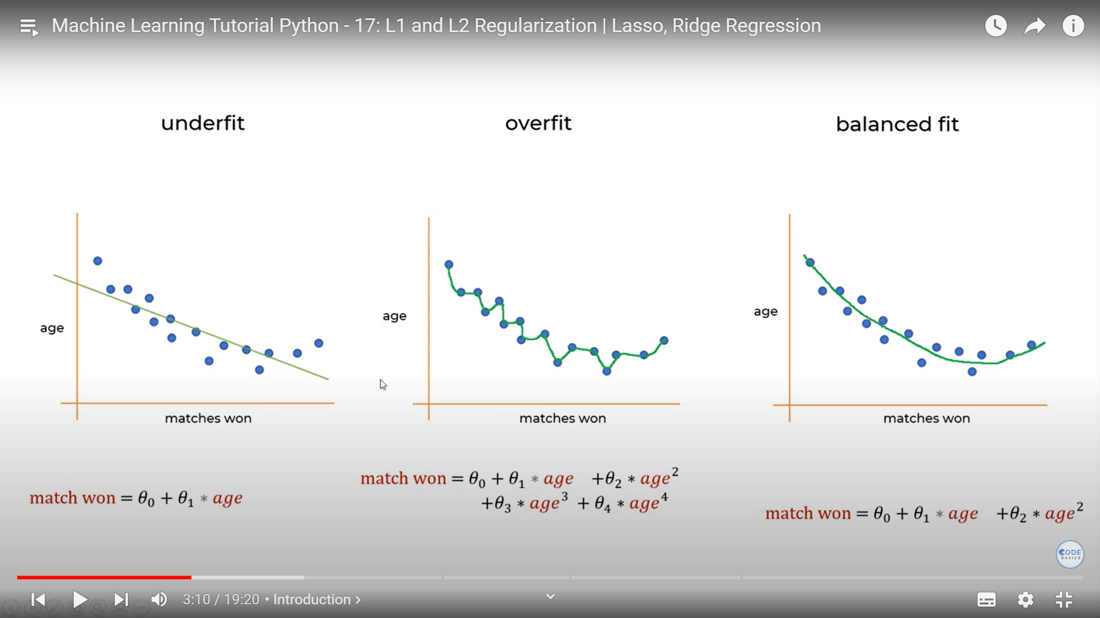

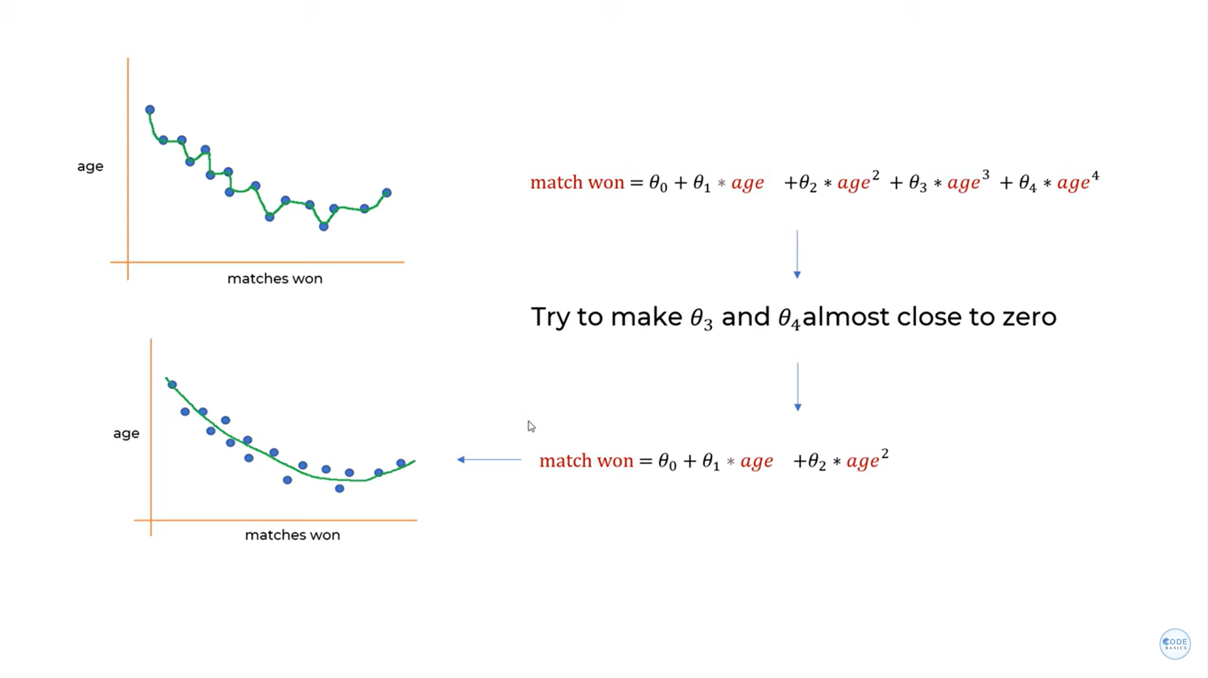

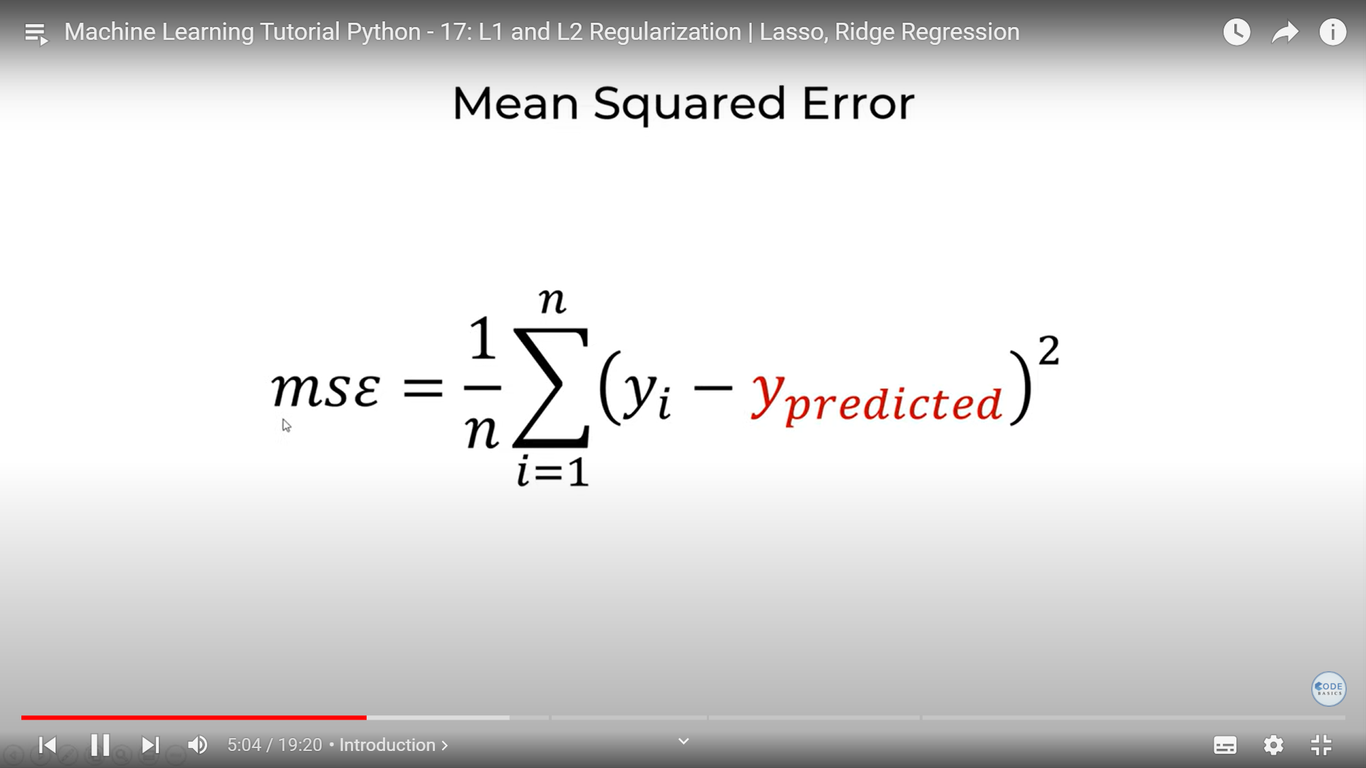

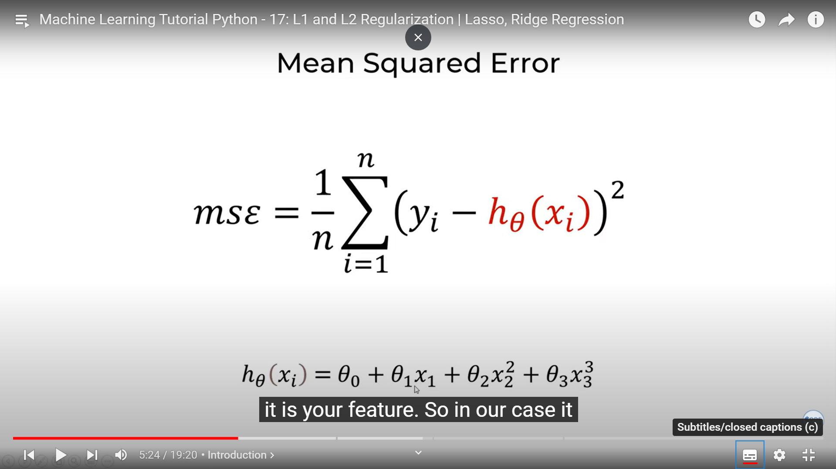

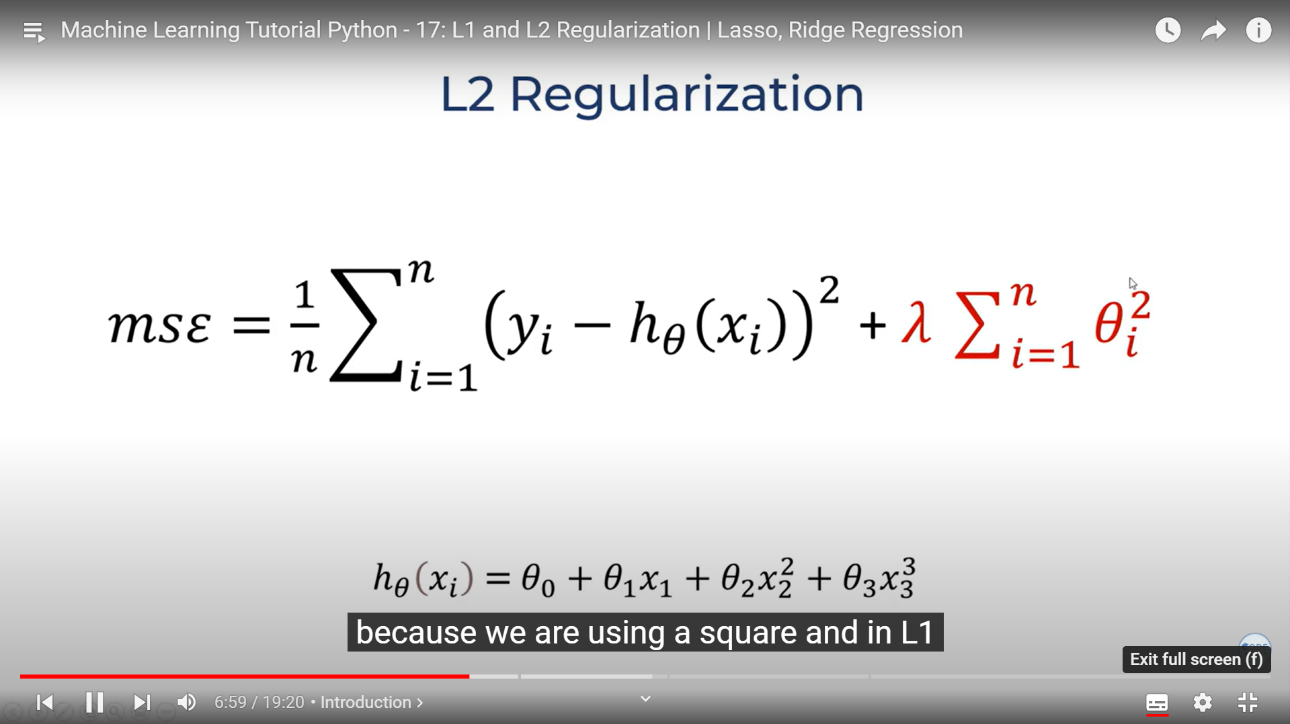

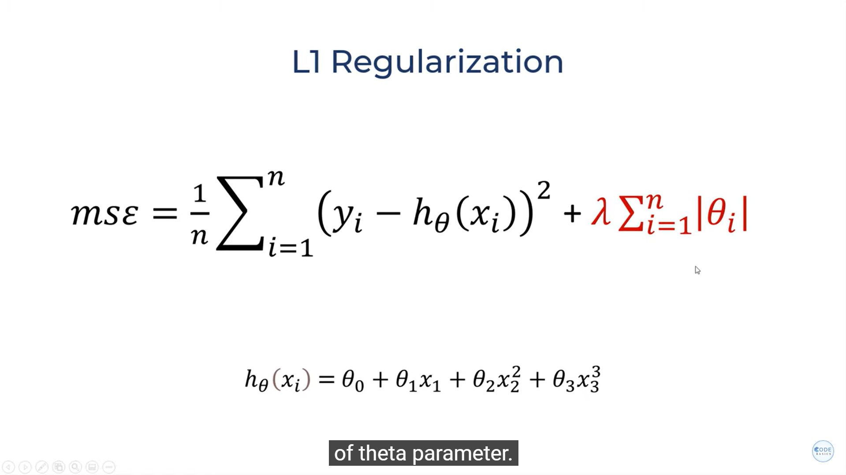

**K nearest neighbors (KNN):**

**Calculate a point based on nearest points**

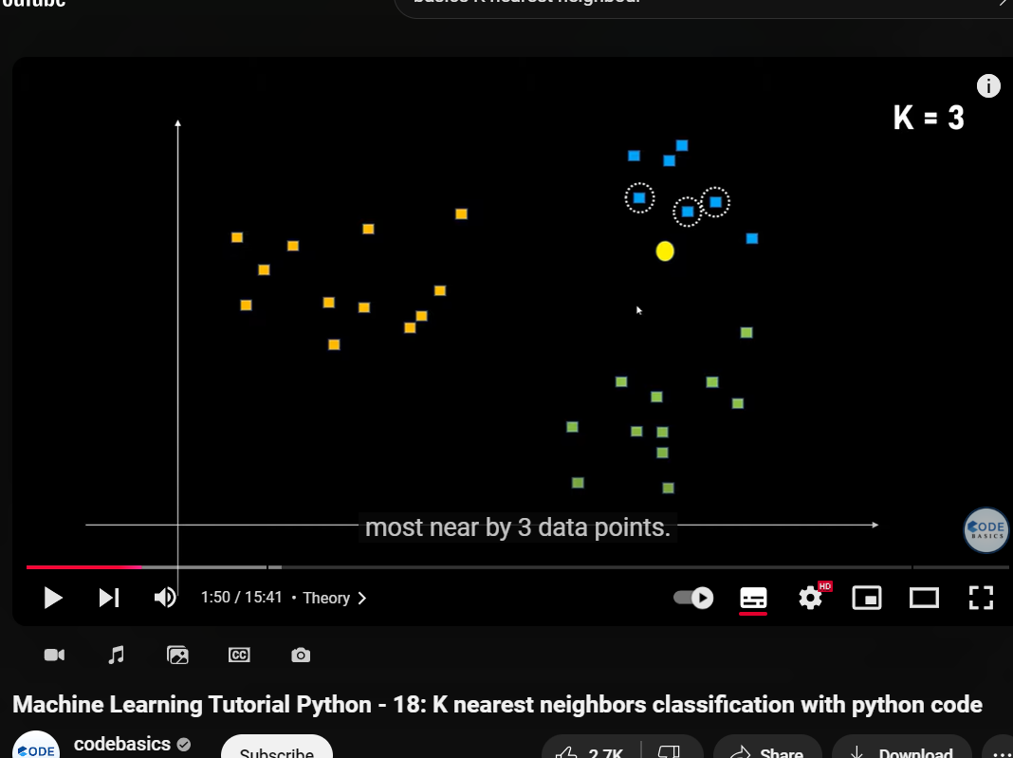

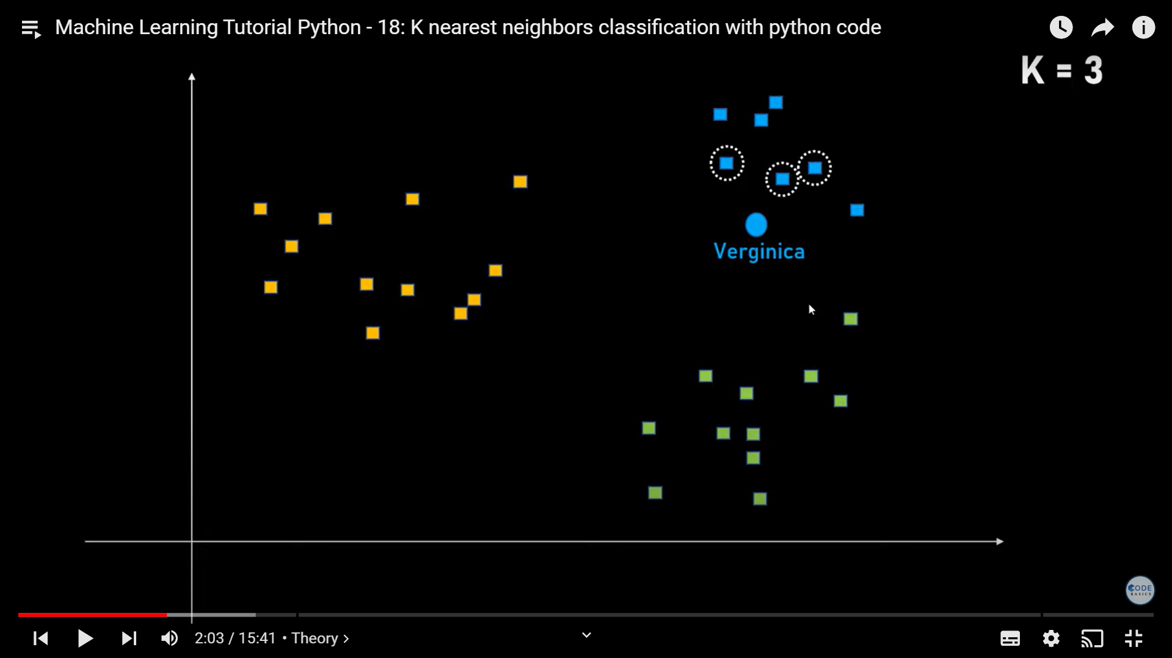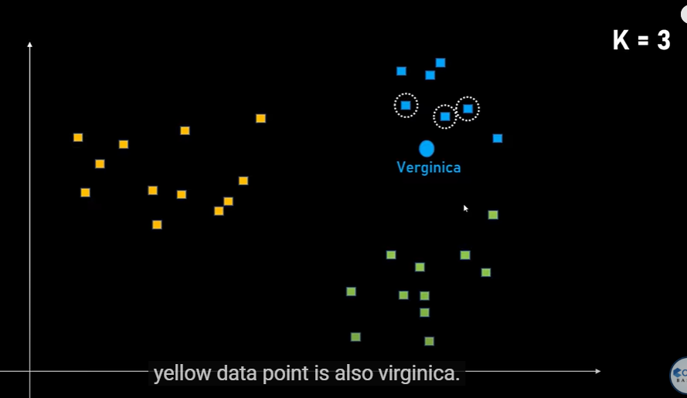

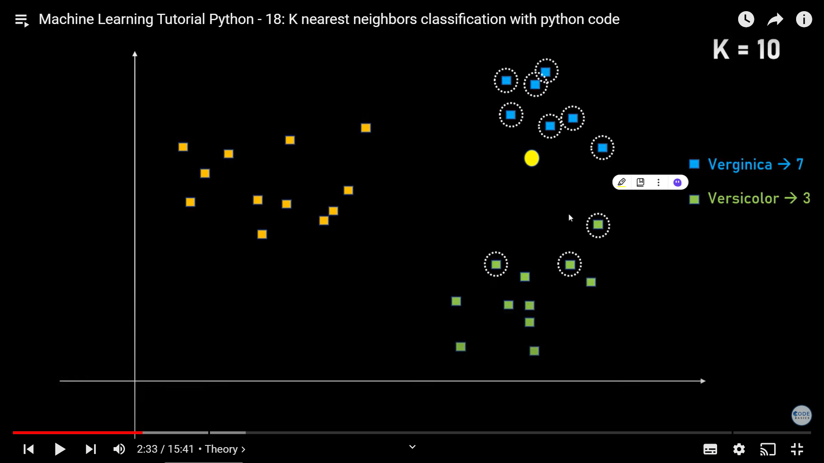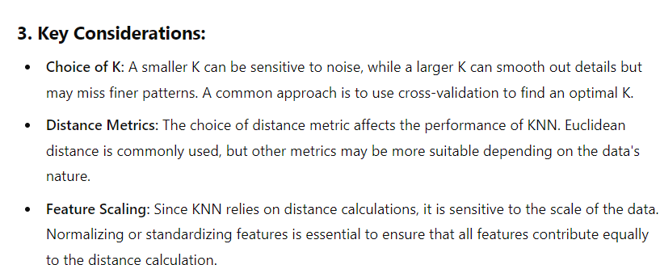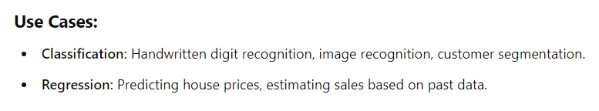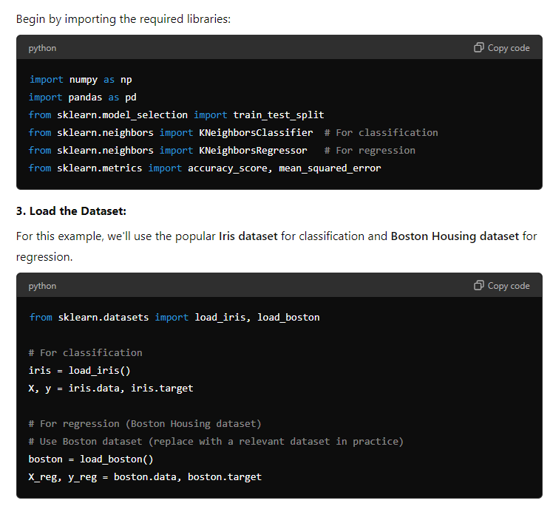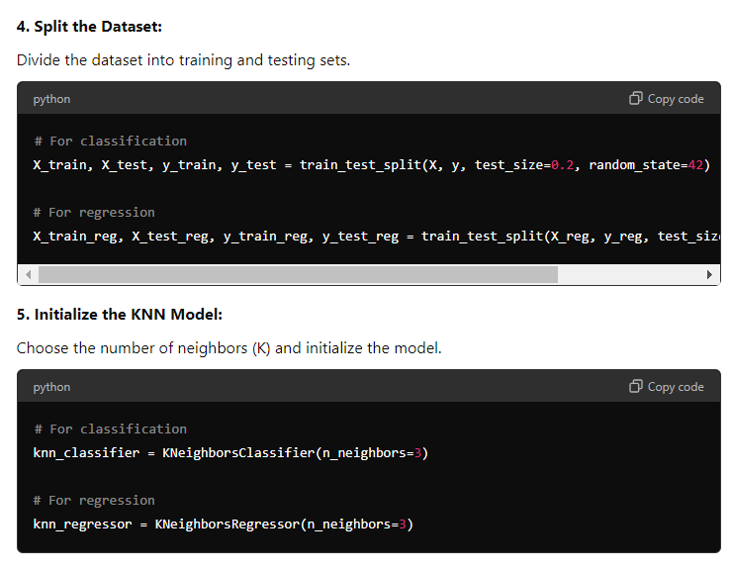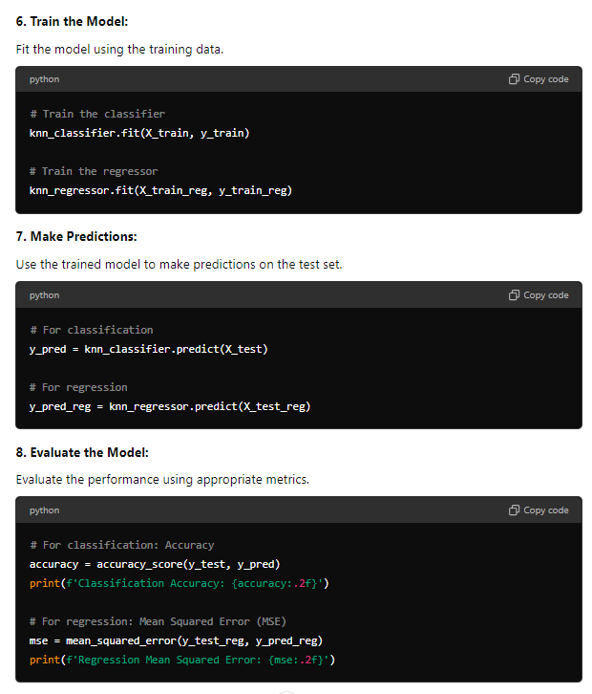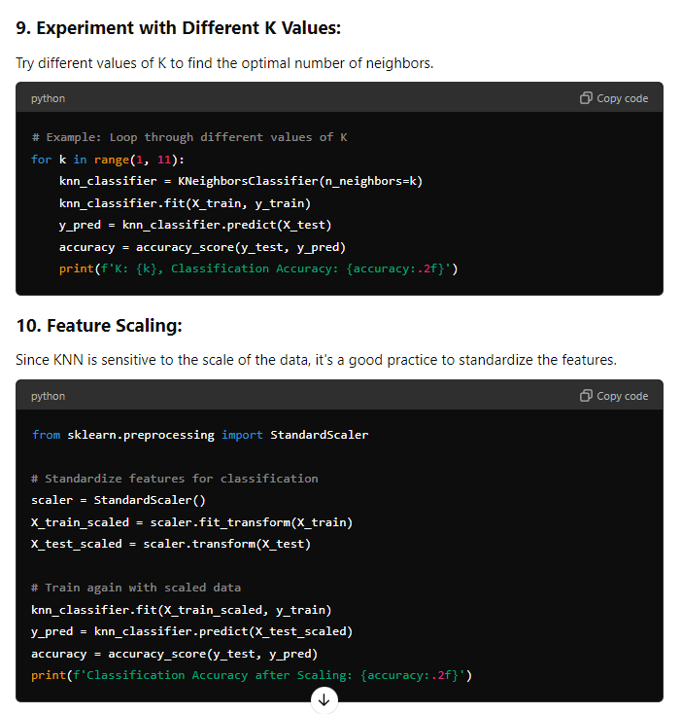

Would you like a practical example of using some of these parameters in a KNN model?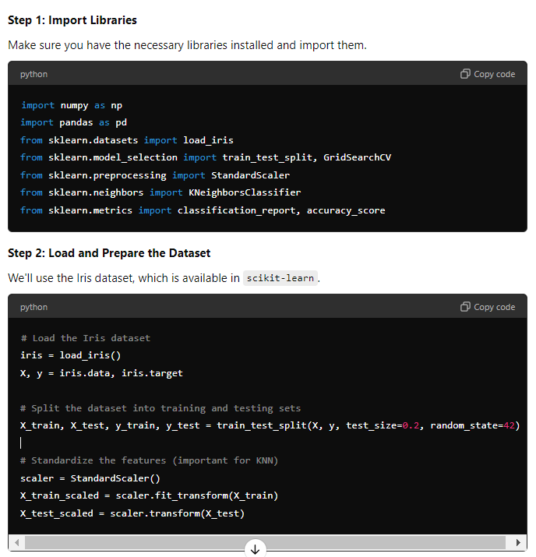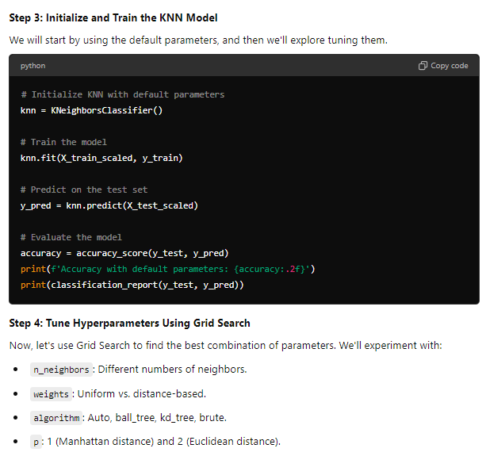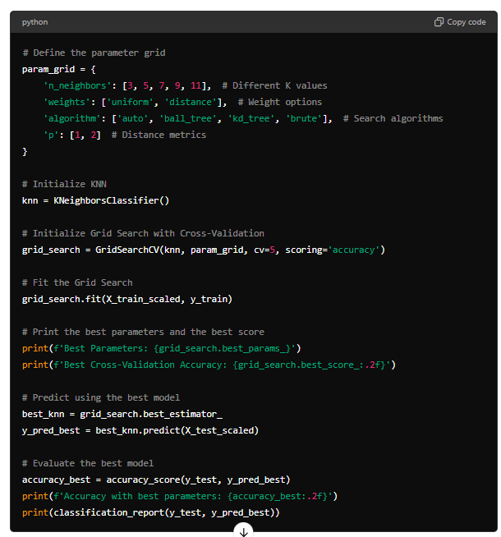

##########################################################################################

describe all the significant and useful parameters related to KNN:

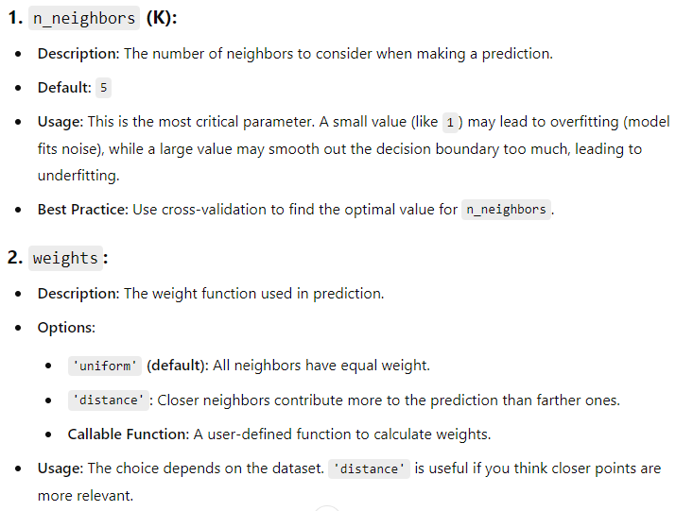

The K-Nearest Neighbors (KNN) algorithm in scikit-learn offers several significant parameters that you can tune to optimize its performance for a given dataset. Understanding these parameters can help you improve the accuracy, efficiency, and applicability of the KNN model.

### **1. `**n_neighbors`** (K):**

- **Description:** The number of neighbors to consider when making a prediction.

- **Default:** `5`

- **Usage:** This is the most critical parameter. A small value (like `1`) may lead to overfitting (model fits noise), while a large value may smooth out the decision boundary too much, leading to underfitting.

- **Best Practice:** Use cross-validation to find the optimal value for `n_neighbors`.

### **2. `**weights**`:**

- **Description:** The weight function used in prediction.

- **Options:**

- **`'uniform'` (default):** All neighbors have equal weight.

- **`'distance'`:** Closer neighbors contribute more to the prediction than farther ones.

- **Callable Function:** A user-defined function to calculate weights.

- **Usage:** The choice depends on the dataset. `'distance'` is useful if you think closer points are more relevant.

### **3. `**algorithm**`:**

- **Description:** The algorithm used to compute the nearest neighbors.

- **Options:**

- **`'auto'` (default):** Automatically selects the best algorithm based on the input data.

- **`'ball_tree'`:** Ball Tree data structure for efficient neighbor searches.

- **`'kd_tree'`:** KD-Tree data structure for efficient neighbor searches.

- **`'brute'`:** Brute-force search by computing distances between all points.

- **Usage:** Use `'auto'` for simplicity, but you can experiment with others if performance is an issue with large datasets.

### **4. `**leaf_size**`:**

- **Description:** The size of the leaf in the Ball Tree or KD-Tree.

- **Default:** `30`

- **Usage:** Affects the speed of the construction and query for Ball Tree and KD-Tree algorithms. Smaller values may lead to faster queries but higher memory usage.

- **Best Practice:** Tuning `leaf_size` can help optimize performance in terms of speed and memory usage, particularly for large datasets.

### **5. `**p**`:**

- **Description:** The power parameter for the Minkowski distance metric.

- **Default:** `2`

- **Options:**

- **`1`:** Manhattan distance (L1 norm).

- **`2`:** Euclidean distance (L2 norm, default).

- **Other Values:** Represents different Minkowski distances.

- **Usage:** Choose `1` for Manhattan distance if the data has many outliers or is sparse; otherwise, the default `2` is a good starting point.

### **6. `**metric**`:**

- **Description:** The distance metric to use for the tree.

- **Default:** `'minkowski'`

- **Options:**

- **Common Metrics:** `'euclidean'`, `'manhattan'`, `'chebyshev'`, `'minkowski'`.

- **Callable Function:** A custom distance function.

- **Usage:** The choice of metric depends on the problem domain. `'euclidean'` and `'manhattan'` are most common, but a custom metric might be necessary for specific applications.

### **7. `**metric_params**`:**

- **Description:** Additional keyword arguments for the distance metric.

- **Default:** `None`

- **Usage:** Allows fine-tuning of the distance metric. For example, if using a custom metric, you can pass specific parameters.

### **8. `**n_jobs**`:**

- **Description:** The number of parallel jobs to run for neighbors search.

- **Default:** `None` (means 1 core).

- **Usage:**

- **`-1`**: Use all available cores.

- **Positive Integer:** Use a specific number of cores.

- **Best Practice:** Set `n_jobs=-1` to speed up computation on large datasets.

### **9. `**radius**`:**

- **Description:** Range of parameter space to use by default for neighbors searches.

- **Default:** `1.0`

- **Usage:** Used with the `RadiusNeighborsClassifier` or `RadiusNeighborsRegressor` instead of `KNeighborsClassifier` or `KNeighborsRegressor`. Determines the range within which points are considered neighbors.

### **10. `**algorithm_options**`:**

- **Description:** Internal options for specific algorithms (`ball_tree`, `kd_tree`).

- **Usage:** This is an advanced option, and you rarely need to modify it unless fine-tuning is required.

**### \*\*****Summary of Key Parameters:\*\***

**| Parameter | Importance Level | Description |**

**|----------------|------------------|---------------------------------------------------|**

**| `n_neighbors` | High | Number of nearest neighbors to consider (K value). |**

**| `weights` | High | How to weight the neighbors (uniform or distance). |**

**| `algorithm` | Medium | Search algorithm to use (auto, ball_tree, kd_tree).|**

**| `leaf_size` | Medium | Size of leaves in search trees; affects speed. |**

**| `p` | Medium | Power parameter for Minkowski distance. |**

**| `metric` | Medium | Distance metric to use. |**

**| `n_jobs` | Low | Number of parallel jobs for computation. |**

### **Choosing the Right Parameters:**

- **Start with Defaults:** Begin with default parameters and adjust `n_neighbors` and `weights` based on the dataset.

- **Cross-Validation:** Use cross-validation to find the optimal combination of `n_neighbors`, `weights`, and `algorithm`.

- **Experiment with Metrics:** Try different distance metrics (`metric`) to see which one performs best for your specific problem.

- **Use Feature Scaling:** Always scale your features before applying KNN since it relies on distance calculations.

**feature engineering**

**feature engineering helps in data cleaning  
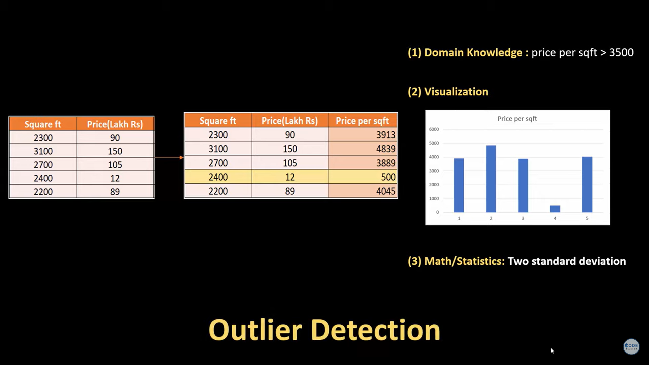**

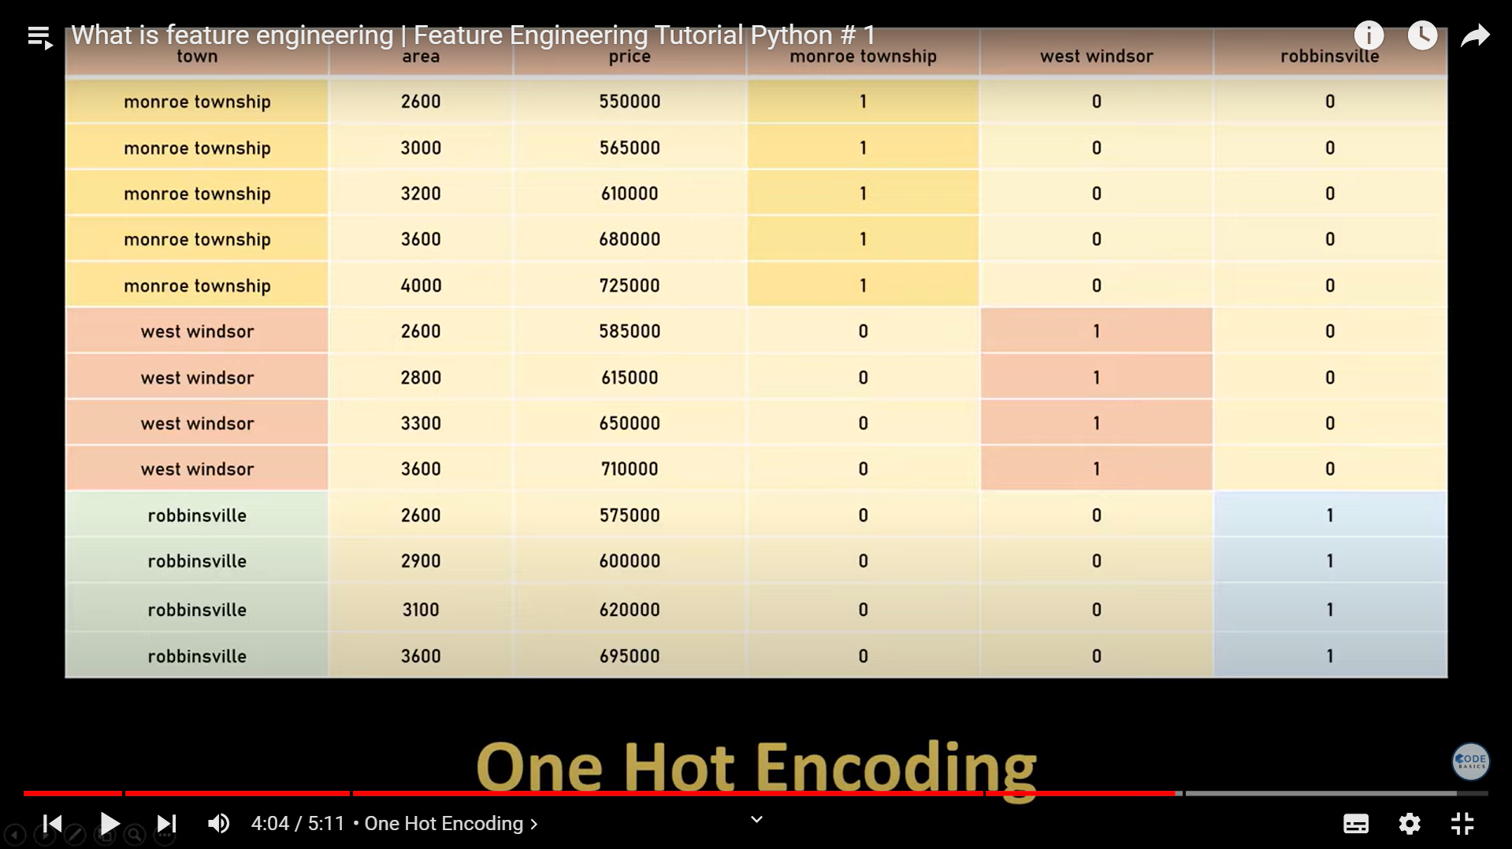

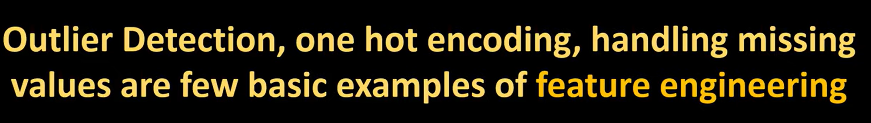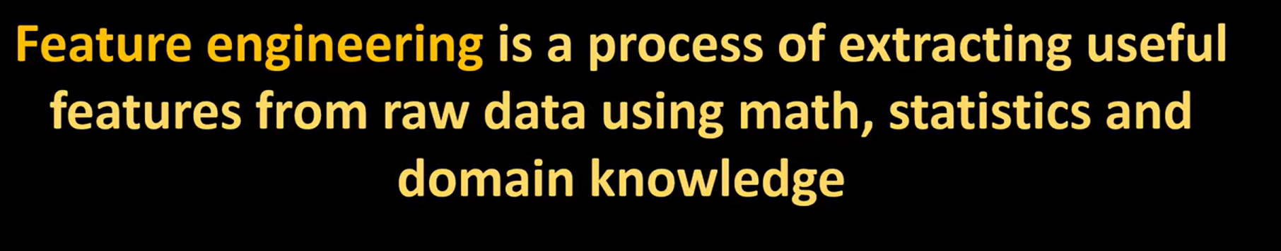

**Percentile is relative based on given data**

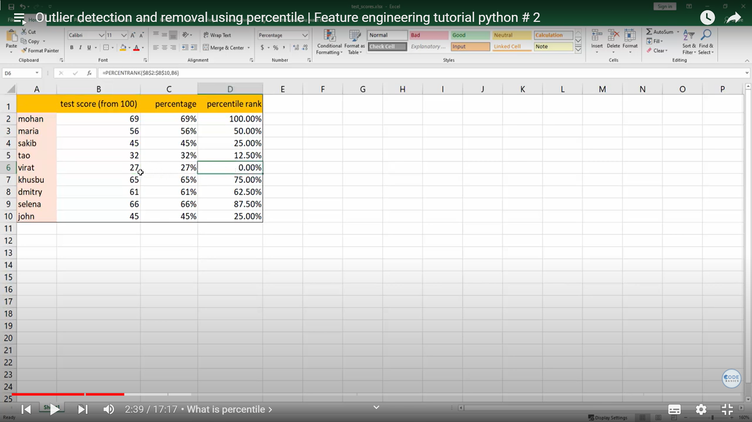

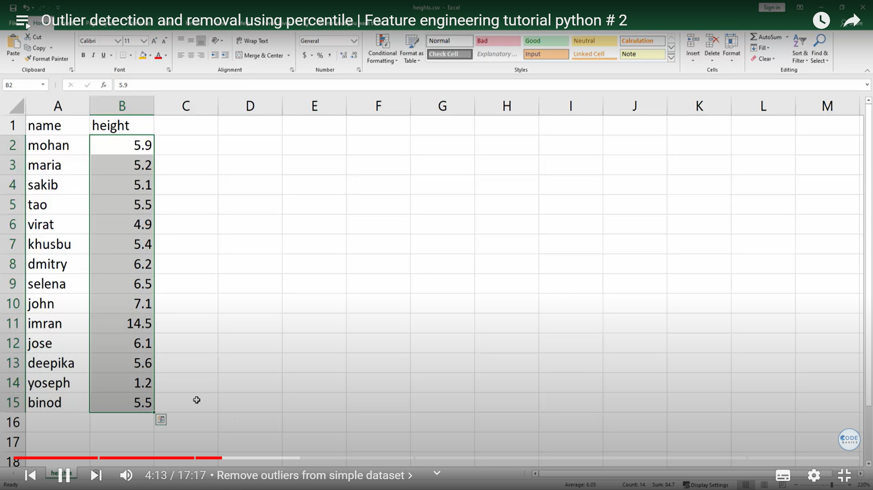

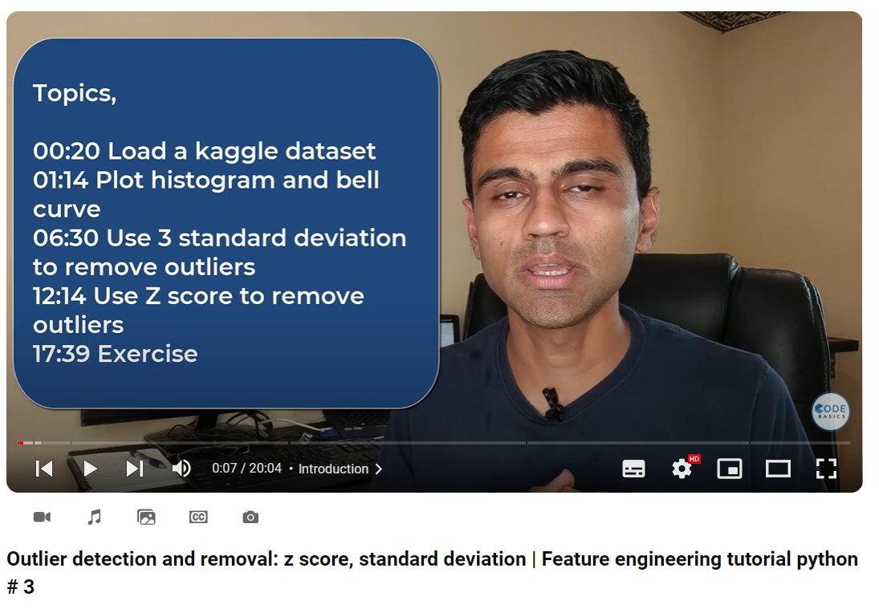

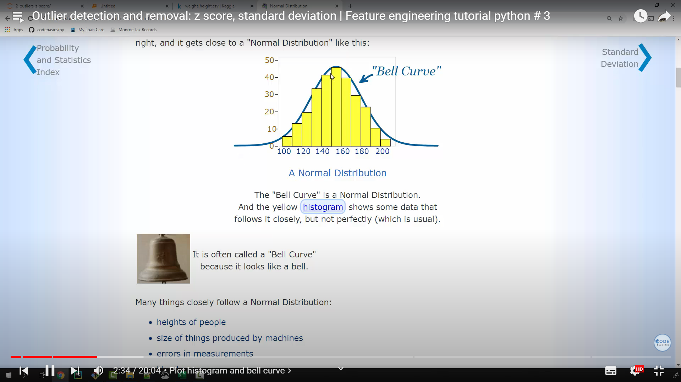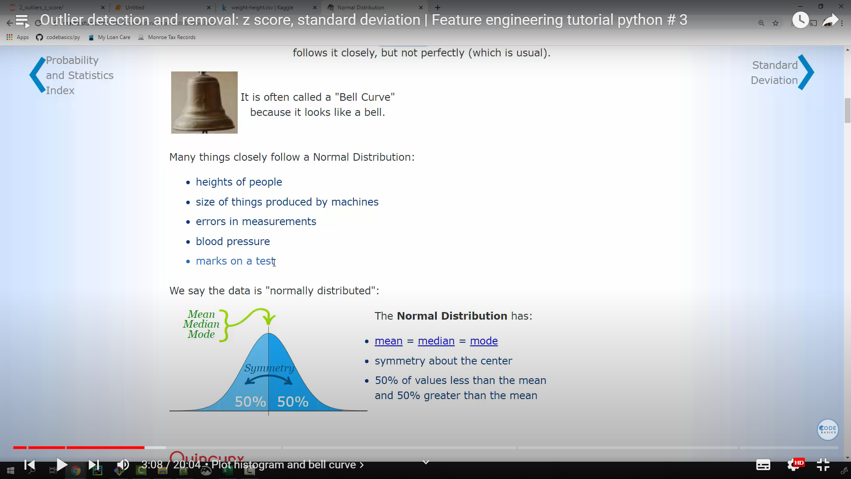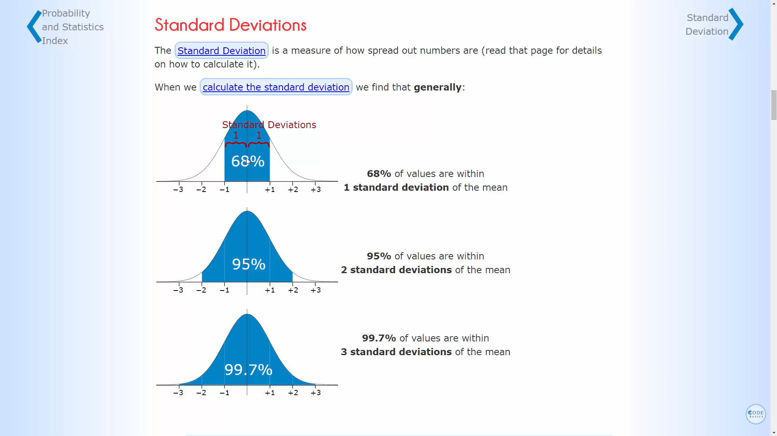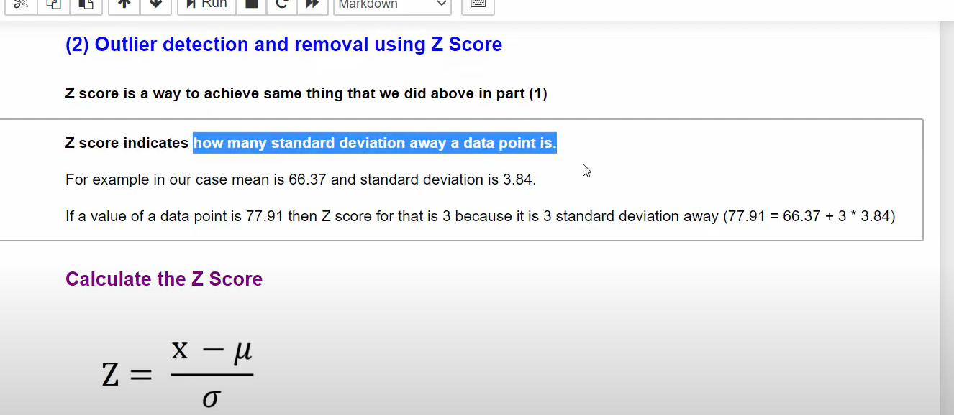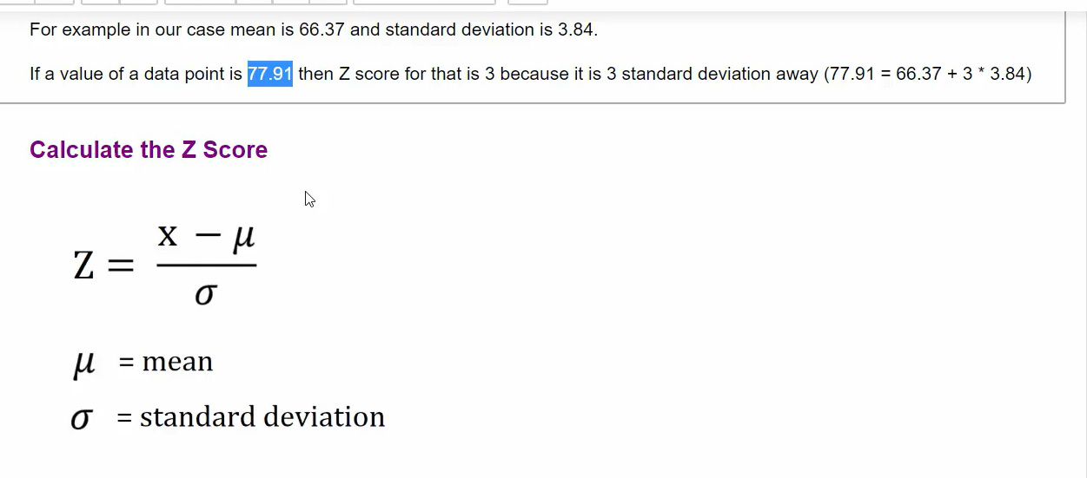

z-score/standard deviation

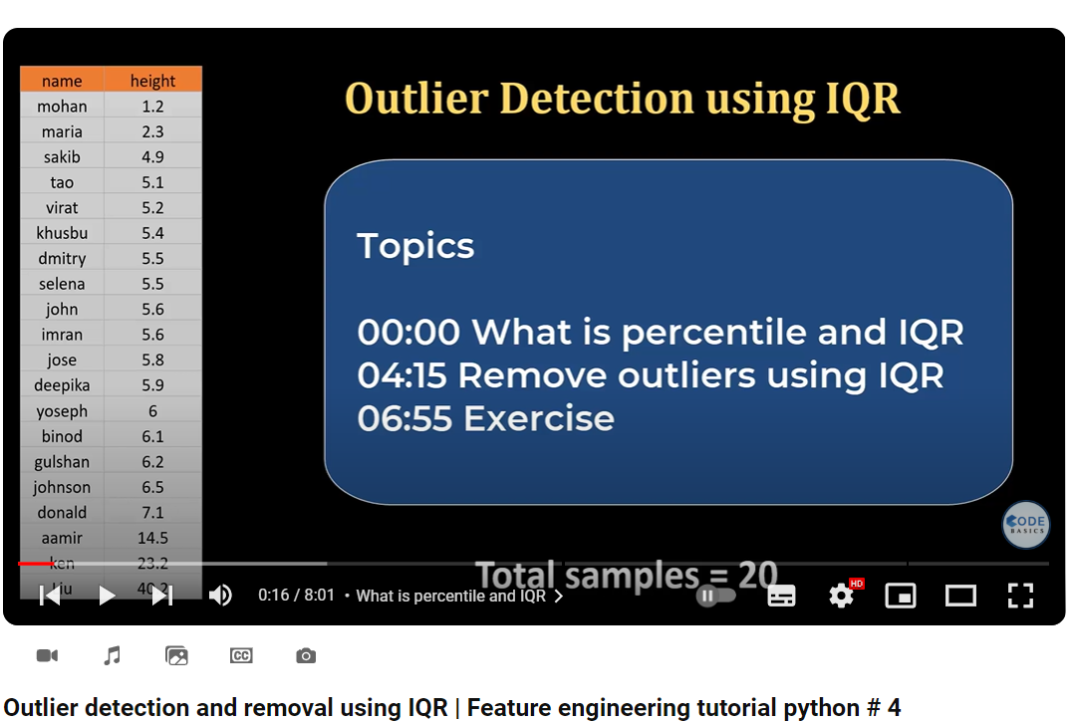 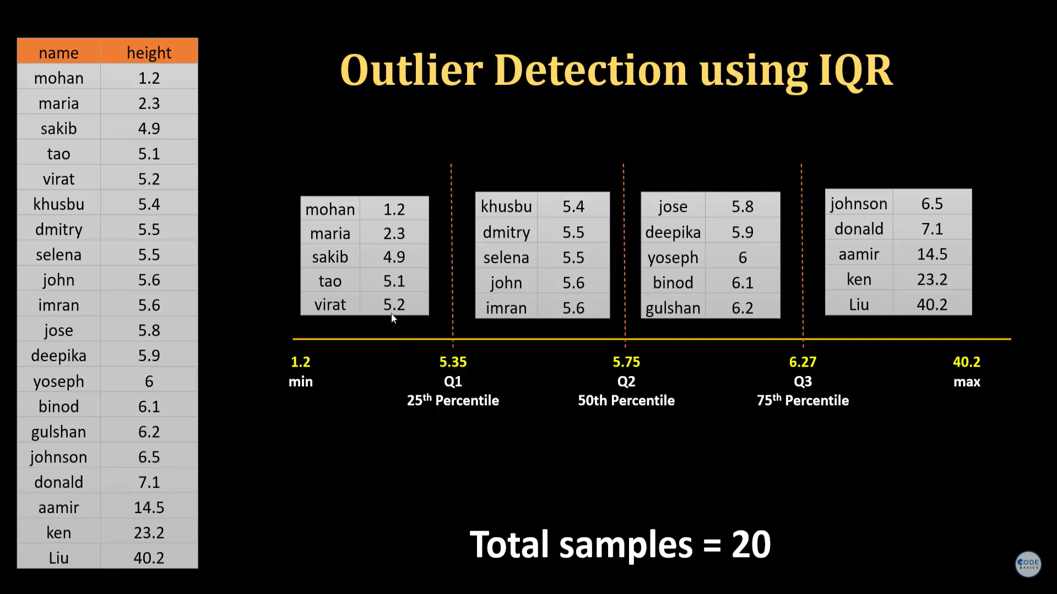 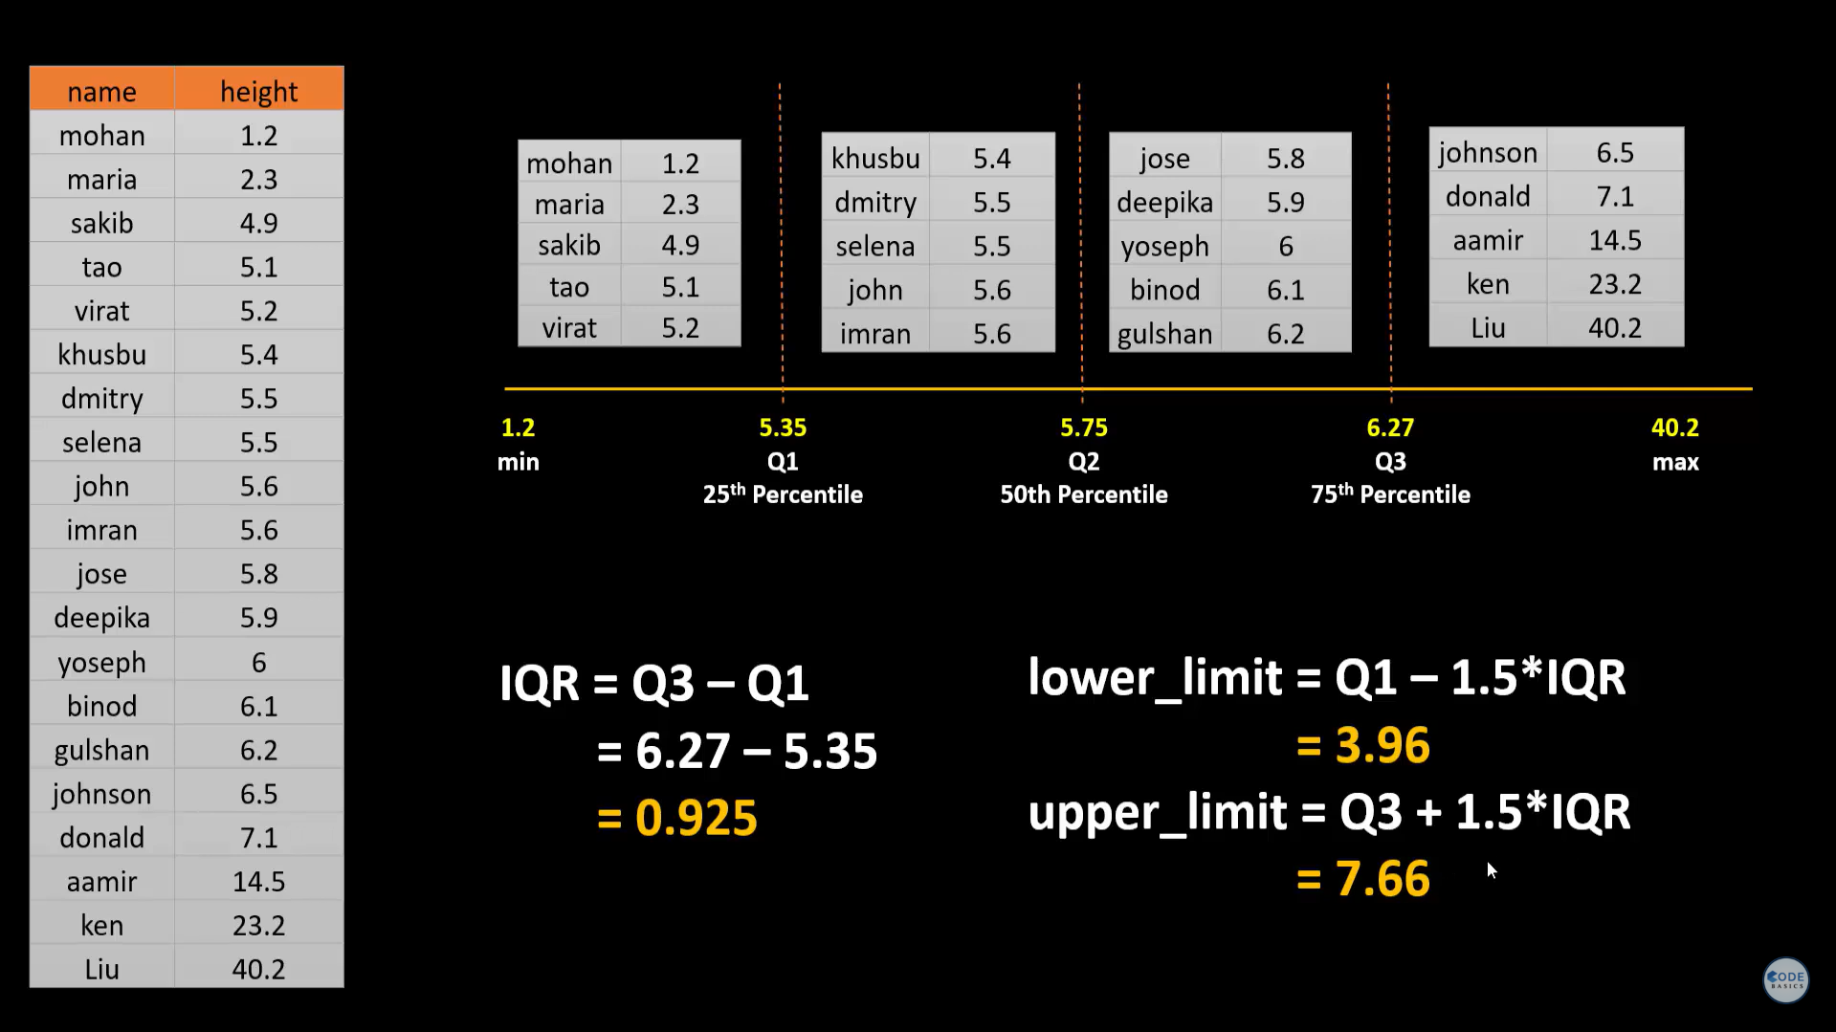

**Link from linkedin:**[**https://www.linkedin.com/posts/mungoliabhishek81_datatrek-datascience-machinelearning-activity-7258727548275064832-frQu?utm_source=share&utm_medium=member_desktop**](https://www.linkedin.com/posts/mungoliabhishek81_datatrek-datascience-machinelearning-activity-7258727548275064832-frQu?utm_source=share&utm_medium=member_desktop)

**https://www.linkedin.com/posts/laila-rahman95_ielts-google-drive-activity-7261568177531174912-OEEq?utm_source=share&utm_medium=member_desktops**

**XGBOOST  
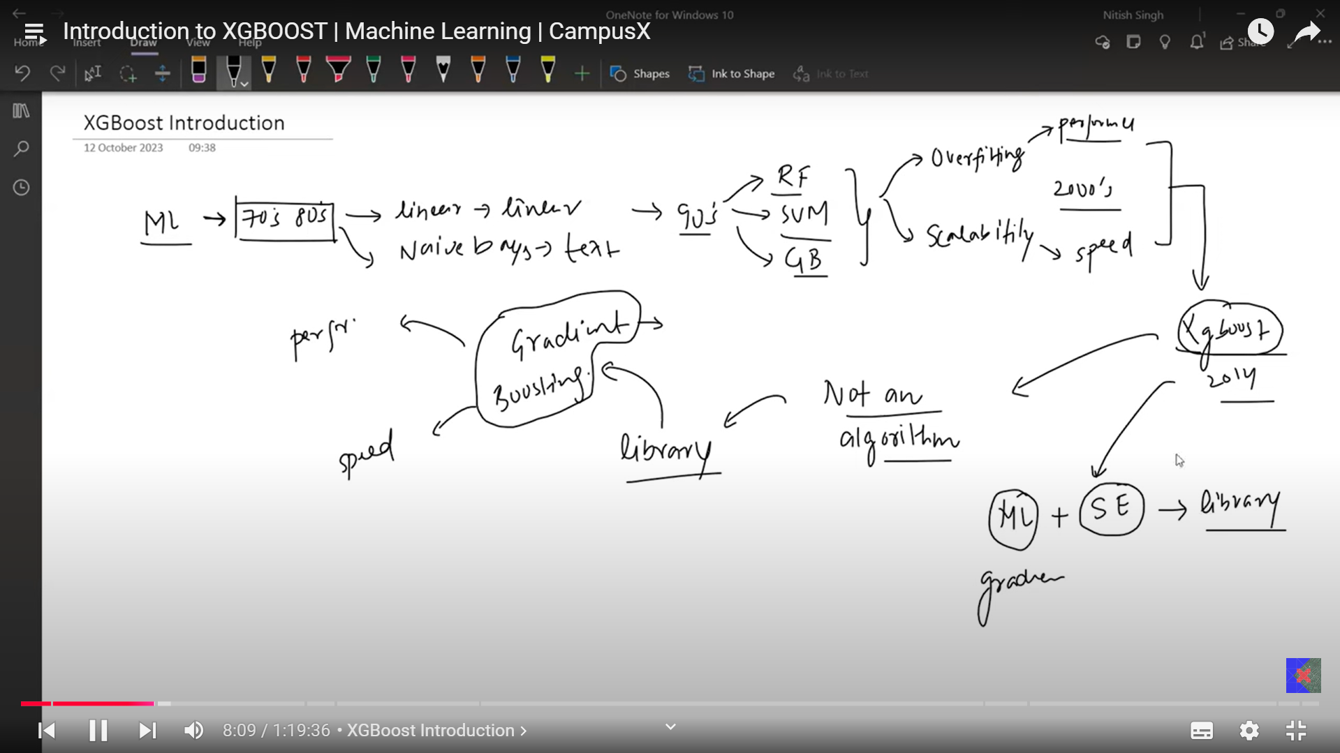**

**Naive Bayes**

**Conditional probability:**

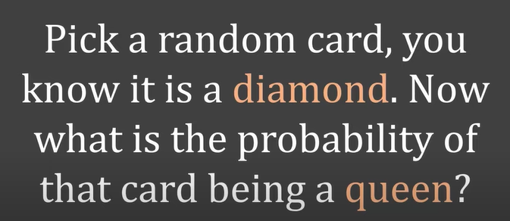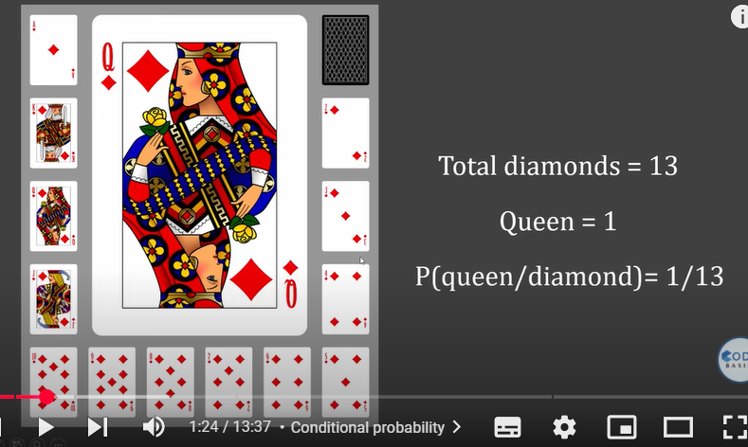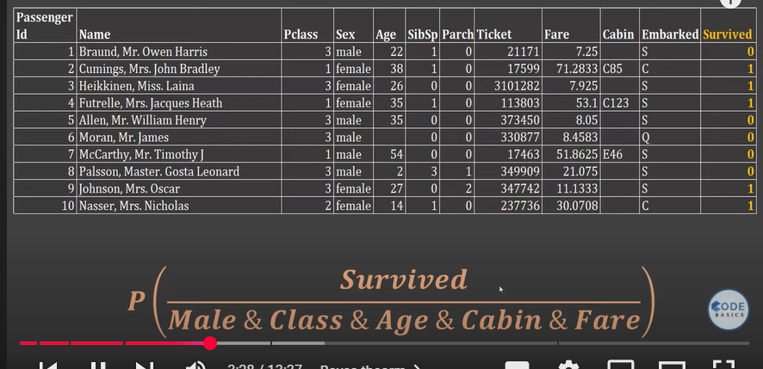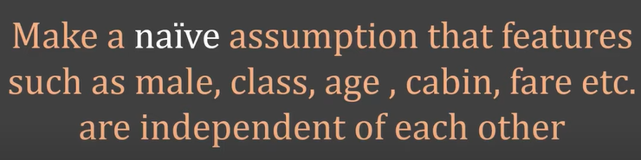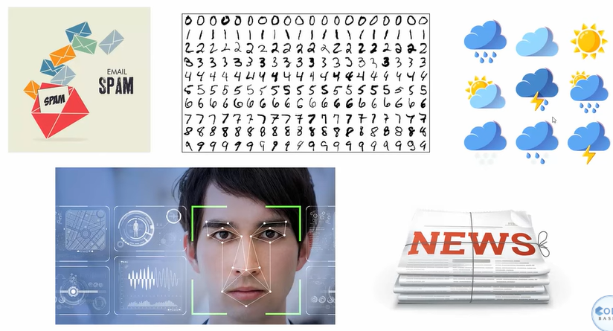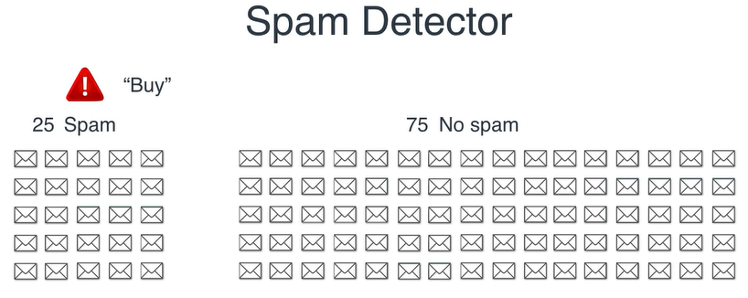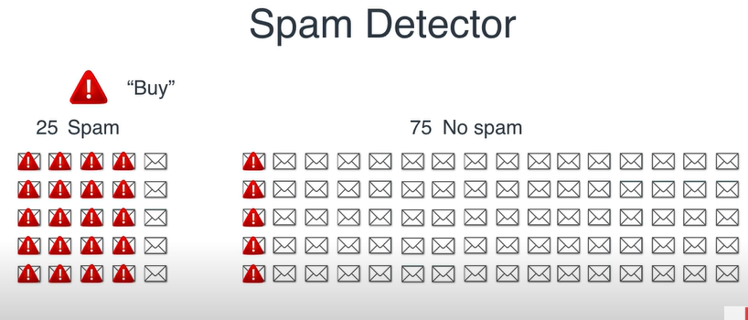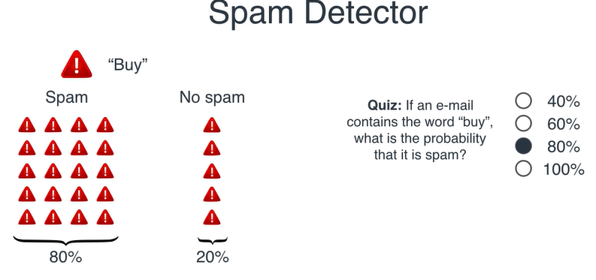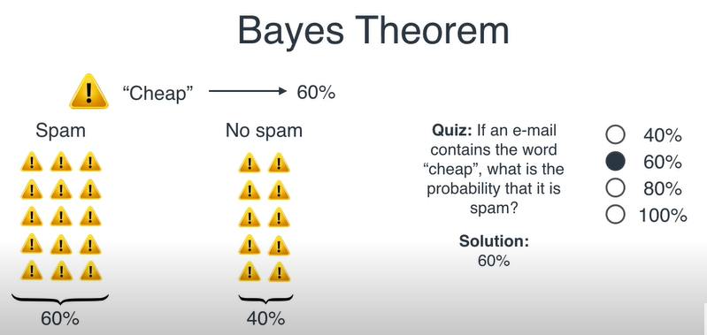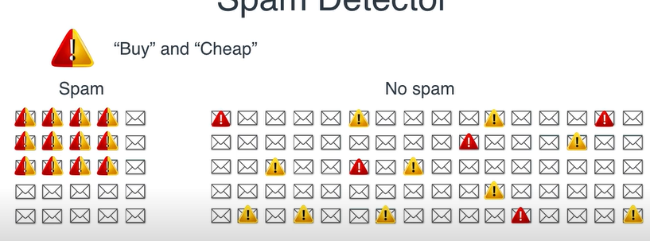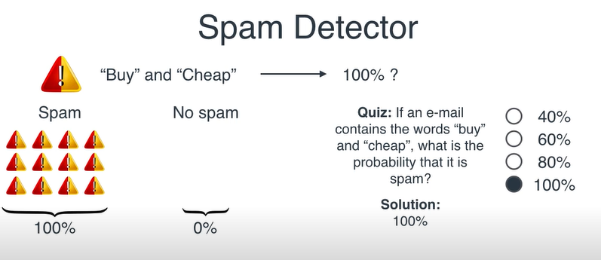

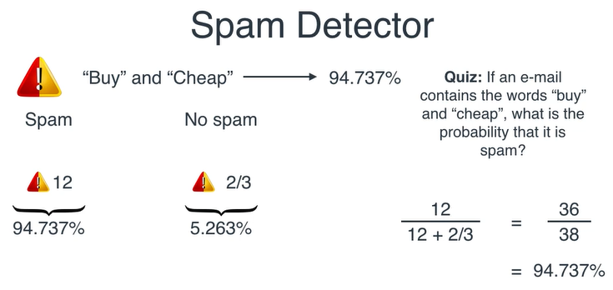

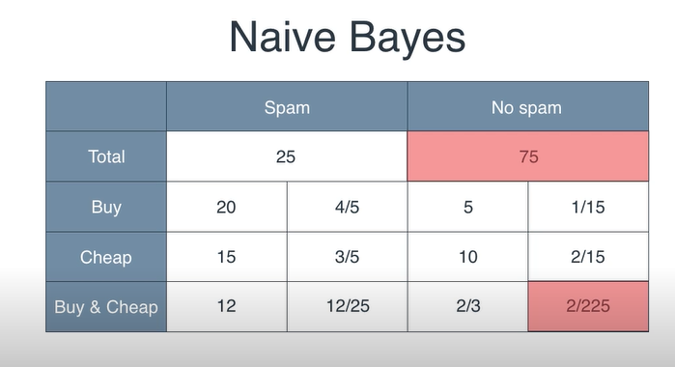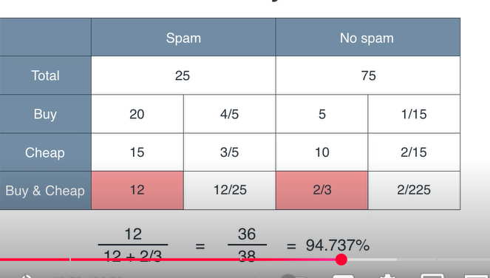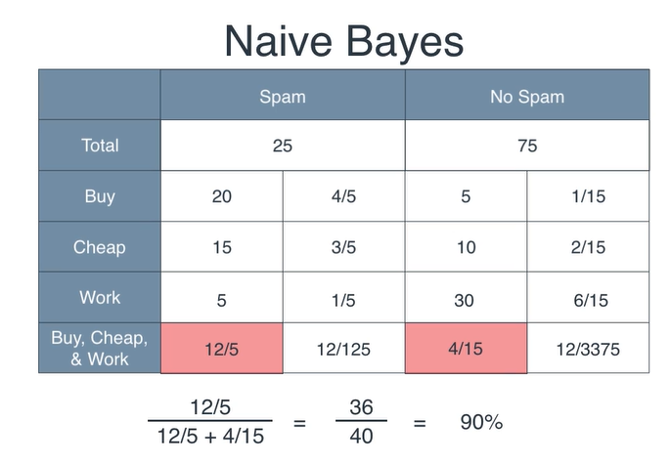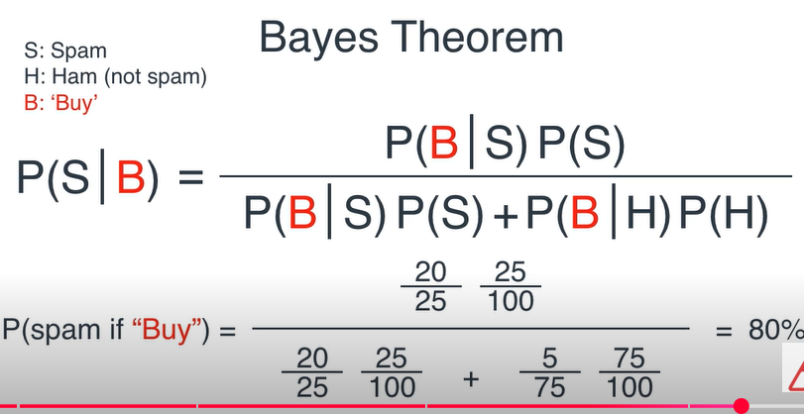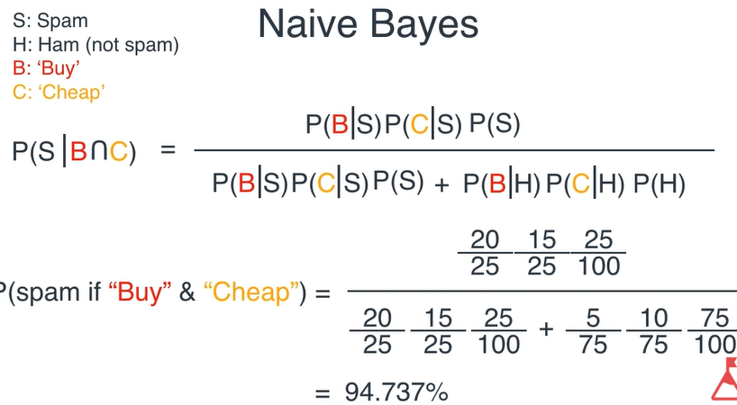

**#############################################In count-vectorizer; we count the unique words from each of the documents**

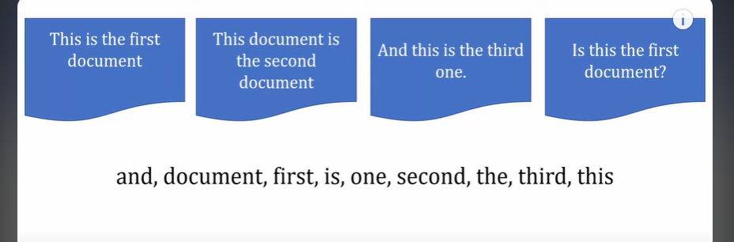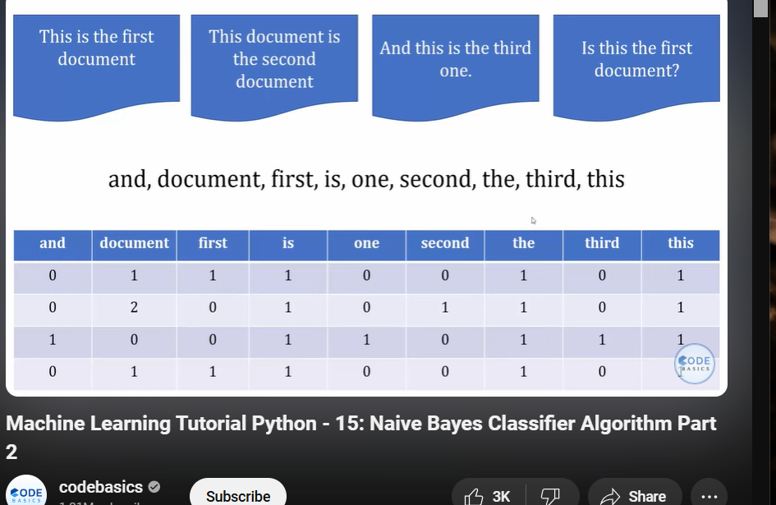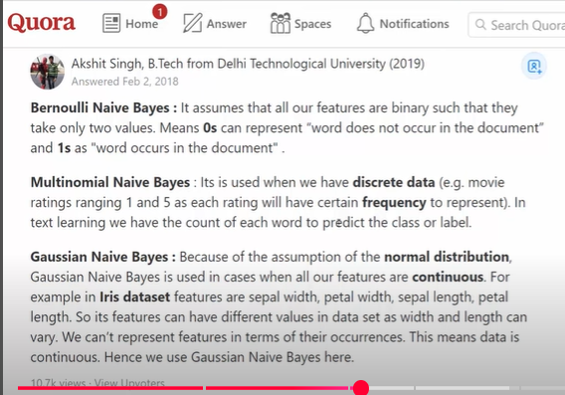

**Principal Component Analysis (PCA)**

**PCA or principal component analysis is a dimensionality reduction technique that can help us reduce dimensions of dataset that we use in machine learning for training.**

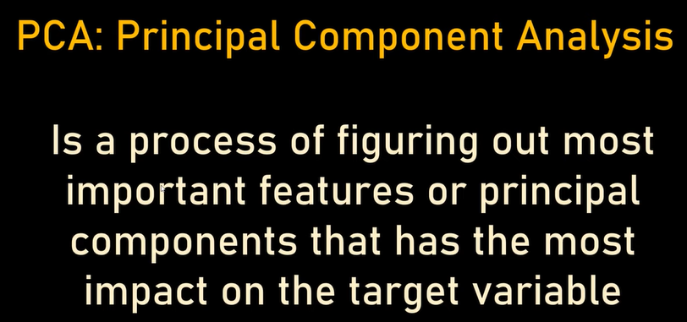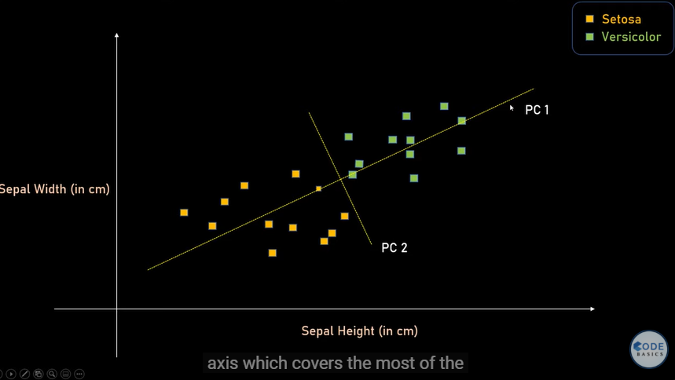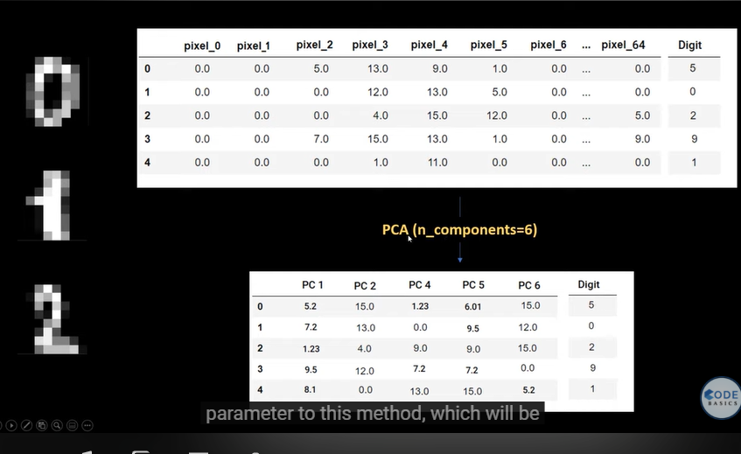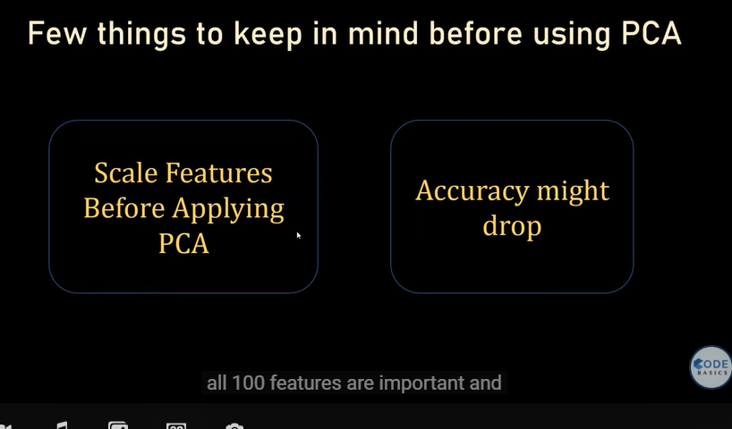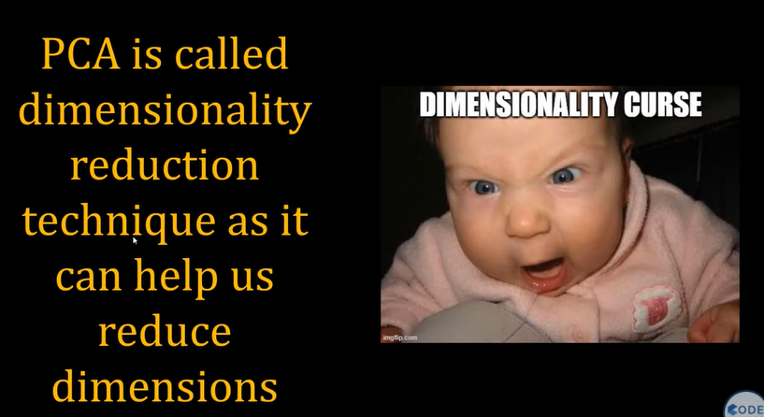

**Bias vs Variance In Machine Learning**

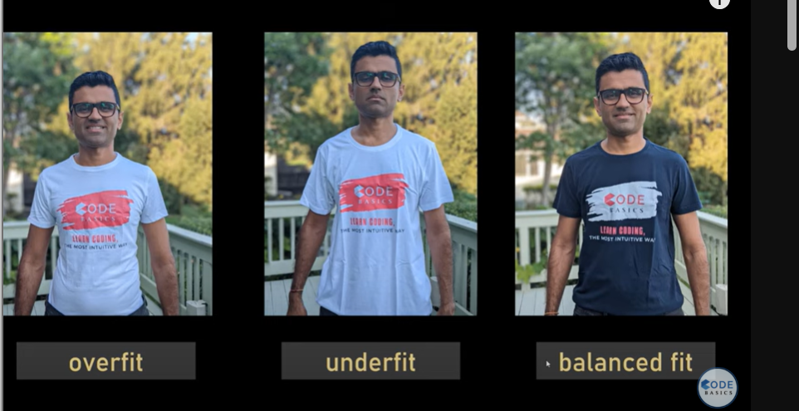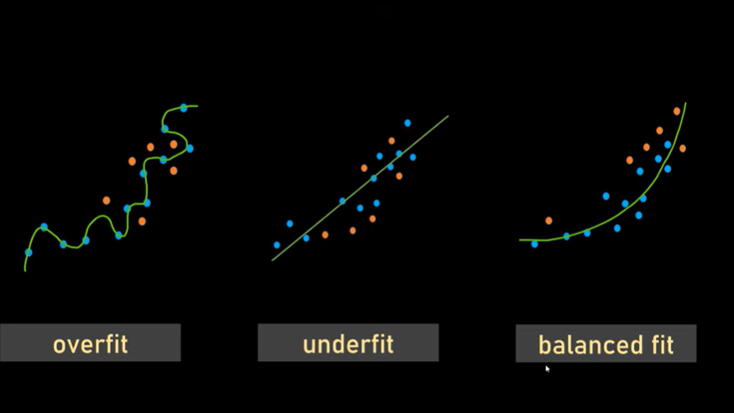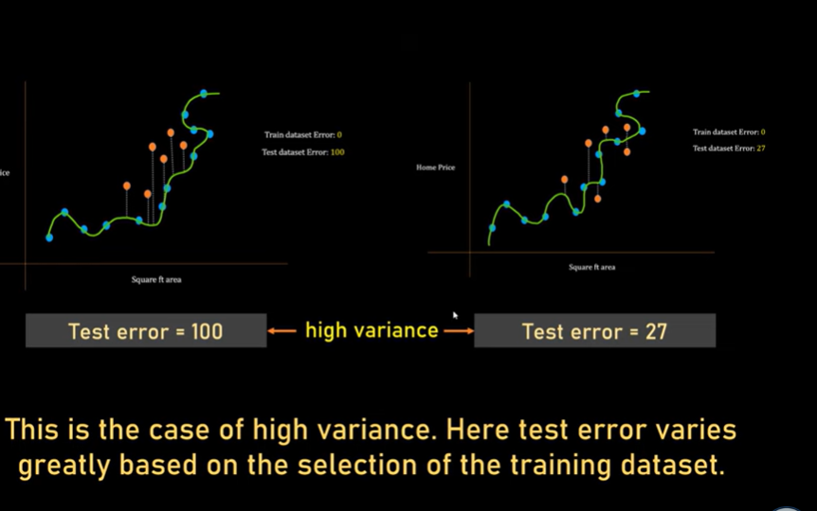**High Bias:  
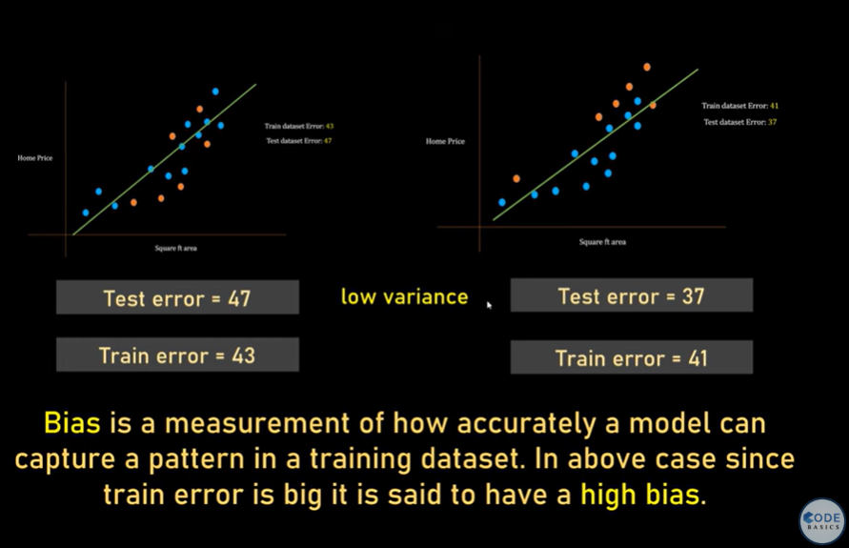**

**Fit:  
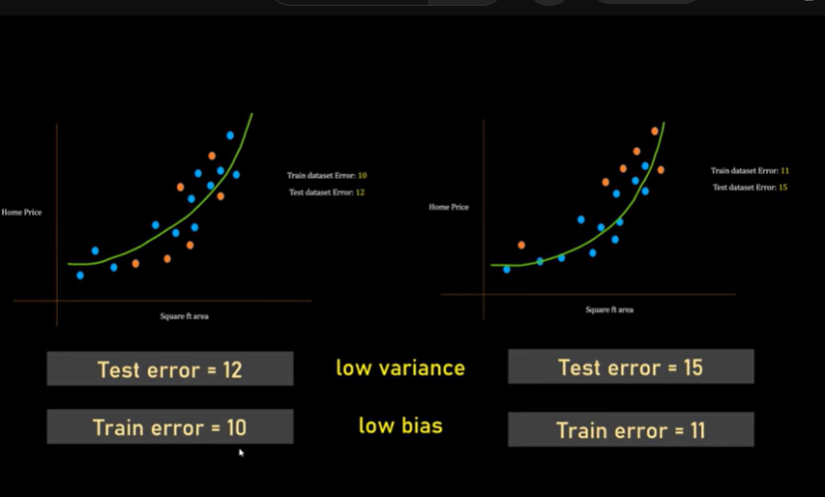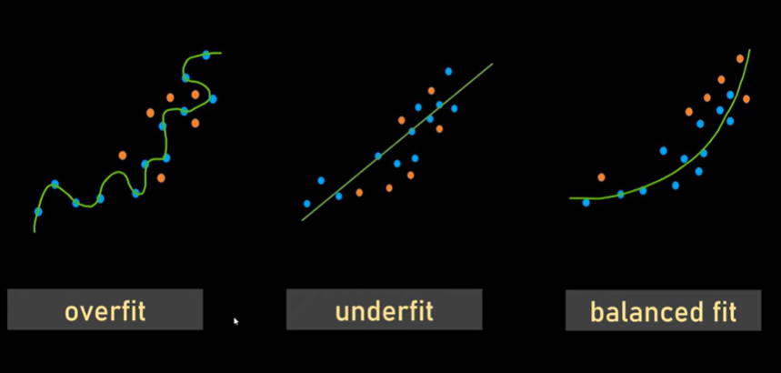**

**in following figure close to center is truth (lowBias) and (white)predicted value in cluster means low varience:  
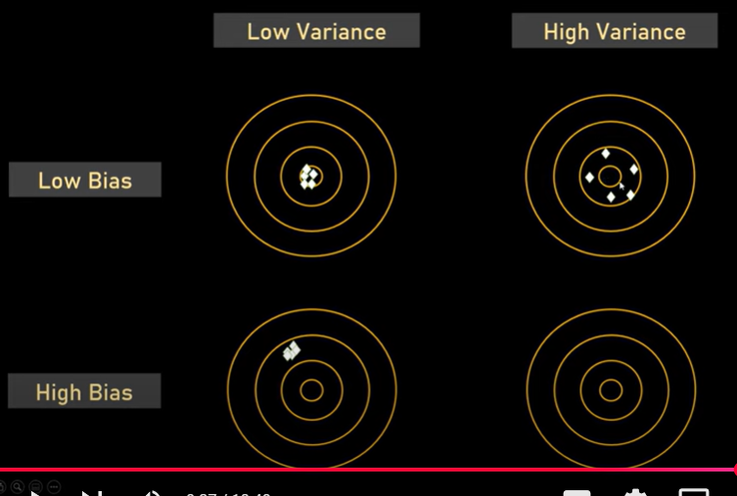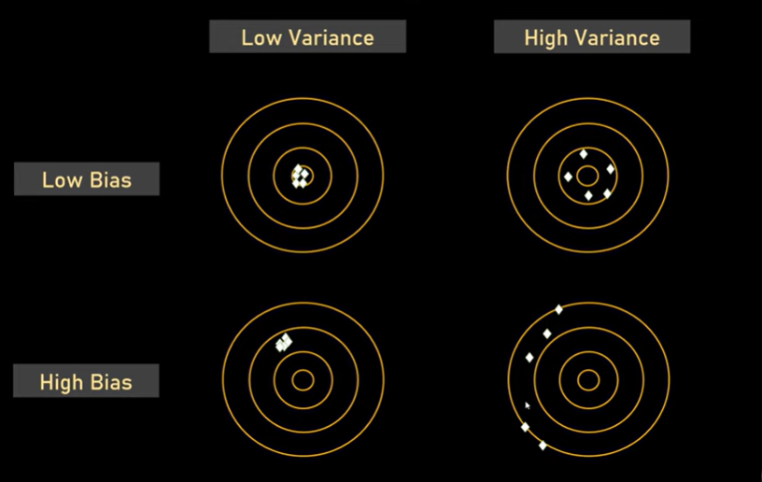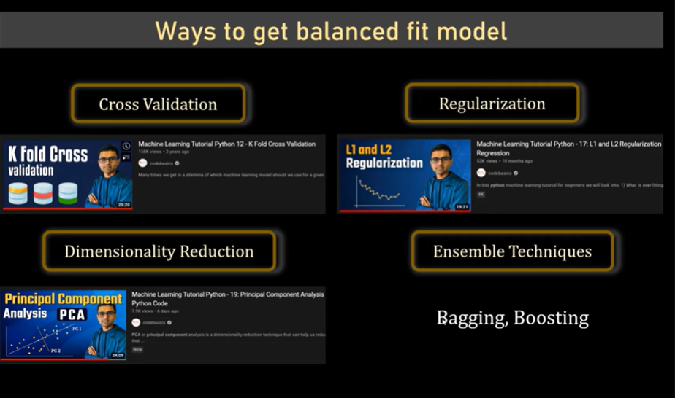**

**Ensemble Learning-Bagging**

**It takes opinion from majority**

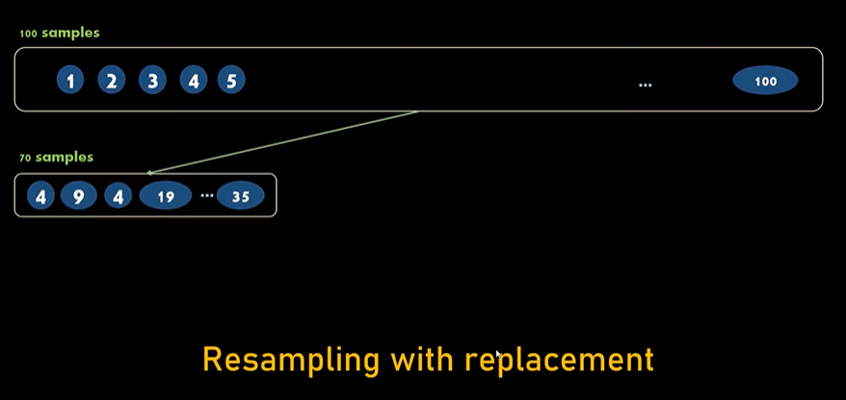**does small sample of data  
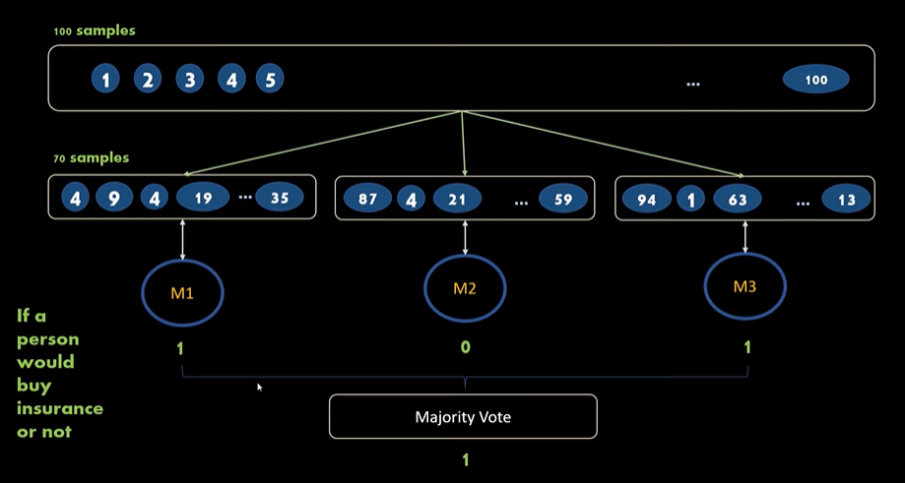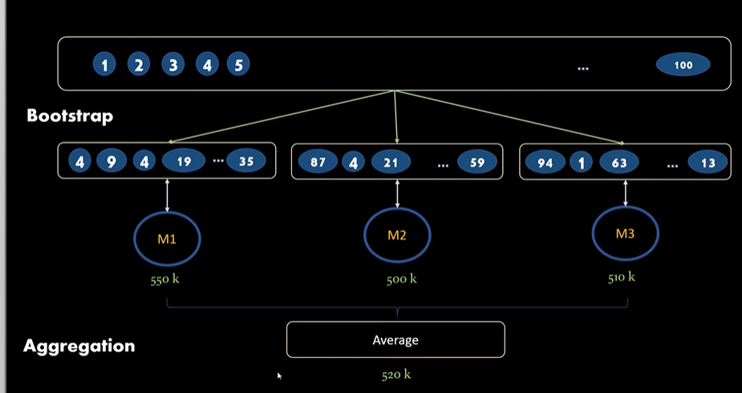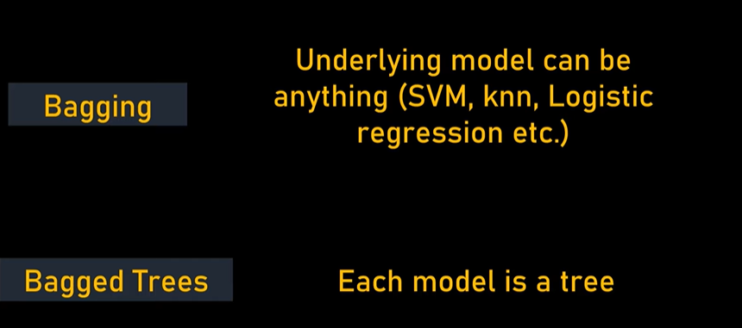when my resulting model have high variance it is better to use bagging**